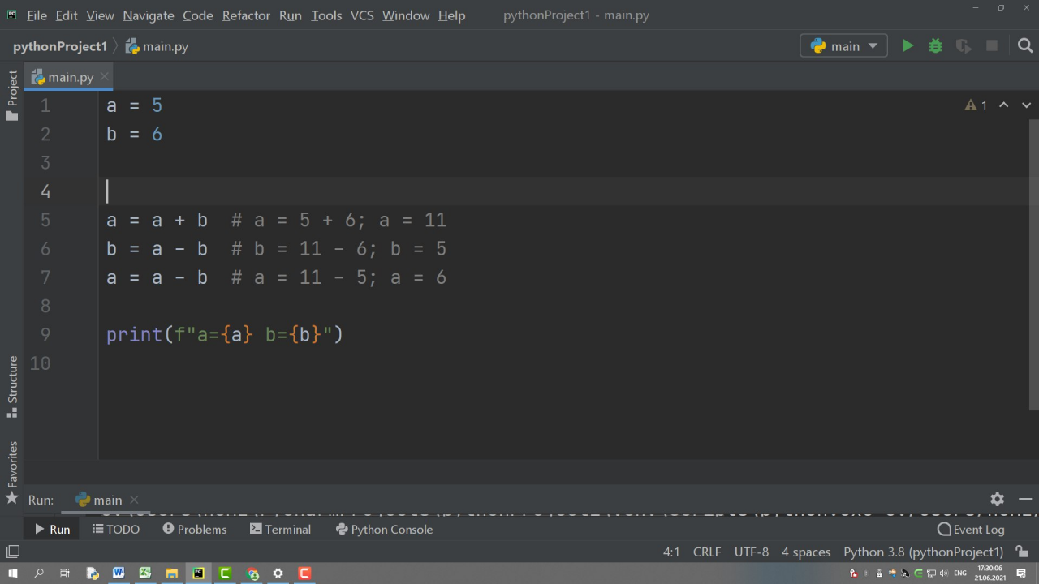

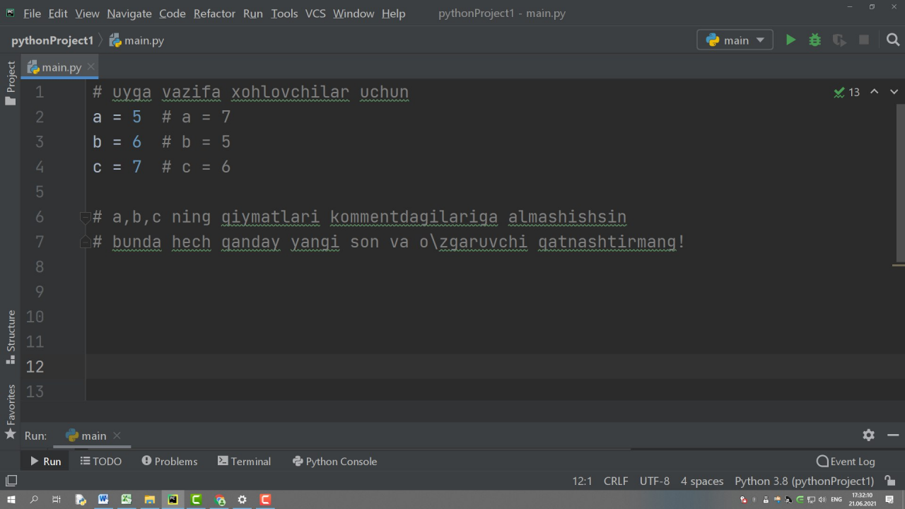

Oʏʙᴇᴋ Nᴀʀᴢᴜʟʟᴀʏᴇᴠ, [22.06.21 11:02]

# 8 - masala.

# 0 - Du, 1 - Se, 2 - Cho, 3 - Pay, 4 - Ju, 5 - Sha, 6 - Yan: k kiritasiz

day = int(input())

dayCode = (day - 1) % 7

print(dayCode)

Oʏʙᴇᴋ Nᴀʀᴢᴜʟʟᴀʏᴇᴠ, [22.06.21 11:02]

# 7 - masala. minut kiritasiz va kun boshidan o'shancha minut o'tgandan keyin

# soat nechi bo'lishi dasturini tuzing

number = int(input("minut: "))

min = number % 60

soat = number // 60

print(f"{soat} : {min}")

Oʏʙᴇᴋ Nᴀʀᴢᴜʟʟᴀʏᴇᴠ, [22.06.21 11:03]

# amallar

a = 5

b = 2

c = a + b # qo'shish

d = a - b # ayirish

e = a * b # ko'paytirish

f = a ** b # daraja

g = a / b # bo'lish

h = a % b # qoldiqli bo'lish

i = a // b # bo'linmani butun qismini olish

print(f"c={c} d={d} e={e} f={f} g={g} h={h} i={i}")

Oʏʙᴇᴋ Nᴀʀᴢᴜʟʟᴀʏᴇᴠ, [22.06.21 11:03]

# ko'p o'zlashtirish

x, y, z = ["olma", "anor", "apelsin"]

print(f"x={x}, y={y}, z={z}")

Oʏʙᴇᴋ Nᴀʀᴢᴜʟʟᴀʏᴇᴠ, [22.06.21 11:03]

# amallar

a = 5

b = 2

c = a + b # qo'shish

d = a - b # ayirish

e = a * b # ko'paytirish

f = a ** b # daraja

g = a / b # bo'lish

h = a % b # qoldiqli bo'lish

i = a // b # bo'linmani butun qismini olish

print(f"c={c} d={d} e={e} f={f} g={g} h={h} i={i}")

Oʏʙᴇᴋ Nᴀʀᴢᴜʟʟᴀʏᴇᴠ, [22.06.21 11:03]

# ko'p o'zlashtirish

x, y, z = ["olma", "anor", "apelsin"]

print(f"x={x}, y={y}, z={z}")

Oʏʙᴇᴋ Nᴀʀᴢᴜʟʟᴀʏᴇᴠ, [22.06.21 11:35]

import math

x = 1

y = 6

z = 3

# max

print(max(x, y, z))

# min

print(min(x, y, z))

# absolut qiymat

print(abs(-5))

# darajaga ko'tarish

print(pow(6, 2))

# sqrt kvadrat ildiz

print(int(math.sqrt(49)))

# ceil bu ko'pi bilan oladi ms 1.1 -> 2

print(math.ceil(1.1))

# floor bu kami bilan oladi ms 1.9 -> 1

print(math.floor(-1.9))

# 1 - masala. kvadrat yuzi?

a = int(input("tomoni a="))

s = pow(a, 2) print(s) # javob 25

# 2 - masala. doirani ajrat aylana uzunligi va doirani yuzi?

import math

radius = int(input("radius = "))

L = 2 * math.pi * radius

S = math.pi * pow(radius, 2)

print(f"uzunligi:{L} yuzi:{S}")

# 3 - masala. doirani ajrat aylana uzunligi va doirani yuzi?

import math

a = int(input("a="))

b = int(input("b="))

c = math.sqrt(pow(a, 2) + pow(b, 2))

c1 = pow(a * a + b * b, 1/2)

print(c, c1)

x = int(input("x="))

y = int(input("y="))

z = int(input("z="))

D = (math.sqrt(abs(pow(x, 2) + pow(y + z, 2) - x)) - abs(y))/(2 * abs(x) + 1)

print(D)

import matplotlib.pyplot as plt

import numpy as np

x = np.arange(0, 4 * np.pi, 0.1) # start,stop,step

y = np.sin(x)

plt.plot(x, y)

plt.show()

Oʏʙᴇᴋ Nᴀʀᴢᴜʟʟᴀʏᴇᴠ, [22.06.21 15:38]

# toifalar

# sonli toifalar: integer float complex

a = 1 # butun tip -> int

b = 1.2 # haqiqiy tip -> float

c = 1j # komplex tip -> complex

# satrli toifalar -> str

name = "Oybek"

d = 'd'

text = """Gulla yashna

fgdfg

dfgdfg

fdg

O'zbekiston"""

# mantiqiy -> bool

Uqituvchimi = True # rost

Uquvchimi = False # yolg'on

Oʏʙᴇᴋ Nᴀʀᴢᴜʟʟᴀʏᴇᴠ, [22.06.21 15:42]

# amallar

c = a + b # 1 - qo'shish

d = a - b # ayirish

e = a * b # ko'p

f = a / b # bo'lish

g = a ** b # daraja

h = a % b # qoldiq

i = a // b # butun qismini olish

print(c, d, e, f, g, h, i)

Oʏʙᴇᴋ Nᴀʀᴢᴜʟʟᴀʏᴇᴠ, [22.06.21 16:05]

# 3 - masala. Sonning yuzlar xonasidagi raqamni chiqarish

number = int(input("son kiriting: ")) # number = 1725

x = number // 100 # 1725 -> 17

y = number % 10 # 17 -> 7

Oʏʙᴇᴋ Nᴀʀᴢᴜʟʟᴀʏᴇᴠ, [22.06.21 16:17]

# 4 - masala. 65 sm ni sm va dm da yozib bering; (1dm = 10sm)

l = 65

dm = l // 10

sm = l % 10

print(f"{dm} dm {sm} sm")

# 2 - masala To'g'ri burchakli uchburchakni katetlari a, b, uni gipotenuzsini toping

import math

a = int(input("a="))

b = int(input("b="))

c = math.sqrt(pow(a, 2) + pow(b, 2))

print(c)

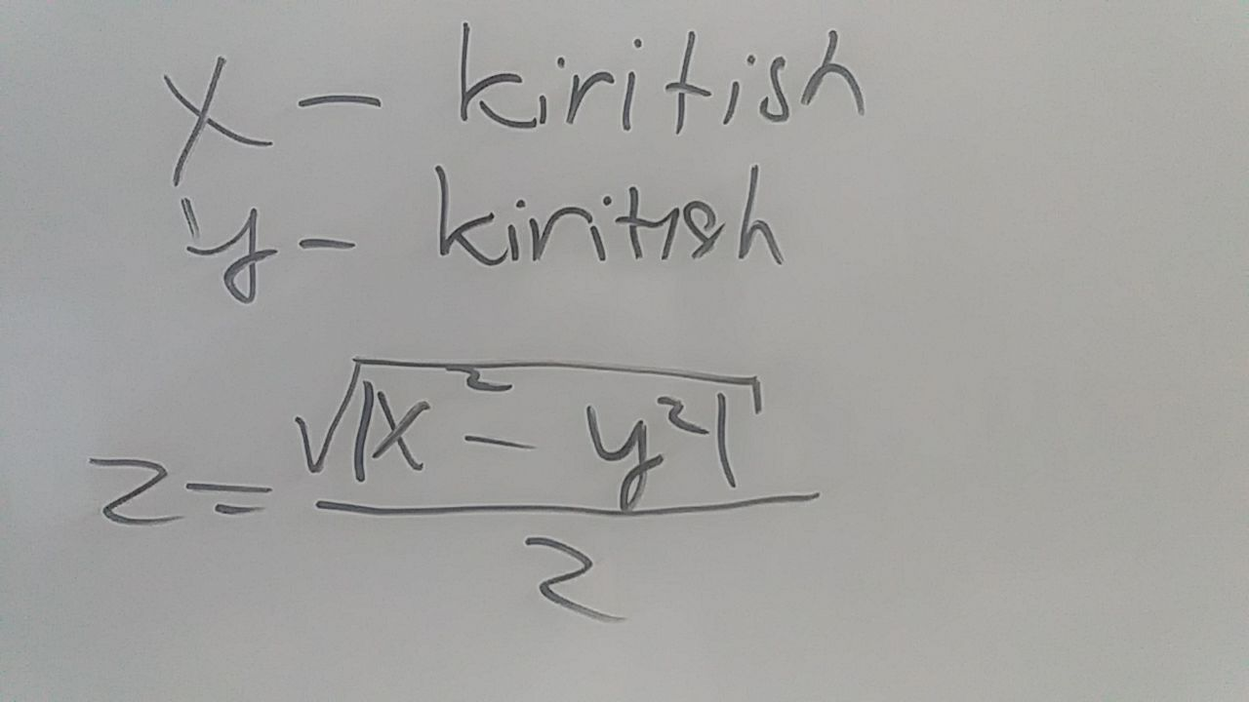

# 3 - masala

import math

x = int(input("x="))

y = int(input("y="))

z = math.sqrt(abs(x 2 - y 2)) / 2

print(z)

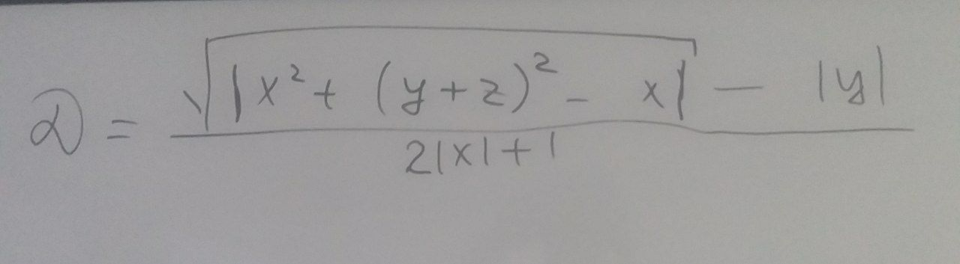

# 4 - masala

import math

x = int(input("x="))

y = int(input("y="))

z = int(input("z="))

D = (math.sqrt(abs(x 2 + (y + z) 2) - x) - abs(y))/(2 * abs(x) + 1)

print(D)

Oʏʙᴇᴋ Nᴀʀᴢᴜʟʟᴀʏᴇᴠ, [23.06.21 10:02]

# 1 - masala

ruyhatdan_utdi = True

uqituvchimi_mi = False

baholaydi = ruyhatdan_utdi and uqituvchimi_mi

print(baholaydi)

Oʏʙᴇᴋ Nᴀʀᴢᴜʟʟᴀʏᴇᴠ, [23.06.21 10:15]

# 3 - masala. O'quvchi o'rin olsa maqtov yorliq oladi

urin_oldimi = True

maqtov_yorliq = urin_oldimi

maqtov_yorliq_yoq = not urin_oldimi

print(f"o'rin oldi: {urin_oldimi}")

print(f"maqtov yorliq bor {maqtov_yorliq}")

print(f"maqtov yorliq yo'q {maqtov_yorliq_yoq}")

Oʏʙᴇᴋ Nᴀʀᴢᴜʟʟᴀʏᴇᴠ, [23.06.21 10:27]

# if shart operatori

a = int(input("a="))

if a > 5: # bu yerda mulohaza -> a>5

print(f"ha {a}, 5 dan katta") # amal1 agar mulohaza rost bo'lsa bajariladi

else:

print(f"Yo'q {a}, 5 dan katta emas") # amal2 agar mulohaza yolg'on bo'lsa bajariladi

name = 'Oybek'

mening_ismim = "Oybek"

# indentifikator = qiymat

# Qiymat : 1 , 2.1 , 3j, "sdfsdf", False, [2,3,3] ...

# indetifikator: a ... z, 0 ... 9

# indentifikator nomi tushunarli bo'lsin

mevaNarxi = 2000

x = 2000

# indentifikator yozish usullari

ismFamiliyaSharif = "Oybek N" # Camel Case

IsmFamiliyaSharif = "fddgd" # Pascal Case

ism_familiya_sharif = "fdsdsfs" #

Oʏʙᴇᴋ Nᴀʀᴢᴜʟʟᴀʏᴇᴠ, [23.06.21 11:04]

# 4 - masala. string uzunligi len funksiyasisiz topish

word = 'Uzbekistan'

uzunligi = 0

for i in word:

uzunligi = uzunligi + 1

print(uzunligi)

Oʏʙᴇᴋ Nᴀʀᴢᴜʟʟᴀʏᴇᴠ, [23.06.21 11:06]

# 4 - masala. string uzunligi len funksiya bilan topish

word = 'Uzbekistan'

uzunligi = len(word)

print(uzunligi)

Oʏʙᴇᴋ Nᴀʀᴢᴜʟʟᴀʏᴇᴠ, [23.06.21 11:10]

# 6 - masala. Matn ichidan so'z bor yo'qligini bilish

matn = "Men Pythonda qiziqib ishlayapman."

bor = "Men" in matn # in -> ichida

print(bor)

Oʏʙᴇᴋ Nᴀʀᴢᴜʟʟᴀʏᴇᴠ, [23.06.21 11:50]

# 7 - masala. Matn ichida necha i harfi bor yo'qligini bilish

matn = "Men Pythonda qiziqib ishlayapman bu men da!!."

iSoni = 0

for i in matn:

if(i == 'i'):

iSoni += 1

print(iSoni)

Oʏʙᴇᴋ Nᴀʀᴢᴜʟʟᴀʏᴇᴠ, [23.06.21 11:54]

# 5 - masala. Matn ichida so'z yoqligini tekshirish

text = "Men Jizzax viloyatida turaman."

print('Oybek' not in text) # in -> ichida

Oʏʙᴇᴋ Nᴀʀᴢᴜʟʟᴀʏᴇᴠ, [23.06.21 12:01]

# slicing -> index bo'yicha ajratib ko'rsatish

sym = '1'

text = "Men Jizzax viloyatida turaman." # to'plam -> massiv

ajratlgan_suz = text[4:10]

print(ajratlgan_suz)

Oʏʙᴇᴋ Nᴀʀᴢᴜʟʟᴀʏᴇᴠ, [23.06.21 12:06]

# slicing -> index bo'yicha ajratib ko'rsatish

sym = '1'

text = "Men Jizzax viloyatida turaman." # to'plam -> massiv

ajratlgan_suz = text[0:10:2] # text[boshlash_indeksi: tugatish_indeksi: sakrash_qadami]

print(ajratlgan_suz)

Nodir Atayev, [23.06.21 12:15]

text = input("matn kiting: ")

ajratilga_suz = text [4:10]

print(ajratilga_suz)

Oʏʙᴇᴋ Nᴀʀᴢᴜʟʟᴀʏᴇᴠ, [23.06.21 12:27]

# split() -> ma'lum belgi yordamida matnni bo'laklash

# yoki so'zlarga ajratib ro'yhat hosil qilish

txt1 = 'Hello World' # Satr

txt2 = ['Hello', 'world'] # ro'yhat (yoki massiv)

print(txt1.split(' '))

txt2 = txt2[0] + ' ' + txt2[1]

print(txt2)

Oʏʙᴇᴋ Nᴀʀᴢᴜʟʟᴀʏᴇᴠ, [23.06.21 12:34]

fullName = input('Ism va familiya kiriting: ')

# kiritilgan shaxs ism familiyasidan foydalanib shaxsning jinsini aniqlang

Oʏʙᴇᴋ Nᴀʀᴢᴜʟʟᴀʏᴇᴠ, [23.06.21 12:34]

[In reply to Oʏʙᴇᴋ Nᴀʀᴢᴜʟʟᴀʏᴇᴠ]

uyga vazifa

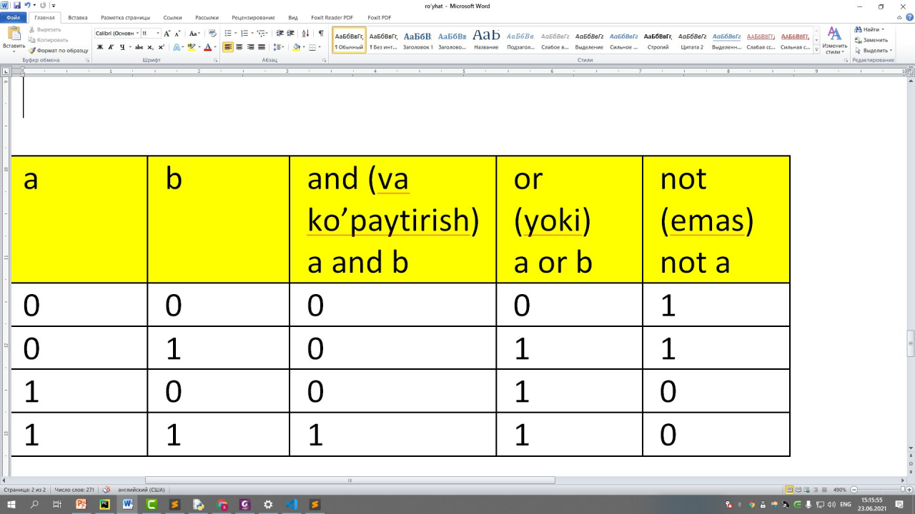

Oʏʙᴇᴋ Nᴀʀᴢᴜʟʟᴀʏᴇᴠ, [23.06.21 15:17]

# if mulohaza :

# mulohaza rost bo'lsa buyerni bajaradi

# else:

# mulohaza yolg'on bo'lsa bu yerni bajaradi

Oʏʙᴇᴋ Nᴀʀᴢᴜʟʟᴀʏᴇᴠ, [23.06.21 15:38]

# pythonda satr ham massivdir.

# indekslar

city = "Jizzax"

print(city[0]) # J

print(city[0:]) # Jizzax

print(city[0:4]) # Jizz

print(city[:5]) # Jizza

print(city[0:4]) # Jizz

print(city[0:5:2]) # Jza

print(city[-1]) # x

print(city[-6:-1]) # Jizza

print(city[-6:-1:2]) # Jza

print(city[-1::-1]) # xazziJ

Oʏʙᴇᴋ Nᴀʀᴢᴜʟʟᴀʏᴇᴠ, [23.06.21 15:47]

# satrlarni qo'shish

x = 'Oybek'

y = 'Narzullayev'

z = x + ' ' + y

g = 'Salom' + ' ' + 'guruh'

print(z)

print(g)

print('2' + '1') # 21

print(2 + 1) # 3

Oʏʙᴇᴋ Nᴀʀᴢᴜʟʟᴀʏᴇᴠ, [23.06.21 15:56]

# split() -> bu satrni ma'lum belgi bilan ajratib tashlab

# alohida ro'yhat hosil qilib uni elementlari qiladi

txt = 'Salom men Jizzaxlikman.'

print(txt) # Salom men Jizzaxlikman.

print(txt.split()) # ['Salom', 'men', 'Jizzaxlikman.']

txt1 = 'Oybek va Shoxzod va ibrohim va Muhammad'

print(txt1.split(' va ')) # ['Oybek', 'Shoxzod', 'ibrohim', 'Muhammad']

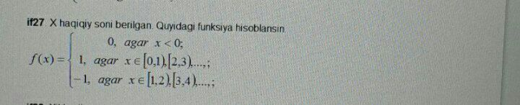

Oʏʙᴇᴋ Nᴀʀᴢᴜʟʟᴀʏᴇᴠ, [24.06.21 09:37]

# string metodlari -> string bu - belgilar va matnlar

# stringlar "", '', """ """, ''' '''

name = "Bunyod"

# upper -> hammasini katta harfga o'tkazish

print(name.upper()) # BUNYOD

# lower -> hammasini kichik harfga o'tkazish

print(name.lower()) # bunyod

# strip -> bu boshi va oxiridagi bo'shliqni (probelni) olib tashlaydi

txt = ' salom dunyo '

print(txt.strip()) # salom dunyo

# 'M' == 'm' pythonda katta va kichik bir xil harflar teng emas

print('M' == 'm') # False

# replace -> almashtirish

ism = 'Kamol'

print(ism.replace("K", "J")) # Jamol

Oʏʙᴇᴋ Nᴀʀᴢᴜʟʟᴀʏᴇᴠ, [24.06.21 09:44]

# string bo'yicha muhim ko'rsatma

# bu to'g'ri

ism = 'Bunyod'

yoshi = '22'

print(ism + ' yoshi: ' + yoshi) # to'g'ri

# bunisi noto'g'ri

ism1 = 'Bunyod'

yoshi = 22

print(ism + ' yoshi: ' + yoshi) # xato

# xulosa: stringga faqat stringni "+" (plyus) yordamida ulang!

Oʏʙᴇᴋ Nᴀʀᴢᴜʟʟᴀʏᴇᴠ, [24.06.21 10:14]

# format() -> bu toifalarni bir xil toifaga o'tkazib qo'yadi

# matn.format(kiritilayotgan_suz)

txt = "Salom mening yoshim {} da"

yosh = 22

print(txt.format(yosh))

# indexsiz formatdan foydalanish

sinfi = 9

uyRaqami = 28

maktabRaqami = 8

txt = 'Men {} - sinfman. Men Yoshlik mahallasida {} - uyda yashayman. {} - maktabda o`qiyman'

print(txt.format(sinfi, uyRaqami, maktabRaqami, ))

# index bilan foydalanish

sinfi = 9

uyRaqami = 28

maktabRaqami = 8

txt = 'Men {1} - sinfman. Men Yoshlik mahallasida {0} - uyda yashayman. {2} - maktabda o`qiyman'

print(txt.format(uyRaqami, sinfi, maktabRaqami)) # txt.format(0, 1, 2, ....)

Oʏʙᴇᴋ Nᴀʀᴢᴜʟʟᴀʏᴇᴠ, [24.06.21 10:28]

# escape lardan foydalanish

txt = 'Mening amakimni ismi O\'tkir'

print(txt) # # Mening amakimni ismi O'tkir

# backslash -> sleshni yagona bo'lish yoki sleshni ortga qaytarish

txt = 'Mening amakimni \\ ismi O\'tkir'

print(txt) # Mening amakimni \ ismi O'tkir

# \n -> yangi satrga o'tish

ismFamiliya = 'Oybek \nNarzullayev'

print(ismFamiliya)

""" Oybek

Narzullayev"""

# \t -> tabulyatsiya -> tab tashlaydi

ismFamiliya = 'Oybek\tNarzullayev'

print(ismFamiliya) # Oybek Narzullayev

# \r -> faqat o'zidan keyin kelganini yozadi

ismFamiliya = 'Oybek \rNarzullayev'

print(ismFamiliya) # Narzullayev

# Operatorlar turlari

"""

1. Arifmetik operatorlar -> +, -, /, *, %, //, **

2. O'zlashtirish operatorlari

3. mantiqiy operatorlar

4. Taqqoslash opertorlari

5. Identifikatsiya opertorlari

6. A'zolik opetorlari

7. Binar operatorlar

"""

# O'zlashtirish operatorlari

" += "

x = 1

print(x)

x += 1 # x += 1 <-> x = x + 1

print(x)

x = x + 1

print(x)

" -= "

y = 10

y -= 2 # y = y - 1 <-> y += 1

print(y)

" *= "

z = 10

z *= 3 # z = z * 2 <-> z *= 2

print(z)

"/=, %=, //=, **="

a = 10

a /= 3 # a = a / 3 <-> a /= 3

print(a)

a = 10

a %= 3

print(a) # a = a % 3 <-> a %= 3

""" &= Va -> mantiqiy ko'paytirish"""

a = 10

a &= 2 # a = a & 2

print(a) # 2

""" |= yoki mantiqiy qo'shish"""

a = 10

a |= 1 # a = a | 1

print(a) # 11

""" ^= XOR amali ikkisi bir xil bo'lsa yolg'on xar hil bo'lsa rost"""

a = 10

a ^= 2 # a = a ^ 2

print(a) #

""" >>= """

a = 20

a >>= 2 # bu degani [20/(2^2)] formulasi -> (a >>= b) <=> [a/(2^b)]

print(a)

""" >>= """

a = 20

a <<= 2 # bu degani [20*(2^2)] formulasi -> (a <<= b) <=> [a*(2^b)]

print(a)

Oʏʙᴇᴋ Nᴀʀᴢᴜʟʟᴀʏᴇᴠ, [25.06.21 13:03]

import math

x = float(input("x="))

def f(x):

if x < 0:

return 0

elif math.floor(x) % 2 == 0 and math.floor(x) <= x and math.floor(x + 1) > x:

return 1

elif math.floor(x) % 2 == 1 and math.floor(x) <= x and math.floor(x + 1) > x:

return -1

print(f(x))

Oʏʙᴇᴋ Nᴀʀᴢᴜʟʟᴀʏᴇᴠ, [25.06.21 13:03]

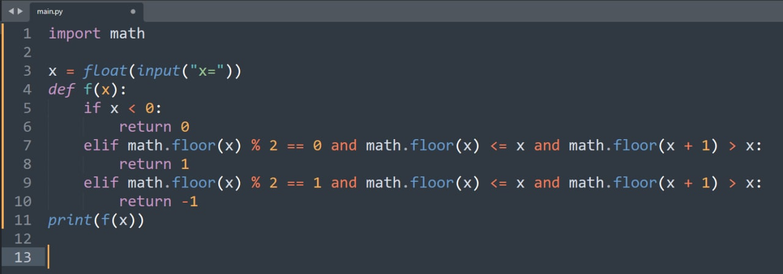

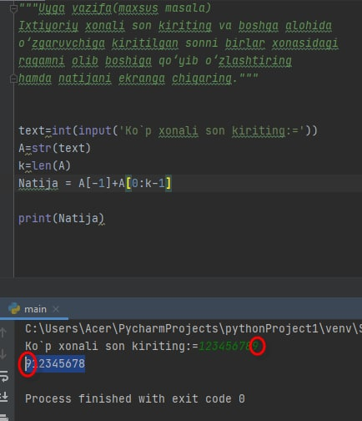

Masalan:

S = "Salom" + " " +"dunyo"

Natija: S="Salom dunyo"

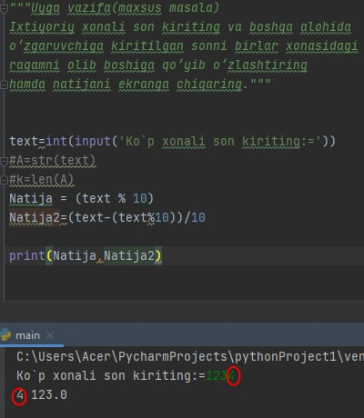

Pythonda soni butun qismi

math.floor(5.9)=5

Maxsus masalani ishlamagan o‘qituvchilar uchun masala:

1-masala

To‘g‘ri to‘rtburchak tomonlari a=3 b=4 uning perimetri P va yuzasi S ni toping.

Yordam:

a=3

a=4

Deb olib P ni va S ni print qiling

Oʏʙᴇᴋ Nᴀʀᴢᴜʟʟᴀʏᴇᴠ, [28.06.21 08:59]

# 9 - sinf 78 - bet 1 - masala

a = int(input("a = "))

if a > 0:

print("a musbat son")

else:

if a == 0:

print("a nolga teng")

else:

print("a manfiy son")

Oʏʙᴇᴋ Nᴀʀᴢᴜʟʟᴀʏᴇᴠ, [28.06.21 09:10]

# 9 - sinf 78 - bet 2 - masala

a = int(input("a = "))

if a % 2 == 0:

print("juft son")

else:

print("toq son")

Oʏʙᴇᴋ Nᴀʀᴢᴜʟʟᴀʏᴇᴠ, [28.06.21 09:25]

# 9 - sinf 78 - bet 3 – masala

a = int(input("a = "))

b = int(input("b = "))

if a == b:

print("Kvadrat")

else:

print("Kvadrat emas")

Oʏʙᴇᴋ Nᴀʀᴢᴜʟʟᴀʏᴇᴠ, [28.06.21 09:42]

# 9 - sinf 78 - bet 4 - masala

a = int(input("a = "))

if a >= 1000 and a < 10000:

print("to'rt xonali")

else:

print("to'rt xonali emas")

Oʏʙᴇᴋ Nᴀʀᴢᴜʟʟᴀʏᴇᴠ, [28.06.21 09:52]

import math

x = float(input("x="))

y = float(input("y="))

R = 4

# choraklarni va kordinata o'qlarida yotishini

if x > 0 and y > 0:

print("birinchi chorak")

elif x < 0 and y > 0:

print("ikkinchi chorak")

elif x < 0 and y < 0:

print("uchinchi chorak")

elif x > 0 and y < 0:

print("to'rtinchi chorak")

elif x == 0 and y != 0:

print("y o'qida yotadi")

elif x != 0 and y == 0:

print("x o'qida yotadi")

elif x == 0 and y == 0:

print("koordinata boshida")

l = math.sqrt(x2 + y2)

if l > R:

print("Aylana tashqarisida")

elif l < R:

print("Aylana ichida")

else:

print("Aylana yoyida")

Oʏʙᴇᴋ Nᴀʀᴢᴜʟʟᴀʏᴇᴠ, [28.06.21 10:16]

# 80 - bet; 1 - masala

x = int(input("x = "))

unlar = x // 10

birlar = x % 10

if unlar % 2 == 0:

print("o'nlar xonasidagi juft")

else:

print("o'nlar xonasidagi toq")

if birlar % 2 == 0:

print("birlar xonasidagi juft")

else:

print("birlar xonasidagi toq")

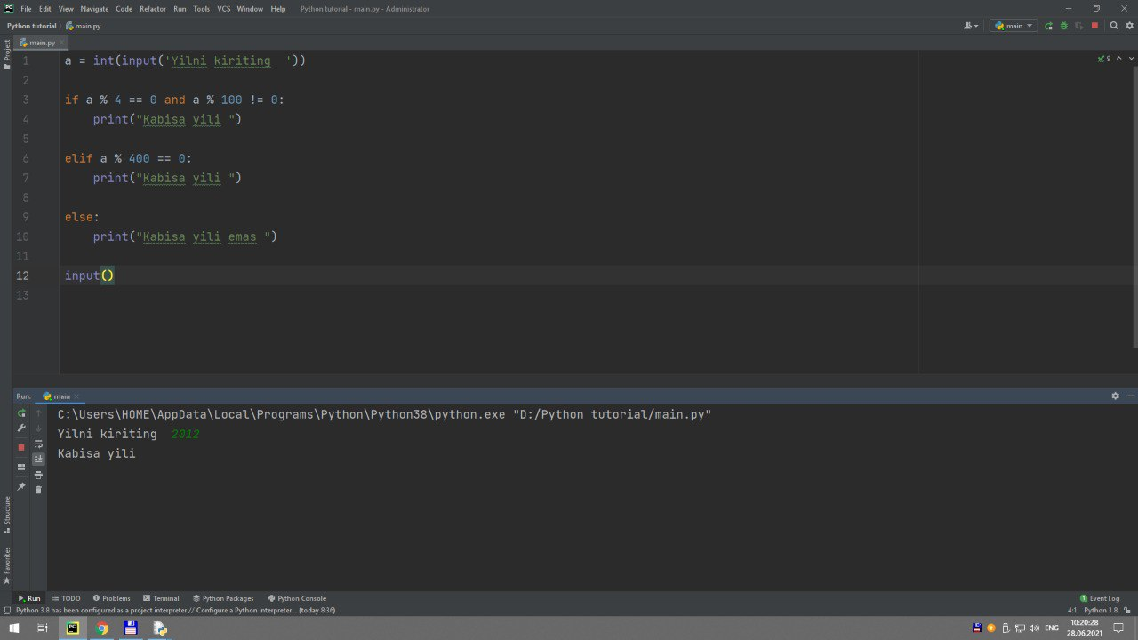

# kabisa yilimi yoki yoqmi?

yil = int(input("yil => "))

if yil % 4 == 0:

if yil % 100 == 0 and yil % 400 != 0:

print("kabisa yil emas")

else:

print("kabisa yili")

else:

print("Kabisa yili emas")

# 80 - bet uchinchi masala

a = int(input("a="))

b = int(input("b="))

if a % 2 == 0:

print(f"{a} soni juft")

if b % 2 == 0:

print(f"{b} soni juft")

Oʏʙᴇᴋ Nᴀʀᴢᴜʟʟᴀʏᴇᴠ, [28.06.21 11:55]

1. Uchta a, b va c butun son berilgan. Ular orasidan musbatlari sonini topish

dasturini tuzing.

2. Uchta a, b va c butun son berilgan. Ular orasidan musbat va manfiylari sonini topish

dasturini tuzing.

3. Ikkita a va b son berilgan. Dastlab kattasini, keyin esa kichigini chiqaruvchi dastur

tuzing.

4. Uchta a, b va c butun son berilgan. Ulardan faqat musbatlari kvadratini hisoblab

chiquvchi dastur tuzing.

5. Kvadrat tenglamani yechish dasturini tuzing.

6. Hafta raqami 1–7 oraliqda kiritilganda, hafta kunini ekranga chiqaruvchi dastur

tuzing.

7. a va b sonlar berilgan. Agar ular musbat va yig‘indisi 100 dan katta bo‘lsa, a sonining

b songa nisbatini, ular musbat va yig‘indisi 100 dan katta bo‘lmasa, a ning b ga ko‘paytmasini

hisoblash dasturini tuzing.

8. Ikkita son berilgan. Agar birinchi son ikkinchisidan katta bo‘lsa, 1 ni, agar ikkinchi

son birinchisidan katta bo‘lsa, 2 ni, agar ikkalasi teng bo‘lsa, 0 ni chiqaruvchi dastur tuzing.

Oʏʙᴇᴋ Nᴀʀᴢᴜʟʟᴀʏᴇᴠ, [28.06.21 12:06]

# 80 - bet 2 - masala

son = int(input("a=")) # uch xonali son

birlar = son % 10 # 566 -> 6 # 566 = 56 * 10 + 6

unlar = son % 100 // 10 # 566 -> 66 -> 6

yuzlar = son // 100 # 566 -> 5 # 566 = 100 * 5 + 66

# a % b degani a sonning ichida b sondan nechta bo'lib qolganini chiqaradi

# a // b bu degani a ning ichida nechta b bor degani

# 212 111 171

if birlar == unlar or birlar == yuzlar or unlar == yuzlar:

print("Takror qaram bor")

else:

print("Takror raqam yo'q")

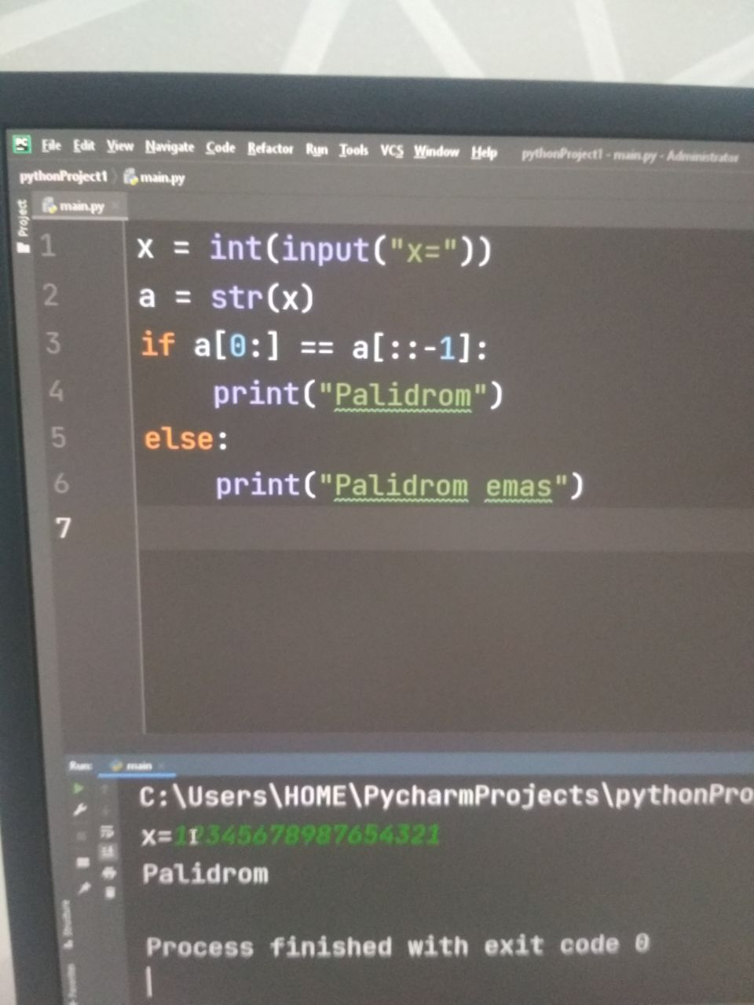

#2-masala Uchta a, b va c butun son berilgan. Ular orasidan musbat va manfiylari sonini topish

a=int(input("1-sonni kiriting="))

b=int(input("2-sonni kiriting="))

c=int(input("3-sonni kiriting="))

musbat=0

manfiy=0

if a>0:

musbat+=1

else:

manfiy+=1

if b>0:

musbat+=1

else:

manfiy+=1

if c>0:

musbat+=1

else:

manfiy+=1

print("musbat son =",musbat," manfiy son= ",manfiy)

# sonni polidromlikka tekshirish

# 123321 1221 1331 11 -> polidrom son

son = int(input("son = "))

a = son

xonalarSoni = 1

while True:

a = a // 10

if a != 0:

xonalarSoni += 1

else:

break

teskariSon = 0

a = son

xonaIndeksi = 0

while True:

teskariSon += a // (10 ** (xonalarSoni - 1)) % 10 * (10 ** xonaIndeksi)

xonaIndeksi += 1

xonalarSoni -= 1

if xonalarSoni == 0:

break

if son == teskariSon:

print("Polidrom")

else:

print("Polidrom emas")

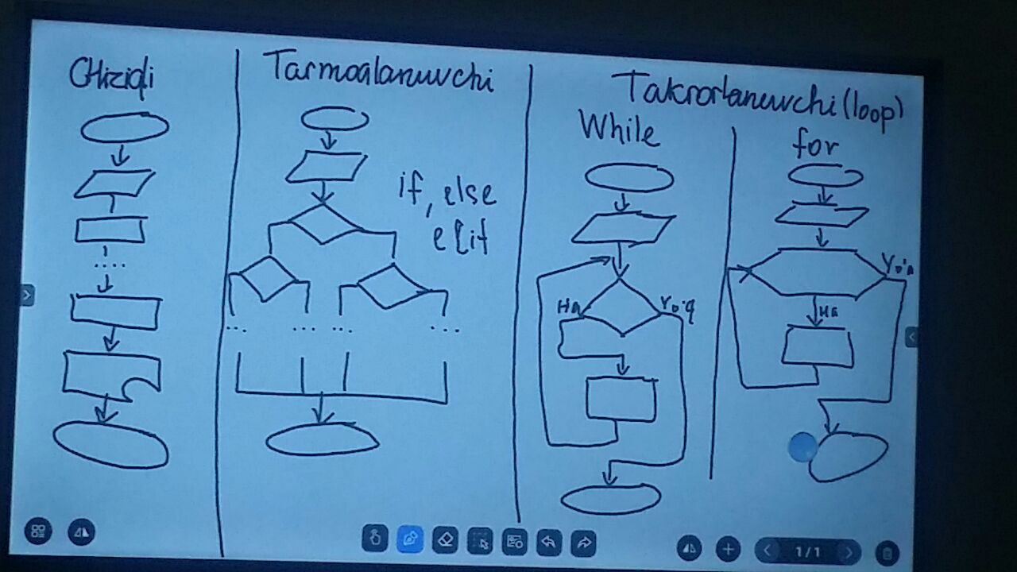

Oʏʙᴇᴋ Nᴀʀᴢᴜʟʟᴀʏᴇᴠ, [29.06.21 09:18]

# 1 - masala. 1 dan 10 gacha sonlarni chiqarish

i = 1

while i <= 10:

print(i)

i += 1 # i = i + 1

Oʏʙᴇᴋ Nᴀʀᴢᴜʟʟᴀʏᴇᴠ, [29.06.21 09:26]

# 2 - masala. 1 da 20 gacha bolgan juft soblarni chiqaring

i = 1 # i ni dastlabki qiymati

while i <= 20: # i 20 ga teng yoki undan kichik bo'sa i + 1 ekranga chiqarilaversin

print(i + 1)

i += 2 # har safar i ni qiymati 2 ga ortsin

Oʏʙᴇᴋ Nᴀʀᴢᴜʟʟᴀʏᴇᴠ, [29.06.21 09:26]

# 3 - masala. 1 da 20 gacha bolgan juft soblarni teskari tartibda chiqaring

i = 20

while i >= 2:

print(i)

i = i - 2

Oʏʙᴇᴋ Nᴀʀᴢᴜʟʟᴀʏᴇᴠ, [29.06.21 09:44]

# 4 - masala. 1 dan 10 gacha bo'lgan sonlarni kvadratlarni chiqaring 64 ni tashlab keting

i = 0

while i < 10:

i += 1

if i ** 2 == 64:

continue

print(i ** 2)

Oʏʙᴇᴋ Nᴀʀᴢᴜʟʟᴀʏᴇᴠ, [29.06.21 09:48]

# break -> kalit so'zi

# 5 - masala. 1 dan 10 gacha bo'lgan sonlarni ikkilanganini

# 8 ning ikkilanganigacha bo'lganini chiqaring

i = 0

while i < 10:

i += 1

print(2 * i)

if 2 * i == 8 * 2:

break

# 9 - sinf 88 - bet 2 - masala

# n >= k bo'lmagunicha n va k ni input qilaveramiz

while True:

n = int(input("n="))

k = int(input("k="))

if k <= n:

break

else:

print(" k soni n ga teng yoki kichik bo'lsin")

# n! ni hisoblash

i = 0

nFaktorial = 1

while i < n:

i += 1

nFaktorial *= i

# k! ni hisoblash

i = 0

kFaktorial = 1

while i < k:

i += 1

kFaktorial *= i

# (n - k)! hisoblash

i = 0

nkFaktorial = 1

while i < (n - k):

i += 1

nkFaktorial *= i

print(nkFaktorial)

# misolni yechish

javob = nFaktorial / (kFaktorial * nkFaktorial)

print(javob)

n = int(input('n='))

k = int(input('n>k='))

d = n - k

s = 1

p = 1

a = 1

b = 1

i = 1

j = 1

while i <= n:

s = s * i

i = i + 1

while j <= k:

p = p * j

j = j + 1

while a <= d:

b = b * a

a = a + 1

F = s / (p * b)

print('F=', F)

# 9 - sinf 88 - bet 3 - masala

a = int(input("a=")) # a ni kiritamiz

b = int(input("b=")) # b ni kiritamiz

i = a # i ni vaqtincha a ga o'zlashtiramiz

if a % 2 == 0: # agar a juft bo'lsa a o'z holida qolsin

pass

elif a % 2 == 1: # agar a toq bo'lsa a o'zidan keyingi juft songa i ni tenglaymiz

i = a + 1

while i < b: # i soni b sonidan kichik bo'lsa davom etsin

print(i) # i ni chiqarish

i += 2 # i ni qiymatini har safar ikkitadan orttirish

Oʏʙᴇᴋ Nᴀʀᴢᴜʟʟᴀʏᴇᴠ, [29.06.21 11:31]

# 9 - sinf 88 - bet 4 - masala

n = int(input("n=")) # n ni kiritamiz

i = 1

while i ** 2 < n:

print(i)

i += 1

Oʏʙᴇᴋ Nᴀʀᴢᴜʟʟᴀʏᴇᴠ, [29.06.21 11:42]

# maxsus masala 1

# ism familiya kiritish bunda agar kiritgan satrda probel bo'lmasa qayta kiritsin

while True:

fullName = input("ism familiya kiriting: ") # Oybek Narzullayev

fNameArray = fullName.split()

if len(fNameArray) == 2:

break

elif len(fNameArray) > 2:

print("Faqat ism familiya kerak ortiqchani yozmang!")

else:

print("Ism va familiyani kiriting!")

while True:

age = input("Yoshingizni kiriting: ")

if int(age) >= 18:

break

else:

print("18 yoshdan katta bo'lsin")

Oʏʙᴇᴋ Nᴀʀᴢᴜʟʟᴀʏᴇᴠ, [29.06.21 11:49]

# a dan z gacha bo'lgan harflarni chiqarish

i = ord("a")

while i <= ord('z'):

print(chr(i))

i += 1

Oʏʙᴇᴋ Nᴀʀᴢᴜʟʟᴀʏᴇᴠ, [29.06.21 11:53]

# maxsus masala 2. Quidagilarni kiritasiz va while yordamida ma‘lumotlarni tog‘ri kiritmagunicha foydalanuvchi qayta kiritishga majburlaysiz

name = ''

grandFatherName = ''

fatherName = ''

jinsi = ''

# erkak -> Duvlonov Bunyod Boymurodovich

# ayol -> Narzullayeva Mohinur Akmalovna

Jamshid Shokirov, [30.06.21 09:24]

# for yordamida 1 dan 10 gacha sonlarni chiqaring

sonlar=[1, 2, 3, 4, 5, 6, 7, 8, 9, 10]

kunlar=("Du", "Se", "Chor", "Pay", "Juma", "Sh", "Yak")

for son in sonlar:

print(son)

for kun in kunlar:

print(kun)

Xurshid Saidov, [30.06.21 09:26]

sonlar = [1, 2, 3, 4, 5, 6, 7, 8, 9, 10]

kunlar = ["Du", "Se", "Ch", "Pa", "Ju", "Sh", "Ya"]

for son in sonlar:

print(son)

for kun in kunlar:

print(kun)

Oʏʙᴇᴋ Nᴀʀᴢᴜʟʟᴀʏᴇᴠ, [30.06.21 09:30]

# for range dan foydalanish

# 1 - masala. for yordamida 0 dan 9 gacha bo'lgan sonlarni va hafta kunlarini chiqaring

# range siz bajarish

sonlar = [0, 1, 2, 3, 4, 5, 6, 7, 8, 9]

for son in sonlar: # for bu sonlar degan ro'yhatni ichidagi har bir elementni har safar son ga tenglab chiqaradi

print(son)

# range bilan bajarish

# 0 - 9 sonlari

for son in range(10): # range(a) 0 dan a gacha bo'lgan sonlarni ketma-ket oladi

print(son)

# 2 dan 7 gacha

for son in range(2, 8): # range(a, b) a dan b gacha bo'lgan sonlarni ketma-ket oladi

print(son)

# 2 dan 15 gacha bo'lgan har ikkitasidan bittasini chiqarish kerak bo'lsin

for son in range(2, 15, 2):

print(son)

# xulosa -> range(boshlanishi, tugashi, qadam)

# range(boshlanishi, tugashi)

# range(tugashi) u holda noldan boshlanadi

Oʏʙᴇᴋ Nᴀʀᴢᴜʟʟᴀʏᴇᴠ, [30.06.21 09:31]

# for loop haqida

# while yordamida satr elementlarini chiqarish

ism = 'Oybek'

index = 0

while index < len(ism):

print(ism[index])

index += 1

# for da bajarilishi

for i in ism:

print(i)

**# continue**

**# 1 - masala 1 dan 10 gacha bo'lgan sonlar orasidan faqat 7 chiqmasin**

for i in range(1, 11):

if i == 7:

continue

print(i)

# 2 - masala 1 dan 10 gacha bo'lgan sonlar orasidan faqat 7 va 9 chiqmasin

for i in range(1, 11):

if i == 7 or i == 9:

continue

print(i)

# 2 - masala 1 dan 30 gacha bo'lgan sonlar orasidan faqat 18 dan 22 gacha bo'lganlari chiqmasin

for i in range(1, 31):

if i >= 18 and i <= 22: # 18 dan katta yoki teng ammo 22 dan kichik yoki teng sonlarni olish

continue

print(i)

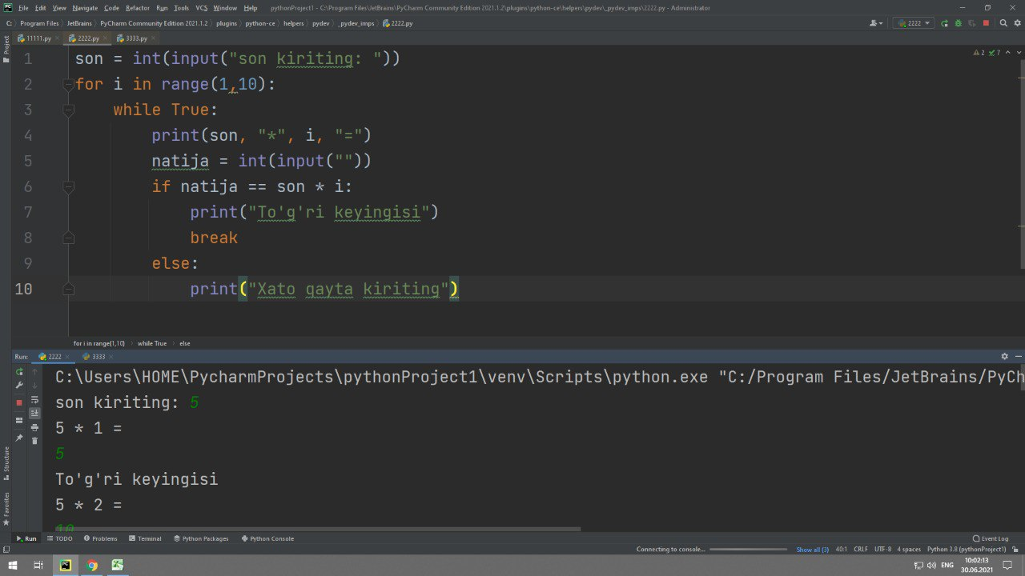

son = int(input("son kiriting: "))

for i in range(1,10):

while True:

print(son, "*", i, "=")

natija = int(input(""))

if natija == son * i:

print("To'g'ri keyingisi")

break

else:

print("Xato qayta kiriting")

**# 1 dan 100 gacha bo'lgan sonlarni kirting lekin oxiri 0,1,2,3,4,5 bilan tugaydigan ikki xonali sonlar chiqmasin**

for son in range(1, 101):

if son % 10 <= 5 and son // 10 > 0:

continue

print(son)

Shukurullo Isroilov, [30.06.21 10:14]

a=int(input('a ni kiriting:'))

b=int(input('b ni kiriting:'))

if a>b :

for son in range(b,a,1):

print(son)

else:

for son2 in range(a,b,1):

print(son2)

**Abduqayumov Shohruh Jamolxonovich, [30.06.21 10:15]**

a = int(input("a="))

b = int(input("b="))

if a > b:

for i in range(b,a+1):

print(i, end=";")

else:

for i in range(b, a-1, -1):

print(i, end=";")

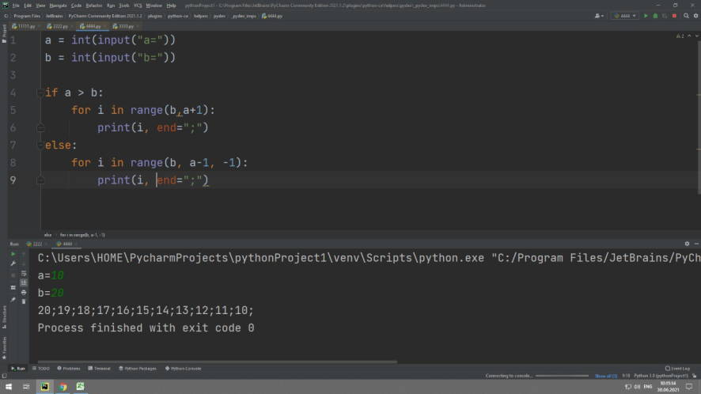

**Behzod Abdushukurov, [30.06.21 10:17]**

a=int(input("a="))

b=int(input("b="))

if b>a:

for i in range(a,b):

print(i)

else:

for i in range(a,b,-1):

print(i)

**Oʏʙᴇᴋ Nᴀʀᴢᴜʟʟᴀʏᴇᴠ, [30.06.21 10:23]**

# maxsus masala 2. matn va ism kiritasiz. Va siz kiritgan ismning hamma harflari ketma-ket matn tarkibi mavjudmi yoki yo'qmi tekshirasiz

# masalan: matn = Ozod vatan yashna gulla bo'stonlik elim kelajagi buyuk. ism = Oybek

# O y b e k

qs=int(input('son kiriting: '))

for i in range(1,20):

if qs==i:

print('bor')

break

else:

#print('yo`q')

Continue

Bekzod Nasimov, [01.07.21 09:35]

sonlar = [2, 3, 5, 1, 9, 6, 4, 0]

sonlar.sort(reverse=False)

print(sonlar)

Oʏʙᴇᴋ Nᴀʀᴢᴜʟʟᴀʏᴇᴠ, [01.07.21 09:47]

# listlar -> ro'yhatlar

# masalan: mevalar = ["olma", "anor", "apelsin", 1, True]

# meva = "olma"

# ichma-ich for ga misol

mevalar = ["olma", "anor", "apelsin"]

# savol: yuqoridagi ro'yhatni har bir harfini alohida qatorga chiqaring!

for meva in mevalar:

for harf in meva:

print(harf)

# 1 - masala. mashinalar ro'yhati berilgan

# ularni har bir harfini alohida qatorga chiqaring

# 2 - masala. berilgan sonlar to'plami ichida eng kichikigini toping:

sonlar = [2, 8, 4, 5, 4, 1, 0, 9]

kichikSon = sonlar[0] # kichikSon = 2

for son in sonlar: # in (inglizcha) -> ichida

if kichikSon > son:

kichikSon = son

print(kichikSon)

# 3 - masala. sonlar to'plami berilgan bu to'plamni o'sish tartibida saralang:

sonlar = [2, 8, 4, 5, 4, 1, 0, 9]

# indert sort -> qo'yish orqali saralash

for index in range(len(sonlar)): #len(sonlar) -> 8

for key in range(len(sonlar)):

if sonlar[index] < sonlar[key]:

sonlar[index] = sonlar[key] + sonlar[index]

sonlar[key] = sonlar[index] - sonlar[key]

sonlar[index] = sonlar[index] - sonlar[key]

print(sonlar)

sonlar.sort(reverse=False)

print(sonlar)

Oʏʙᴇᴋ Nᴀʀᴢᴜʟʟᴀʏᴇᴠ, [01.07.21 11:44]

# for range dan foydalanish

# 1 - masala. for yordamida 0 dan 9 gacha bo'lgan sonlarni va hafta kunlarini chiqaring

# range siz bajarish

sonlar = [0, 1, 2, 3, 4, 5, 6, 7, 8, 9]

for son in sonlar: # for bu sonlar degan ro'yhatni ichidagi har bir elementni har safar son ga tenglab chiqaradi

print(son)

# range bilan bajarish

# 0 - 9 sonlari

for son in range(10): # range(a) 0 dan a gacha bo'lgan sonlarni ketma-ket oladi

print(son)

# 2 dan 7 gacha

for son in range(2, 8): # range(a, b) a dan b gacha bo'lgan sonlarni ketma-ket oladi

print(son)

# 2 dan 15 gacha bo'lgan har ikkitasidan bittasini chiqarish kerak bo'lsin

for son in range(2, 15, 2):

print(son)

# xulosa -> range(boshlanishi, tugashi, qadam)

# range(boshlanishi, tugashi)

# range(tugashi) u holda noldan boshlanadi

Oʏʙᴇᴋ Nᴀʀᴢᴜʟʟᴀʏᴇᴠ, [01.07.21 11:45]

# # continue

#

# # 1 - masala 1 dan 10 gacha bo'lgan sonlar orasidan faqat 7 chiqmasin

# for i in range(1, 11):

# if i == 7:

# continue

# print(i)

#

# # 2 - masala 1 dan 10 gacha bo'lgan sonlar orasidan faqat 7 va 9 chiqmasin

# for i in range(1, 11):

# if i == 7 or i == 9:

# continue

# print(i)

# 2 - masala 1 dan 30 gacha bo'lgan sonlar orasidan faqat 18 dan 22 gacha bo'lganlari chiqmasin

# for i in range(1, 31):

# if i >= 18 and i <= 22: # 18 dan katta yoki teng ammo 22 dan kichik yoki teng sonlarni olish

# continue

# print(i)

# xulosa: continue bu - siklda malumbir oraliq yoki qadamni tashlab o'tish degani

# break

# 3 - masala.

qidirilayotgan_son = int(input("qidirayotgan raqamingizni kiriting: "))

for i in range(1, 11):

if qidirilayotgan_son == i:

print("bor")

break

else:

print("yo'q")

Oʏʙᴇᴋ Nᴀʀᴢᴜʟʟᴀʏᴇᴠ, [01.07.21 11:45]

# for loop haqida

# while yordamida satr elementlarini chiqarish

ism = 'Oybek'

index = 0

while index < len(ism):

print(ism[index])

index += 1

# for da bajarilishi

for i in ism:

print(i)

**Oʏʙᴇᴋ Nᴀʀᴢᴜʟʟᴀʏᴇᴠ, [01.07.21 11:51]**

import random

imkoniyat = 1

yutdimi = False

while imkoniyat <= 5:

tasodifiySon = random.randint(1, 10)

kiritilganSon = int(input("son -> "))

if kiritilganSon == tasodifiySon:

print("yutdingiz")

yutdimi = True

break

imkoniyat += 1

if not yutdimi:

print("yutqazdingiz")

**Xurshid Saidov, [01.07.21 11:51]**

import random

imkoniyat = 1

while imkoniyat <= 5:

kiritilganSon = int(input("a = "))

tasodifiySon = random.randint(1, 10)

if kiritilganSon == tasodifiySon:

print("Yutdingiz!")

break

else:

print("Yutqazdingiz")

imkoniyat += 1

Oʏʙᴇᴋ Nᴀʀᴢᴜʟʟᴀʏᴇᴠ, [01.07.21 11:44]

# for range dan foydalanish

# 1 - masala. for yordamida 0 dan 9 gacha bo'lgan sonlarni va hafta kunlarini chiqaring

# range siz bajarish

sonlar = [0, 1, 2, 3, 4, 5, 6, 7, 8, 9]

for son in sonlar: # for bu sonlar degan ro'yhatni ichidagi har bir elementni har safar son ga tenglab chiqaradi

print(son)

# range bilan bajarish

# 0 - 9 sonlari

for son in range(10): # range(a) 0 dan a gacha bo'lgan sonlarni ketma-ket oladi

print(son)

# 2 dan 7 gacha

for son in range(2, 8): # range(a, b) a dan b gacha bo'lgan sonlarni ketma-ket oladi

print(son)

# 2 dan 15 gacha bo'lgan har ikkitasidan bittasini chiqarish kerak bo'lsin

for son in range(2, 15, 2):

print(son)

# xulosa -> range(boshlanishi, tugashi, qadam)

# range(boshlanishi, tugashi)

# range(tugashi) u holda noldan boshlanadi

Oʏʙᴇᴋ Nᴀʀᴢᴜʟʟᴀʏᴇᴠ, [01.07.21 11:45]

# continue

# 1 - masala 1 dan 10 gacha bo'lgan sonlar orasidan faqat 7 chiqmasin

# for i in range(1, 11):

# if i == 7:

# continue

# print(i)

# 2 - masala 1 dan 10 gacha bo'lgan sonlar orasidan faqat 7 va 9 chiqmasin

# for i in range(1, 11):

# if i == 7 or i == 9:

# continue

# print(i)

#

# # 2 - masala 1 dan 30 gacha bo'lgan sonlar orasidan faqat 18 dan 22 gacha bo'lganlari chiqmasin

# for i in range(1, 31):

# if i >= 18 and i <= 22: # 18 dan katta yoki teng ammo 22 dan kichik yoki teng sonlarni olish

# continue

# print(i)

# xulosa: continue bu - siklda malumbir oraliq yoki qadamni tashlab o'tish degani

# break

# 3 - masala.

qidirilayotgan_son = int(input("qidirayotgan raqamingizni kiriting: "))

for i in range(1, 11):

if qidirilayotgan_son == i:

print("bor")

break

else:

print("yo'q")

Oʏʙᴇᴋ Nᴀʀᴢᴜʟʟᴀʏᴇᴠ, [01.07.21 11:45]

# for loop haqida

# while yordamida satr elementlarini chiqarish

ism = 'Oybek'

index = 0

while index < len(ism):

print(ism[index])

index += 1

# for da bajarilishi

for i in ism:

print(i)

Oʏʙᴇᴋ Nᴀʀᴢᴜʟʟᴀʏᴇᴠ, [02.07.21 09:18]

# Bugungi mavzu massivlar -> Array

# python aynan massiv tuhdhuncha yo'q

a = '123456'

b = 123

sonlar = [1, 2, 3, 'salom', True, [1, 2.3]] # ro'yhat

print(type(sonlar))

# xulosa: Pythonda massiv o'rniga ro'yhatdan foydalaniladi

# Ro'yhatning massivdan asosiy farqi bu turli xil toifali elementlarga ega bo'lishi

# List -> Ro'yhat

""" ro'yhat elementiga murojaat """

ruyhatElementi = sonlar[3]

print(ruyhatElementi)

# xulosa elementga murojaat indeks orqali ham amalga oshiriladi

""" ro'yhat elementini yangilash """

mashinalar = ["Nexia", "Laceti", "Malibu"]

# yangilanish

mashinalar[0] = "Cobalt"

print(mashinalar) # endi: mashinalar = ["Cobalt", "Laceti", "Malibu"]

""" Ro'yhat uzunligi yoki elementlari soni """

mevalar = ['olma', 'anor']

print(len(mevalar)) # uzunligi -> 2

""" metod yozish -> .metod(parametri) """

""" Ro'yhatga element qo'shish -> append() metodi"""

mevalar = ['olma', 'anor']

mevalar.append("gilos") # mevalar = ['olma', 'anor', "gilos"]

print(mevalar)

# xulosa: append ro'yhatni oxiriga element qo'shadi

""" Ro'yhatni tozalash -> hamma elementni o'chirish -> clear methodi"""

sonlar = [1, 2, 3, 4]

sonlar.clear() # parametr qabul qilmaydi

print(sonlar)

""" bir ro'yhatni boshqaisiga nusxalash copy() methodi"""

sonlar = [1, 2, 3, 4]

sonlar1 = sonlar.copy() # parametr qabul qilmaydi

print(sonlar1)

""" Ro'yhatda bir xil elementlarni sanash -> count() methodi """

sonlar = [1, 2, 2, 3, 4, 4, 0, 5, 4]

print(sonlar.count(4)) # berilgan ro'yhatda 4 soni 3 ta

""" extend() bu ro'yhatga boshqa ro'yhatni ulash """

sonlar = [1, 2, 2, 3, 4, 4, 0, 5, 4]

sonlar1 = [9, 8, 2]

sonlar.extend(sonlar1)

print(sonlar)

""" index() -> bu elementni ro'yhatdagi indeksini qaytaradi """

sonlar = [1, 2, 3, 'salom', True, [1, 2.3]]

# index->[0, 1, 2, 3, 4, 5 ]

print(sonlar.index("salom")) # javobi -> 3

""" insert methodi -> bu elmentni o'zingiz hohlagan ro'yhat indeksiga kiritish """

sonlar = [9, 8, 2]

sonlar.insert(2, 3) # insert(indeks, kiritilayotgan_son)

print(sonlar)

Oʏʙᴇᴋ Nᴀʀᴢᴜʟʟᴀʏᴇᴠ, [02.07.21 09:37]

# 1 - masala.

# 1. o'quvchilar ro'yhatini e'lon qiling unga oxiriga yangi o'quvchi qo'shing (print qiling) append

# 2. keyin o'rtasiga yangi o'quvchi qo'shing (print qiling) insert

# 3. o'quvchilar sonini toping (print qiling) len

# 4. o'quvchilar ro'yhatiga yana bor ismlardan birini kiriting

# va shu ismli o'quvchi nechtaligini toping (print qiling) append yoki insert , count

# 5. yangi o'quvchilar ro'yhatini e'lon qilib eski ro'yhatga ulang

# va eski ro'yhatni (print qiling) extend

# 6. ixtiyoriy o'quvchini indeksini topib bering (print qiling) index

# 7. ro'yhatni tozalang (print qiling) clear

Oʏʙᴇᴋ Nᴀʀᴢᴜʟʟᴀʏᴇᴠ, [02.07.21 09:49]

# maxsus masala 1. ro'yhat berilgan. input qilingan yangi o'zgaruvchini input qilingan

# yangi indeksga insert metodisiz joylashtiring

# masalan:

# sonlar = [1, 2, 3, 4] bo'lsin

# input -> element = 10, index = 2

# javobi ikkinchi indeksga 10 degan son kiritilsin

# sonlar = [1, 2, 10, 3, 4]

ruyhat=["tiko","nexia","cobalt","cobalt"]

for i in range(ruyhat.count("cobalt")):

ruyhat.remove("cobalt")

print(ruyhat)

ruyhat=["tiko","nexia","Damas","Damas"]

for i in range(ruyhat.count("Damas")):

ruyhat.remove("Damas")

print(ruyhat)

mashinalar = ["BMV","Mercedes Bens","BMV","Captiva","Malibu","BMV"]

for i in range(mashinalar.count(input())):

mashinalar.remove(input())

print(mashinalar)

ruyhat=[2,4,6,8,1,3]

for i in range(len(ruyhat)):

if ruyhat[i]%2 == 0:

print(ruyhat[i])

if ruyhat[i]%2 != 0:

print(ruyhat[i])

sonlar = [1,5,3,9,7,4,6]

a = []

b =[]

for i in sonlar:

if i%2==0:

a.append(i)

for i in sonlar:

if i%2==1:

a.append(i)

print(a)

# 2 - masala. butun sonlardan iborat ro'yhat berilgan juftlarni ekranga chiqaring:

sonlar = [1, 2, 3, 4, 5, 6]

for son in sonlar:

if son % 2 == 0:

print(son)

# 3 - masala. Butun sonlardan iborat ro'yhat berilgan

# oldin juftlarini keyin toqlarini yangi ro'yhatga o'zlashtrib konsolga chiqaring

sonlar = [1, 2, 3, 4, 5, 6]

sonlar1 = []

# birinchi juftlarini o'zlashtiramiz

for son in sonlar:

if son % 2 == 0:

sonlar1.append(son)

# ikkinchi toqlarini o'zlashtiramiz

for son in sonlar:

if son % 2 == 1:

sonlar1.append(son)

print(sonlar1)

**# 5 - masala**

# raqamini kiritasiz va shu indeksgacha fibonachi sonlar ro'yhatini tuzasiz

# fibonachi sonlari -> 1, 1, 2, 3, 5, 8, 13, 21 ...

indeks = int(input("=>"))

a = []

for i in range(indeks + 1):

if i == 0 or i == 1:

a.append(1)

else:

a.append(a[i - 1] + a[i - 2])

print(a)

a = [1,2,3,4,5,6,7,8,9,10]

for i in range(len(a)):

if i == len(a) -1:

a[i]=0

else:

a[i]=a[i +1]

print(a)

Maxsus masala.

Ikkita bo’sh ro’yhat e’lon qiling. A = [ ], B = [ ];

Quyidagilar talab qilinadi:

1. A ro’yhatga 1 dan 10 gacha bo’lgan sonlarni tasofdifiy ravishta kiriting. Bunda son takrorlanmasin. Shunda ro’yhatni 10 ta elementi bo’lsin.

2. A ro’yhatni o’shish tartibida saralang.

3. Endi A ro’yhatdagi elementlari indekslari o’zgarishlarini B ro’yhatga saqlang. Bu qanday o’zgarish deysizmi?

Masalan:

A Ro’yhat tasodifiy sonlar natijasida quyidagi elementlarni olsin:

A = [2, 3, 1, 8, 5, 7, 6, 9, 10, 4]

A ro’yhat saralangandan so’ng quyidagicha bo’lsin:

A = [1, 2, 3, 4, 5, 6, 7, 8, 9, 10]

A ro’yhatdagi o’zgarishlar:

2 -> 1 ta oldinga siljidi -> 1;

3 -> 1 ta oldinga siljidi -> 1;

1 -> 2 ta orqaga siljidi -> -1;

8 -> 4 ta oldinga siljidi -> 4;

5 -> joyida qoldi -> 0;

7 -> 1 ta oldinga siljidi -> 1;

6 -> 1 ta orqaga siljidi -> -1;

9 -> 1ta oldinga siljidi -> 1;

10 -> 1ta oldinga siljidi -> 1;

4 -> 6 ta orqaga siljidi -> -6;

Siz mana shu o’zgarishlarni B ro’yhatga saqlang yani:

B = [1, 1, -1, 4, 0, 1, -1, 1, 1, -6] bo’lsin.

Izoh: istalgan metoddan va toifadan foydalaning. Xohlasangiz A va B dan tashqari yana boshqa ro‘yhat e‘lon qilishingiz mumkin

Oʏʙᴇᴋ Nᴀʀᴢᴜʟʟᴀʏᴇᴠ, [05.07.21 09:05]

# """ Ro'yhatlar (Ko'p o'lchovli ro'yhatlar) """

# numbers = [1, 2, 3, 4, 5, 'ha', True]

#

# # Ro'yhatni o'zi ham ro'yhat elementi bo'la oladimi?

# # Javob: ha

#

# """ chop etish """

# matrix = [[1, 2, 3], [4, 5, 6], [7, 8, 9]]

# list1 = [[[1, 2, 3], 2, 3], [4, 5, 6]]

#

# for element in matrix:

# print(element)

#

# for element in matrix:

# for raqam in element:

# print(raqam)

#

# # satrlar ham massiv bo'la oladi:

#

# satr = "O'zbekiston"

#

# for harf in satr:

# print(harf)

#

# gap = ["Men", "Pythonda", "ishlayapman"]

# for suz in gap:

# print(suz)

#

# for suz in gap:

# for harf in suz:

# print(harf)

""" indekslar bilan ishlash """

numbersList = [[1, 2, 3], [4, 5, 6], [7, 8, [1, 2, 3, 4, [5, 6]]]]

print(numbersList[2][0])

print(numbersList[2][2][4][1])

""" ko'p o'lchovli ro'yhatni yaratishni maxsus usullari """

numbersList = [[[1, 2, 3] * 1] * 3] * 2

print(numbersList)

numbersList = [[0] * 4 for i in range(4)]

print(numbersList)

Oʏʙᴇᴋ Nᴀʀᴢᴜʟʟᴀʏᴇᴠ, [05.07.21 09:07]

""" 1 - masala. 10 raqamini indeksi orqali print qiling """

numbersList = [[1, 2, 3, 4], [0, [1, 2, [4, 5, [10, 11]], 4], 5], 12]

Nodir Atayev, [05.07.21 09:14]

nambersList = [[1, 2, 3, 4], [0, [1, 2, [4, 5, [10, 11]], 4], 5], 12]

print(nambersList[1][1][2][2][0])

Nodir Atayev, [05.07.21 09:21]

matritsa = [[2, 3, 7], [4, 7, 6]] + [[1, 9, 8], [2, 5, 8], [3, 6, 9]]-[[7, 4, 1], [1, 5, 9], [3, 5, 7]]

Shukurullo Isroilov, [05.07.21 09:29]

#1-masala:

nambersList = [[1,5],[2,8]]

nambersList2=[[4,5],[8,1]]

print([nambersList[0][0]+nambersList2[0][0],nambersList[0][1]+nambersList2[0][1]],[nambersList[1][0]+nambersList2[1][0],nambersList[1][1]+nambersList2[1][1]])

Shukurullo Isroilov, [05.07.21 09:29]

Javob: [5, 10] [10, 9]

Shukurullo Isroilov, [05.07.21 09:34]

3*3 matritsa:

Shukurullo Isroilov, [05.07.21 09:34]

nm=[[1]*3]*3

print(nm)

Shukurullo Isroilov, [05.07.21 09:29]

Javob: [5, 10] [10, 9]

Shukurullo Isroilov, [05.07.21 09:34]

3*3 matritsa:

Shukurullo Isroilov, [05.07.21 09:34]

nm=[[1]*3]*3

print(nm)

Oʏʙᴇᴋ Nᴀʀᴢᴜʟʟᴀʏᴇᴠ, [05.07.21 11:12]

""" Ro'yhatlar (Ko'p o'lchovli ro'yhatlar) """

numbers = [1, 2, 3, 4, 5, 'ha', True]

# Ro'yhatni o'zi ham ro'yhat elementi bo'la oladimi?

# Javob: ha

""" chop etish """

matrix = [[1, 2, 3], [4, 5, 6], [7, 8, 9]]

list1 = [[[1, 2, 3], 2, 3], [4, 5, 6]]

for element in matrix:

print(element)

for element in matrix:

for raqam in element:

print(raqam)

# satrlar ham massiv bo'la oladi:

satr = "O'zbekiston"

for harf in satr:

print(harf)

gap = ["Men", "Pythonda", "ishlayapman"]

for suz in gap:

print(suz)

for suz in gap:

for harf in suz:

print(harf)

""" indekslar bilan ishlash """

numbersList = [[1, 2, 3], [4, 5, 6], [7, 8, [1, 2, 3, 4, [5, 6]]]]

print(numbersList[2][0])

print(numbersList[2][2][4][1])

""" ko'p o'lchovli ro'yhatni yaratishni maxsus usullari """

numbersList = [[[1, 2, 3] * 1] * 3] * 2

print(numbersList)

numbersList = [[0] * 4 for i in range(4)]

print(numbersList)

""" 1 - masala. 10 raqamini indeksi orqali print qiling """

numbersList = [[1, 2, 3, 4], [0, [1, 2, [4, 5, [10, 11]], 4], 5], 12]

""" 2 - masala. 5 ni chiqarib bering"""

numbersList = [[1, 2, 3], [4, 5, 6], [7, 8, 9]]

""" 3 - masala 2 ta 2X2 matritsa tuzib ularni qo'shing va javobini yangi matrisaga o'zlashtirib

print qiling. """

A1 = [[1, 2], [3, 4]]

A2 = [[5, 6], [7, 8]]

B = [[[], []], [[], []]]

# B[0][0] = A1[0][0] + A2[0][0]

# B[0][1] = A1[0][1] + A2[0][1]

# B[1][0] = A1[1][0] + A2[1][0]

# B[1][1] = A1[1][1] + A2[1][1]

# print(B)

for i in range(2):

for j in range(2):

B[i][j] = A1[i][j] + A2[i][j]

print(B)

# 00 10

# 01 11

""" 4 - masala. 3X3 matritsa tuzib bering """

matrix = [[1, 1, 1], [2, 2, 2], [3, 3, 3]]

"""3X2"""

matrix = [[1, 2], [3, 4], [5, 6]]

B = [[[], [], []], [[], [], []], [[], [], []]]

for i in range(3):

for j in range(3):

B[i][j] = int(input(f"B[{i}][{j}] = "))

print(B)

""" 5 - masala. 3X3 matritsa har bir elementini alohida qatorga chiqaring """

a = [[1, 2, 3], [4, 5, 6], [7, 8, 9]] # matrintsani tuzamiz

# 1 -usul

for element in a: # a ni ichidan qavs to'plamlarni oladi masalan [1, 2, 3]

for i in element: # olingan qavs to'plam ichidagi elementlarni oladi masalan [1, 2, 3] dan 1 ni oladi

print(i)

# 2 - usul

for i in range(3):

for j in range(3):

print(a[i][j])

""" 6 - masala 2x2 ro'yhat berilgan ana shu ro'yhatni 1 o'lovchili ro'yhatga o'zlashriting

masalan:

[[1,2], [3, 4]] -> [1, 2, 3, 4]

"""

c = [] # c = [1, 2, 3, 4]

a = [[1, 2], [3, 4]]

for j in a: # a ning ichidagi ro'yhatchalarni oladi

for g in j: # olingan ro'yhatchani ichidagi elementni oladi

c.append(g) # olingan elementni c ga joylaydi

print(c)

c = a[0] + a[1] # bu degani: [1, 2] + [3, 4] = [1, 2, 3, 4]

print(c)

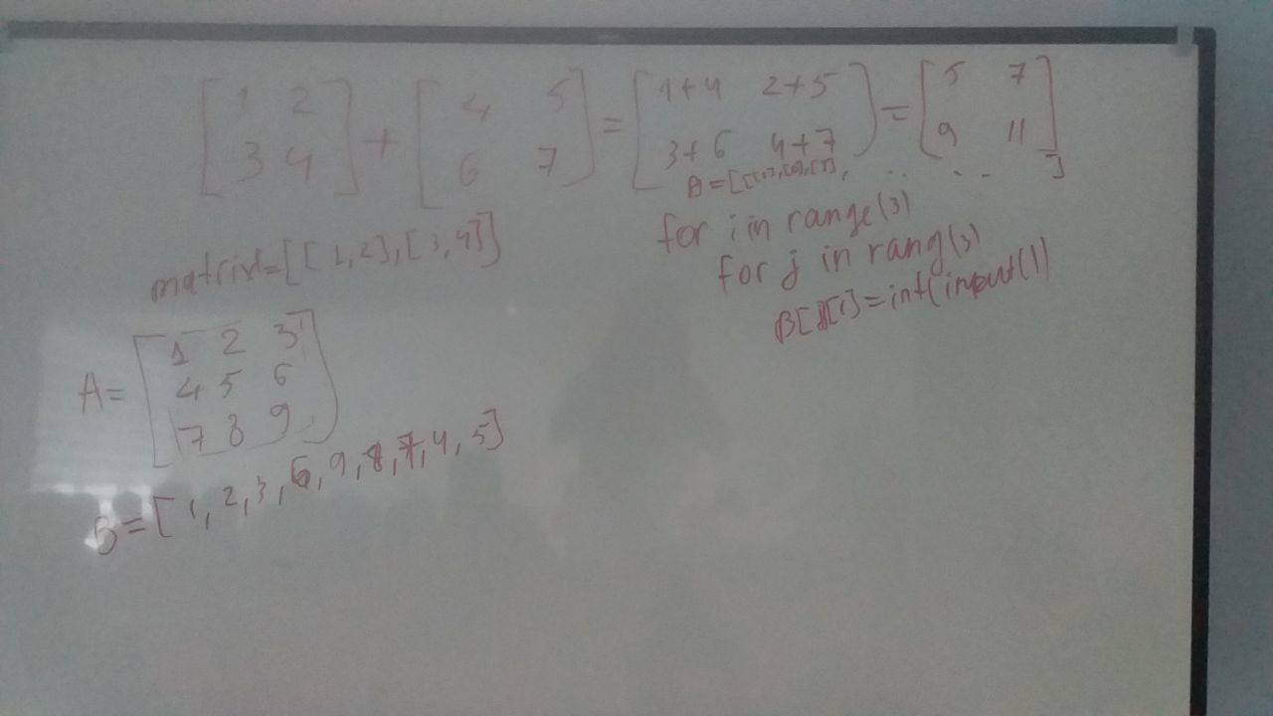

Nodir Atayev, [05.07.21 11:21]

a = [[1, 2, 3], [4, 5, 6], [7, 8, 9]]

print([a[0][0],a[0][1], a[0][2],a[1][2], a[2][2], a[2][1], a[2][0], a[1][0], a[1][1]])

Shukurullo Isroilov, [05.07.21 11:41]

# 5-masala

B=[[1,2],[4,8],[7,8]]

for i in B:

for j in i:

if j%2==0:

print(j)

Shukurullo Isroilov, [05.07.21 11:46]

# 5-masala

c=[]

B=[[1,2],[4,8],[7,8]]

for i in B:

for j in i:

if j%2==0:

c.append(j)

print(c)

Shukurullo Isroilov, [05.07.21 11:46]

natijani massiv ko'rinishida beradi

Shukurullo Isroilov, [05.07.21 11:50]

# 9-masala

c=[]

B=[[1,2],[4,8],[7,8]]

for i in B:

for j in i:

if j%2==0:

c.append(j/2)

else:

c.append(j*2)

print(c)

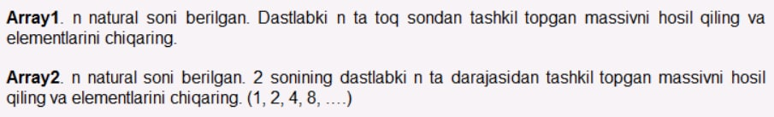

Oʏʙᴇᴋ Nᴀʀᴢᴜʟʟᴀʏᴇᴠ, [05.07.21 13:47]

[In reply to Oʏʙᴇᴋ Nᴀʀᴢᴜʟʟᴀʏᴇᴠ]

#1 - masala

n = int(input("n = "))

for i in range(n): # n = 3 -> 0,1,2,3

print(2 * i + 1) # toq son formulasi orqali dastlabki n ta toq sonni chiqarish

Oʏʙᴇᴋ Nᴀʀᴢᴜʟʟᴀʏᴇᴠ, [05.07.21 13:52]

# 2 - masala

n = int(input("n = "))

# 1, 2, 4, 8, 16, 32, ....

for i in range(n):

print(2 ** i) # ikkining darajalari chiqadi

Oʏʙᴇᴋ Nᴀʀᴢᴜʟʟᴀʏᴇᴠ, [05.07.21 14:39]

[In reply to Oʏʙᴇᴋ Nᴀʀᴢᴜʟʟᴀʏᴇᴠ]

# 7 - masala

n = int(input("n = "))

a = []

for i in range(n): # 0 dan 4 gacha qadam

j = int(input(f"j{i} = "))

a.append(j)

for i in range(n - 1, -1, -1): # 4 dan 0 gacha teskari qadam 4, 3, 2, 1, 0 (-1)

print(a[i])

# range(boshlash, tugash(o'zi kirmaydi), qadam)

Oʏʙᴇᴋ Nᴀʀᴢᴜʟʟᴀʏᴇᴠ, [05.07.21 14:46]

[In reply to Oʏʙᴇᴋ Nᴀʀᴢᴜʟʟᴀʏᴇᴠ]

# 8 - masala

n = int(input("n = "))

a = []

# massiv elementlarini kiritamiz

for i in range(n): # 0 dan n (n kirmaydi) gacha qadam

j = int(input(f"j{i} = "))

a.append(j)

toqIndex = []

for i in range(n):

if a[i] % 2 == 1:

toqIndex.append(i)

print(toqIndex)

print(f"Toq sonlar soni -> {len(toqIndex)}")

# 8 - masala

n = int(input("n = "))

a = []

# massiv elementlarini kiritamiz

for i in range(n): # 0 dan n (n kirmaydi) gacha qadam

j = int(input(f"j{i} = "))

a.append(j) # joylash

juftIndex = []

for i in range(n):

if a[i] % 2 == 0:

juftIndex.append(i)

# kamayish tartibida saralaymiz

juftIndex.sort(reverse=True) # reverse=True degani kamayish tartibini anglatadi

print(juftIndex) # ekranga chqaramiz

print(f"Juft sonlar soni -> {len(juftIndex)}")

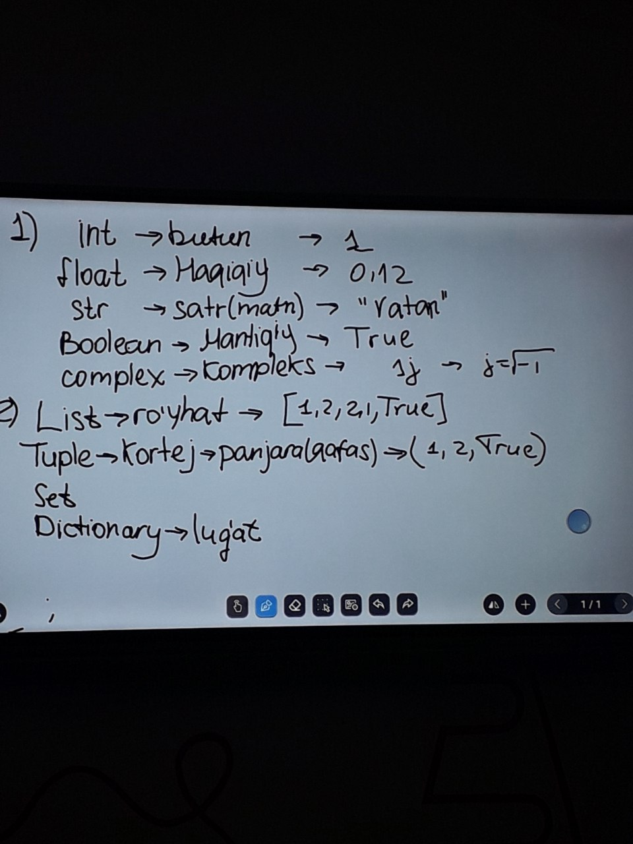

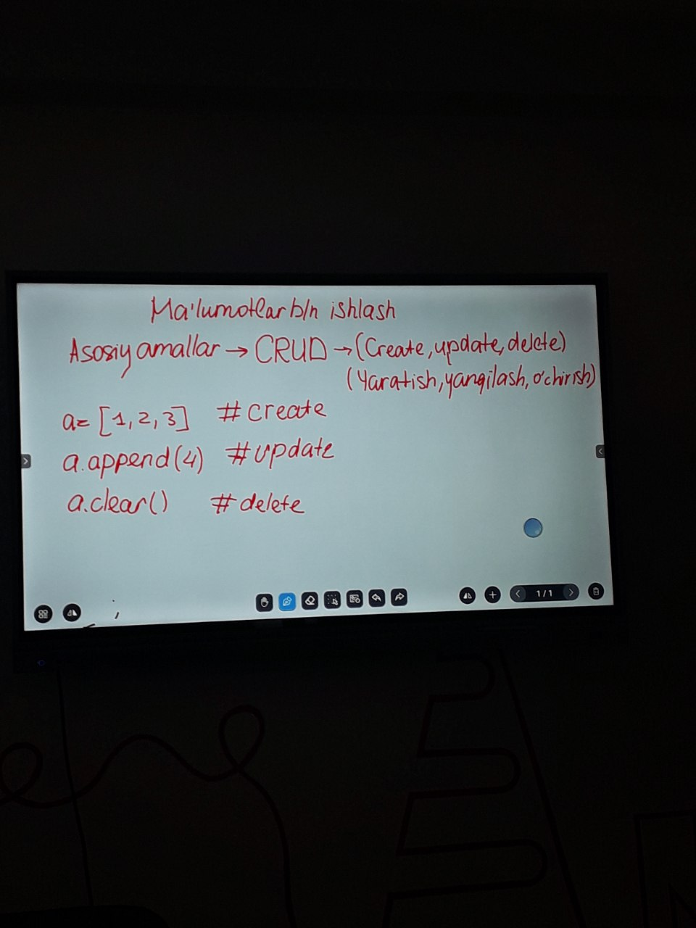

Hasan Fozilov, [06.07.21 09:35]

# # # # # # # numbers = (1, 2, 3, 4)

# # # # # # # print(type(numbers))

# # # # # # a = tuple([1, 2, 3, 4])

# # # # # # print(type(a))

# # # # # numbers = (1, 2, 3, 4)

# # # # # numbers = list(numbers)

# # # # # numbers[1] = 9

# # # # # numbers = tuple(numbers)

# # # # # print(numbers)

# # # # numbers = (1, 2, 3, 4)

# # # # i=0

# # # # while i < len(numbers):

# # # # print(numbers[i])

# # # # i+=1

# # # #

# # # # for i in numbers:

# # # # print(i)

# # # #

# # # # for i in range(len(numbers)):

# # # # print(numbers[i])

# # # numbers1 = (1, 2, 3)

# # # numbers2 = (4, 5, 6)

# # # numbersAll = numbers1 + numbers2

# # # print(numbersAll)

# # numbers = (1, 2, 3, 4)

# # myNumbers = numbers * 2

# # print(myNumbers)

# """ kortej metodlari """

# numbers = (1, 2, 3, 4, 5, 2, 3, 1, 4)

# #count()

# print(numbers.count(2))

# #index()

# print(numbers.index(2))

# #masala:

# x = (1)

# y=(1,)

# print(type(x))

# print(type(y))

# # yo'qlik qiymatlari

# a = None

# b = ''

# c = []

# d = ()

# e = 0

# h = False

# print(f"{bool(a)} {bool(b)} {bool(c)} {bool(e)} {bool(h)}")

Xurshid Saidov, [06.07.21 09:36]

"""kortejlar (tuple)"""

numbers = (1, 2, 3, 4)

numbers1 = [1, 2, 3, 4]

print(type(numbers))

print(type(numbers1))

""" konstruktor """

a = tuple([1, 2, 3, 4])

print(type(a))

""" kortej elementlariga murojaat """

numbers = (1, 2, 3, 4)

print(numbers[2])

# bu amallar indexlar orqali amalga oshiriladi

""" kortejda yangilashni faqat ro'yxatga o'tkazib, keyin bajarsa bo'ladi """

numbers = (1, 2, 3, 4)

numbers = list(numbers)

numbers[1] = 9

numbers = tuple(numbers)

print(numbers)

""" kortej elementlarini looplar (for, while) yordamida alohida qilib chiqarish """

numbers = (1, 2, 3, 4)

i = 0

while i < len(numbers):

print(numbers[i])

i += 1

for i in numbers:

print(i)

# fordan indeks bo'yicha foydalanish

for i in range(len(numbers)):

print(numbers[i])

""" kortejlarni qo'shish """

numbers1 = (1, 2, 3, 4)

numbers2 = (5, 6, 7, 8)

numbersAll = numbers1 + numbers2

print(numbersAll)

""" kortejlarni songa ko'paytirish """

numbers = (1, 2, 3, 4)

myNumbers = numbers * 2

print(myNumbers)

""" kortej metodlari """

# count()

numbers = (1, 2, 3, 4, 4, 3, 2, 2)

print(numbers.count(2))

# index

print(numbers.index(2))

# masala

x = (1)

y = (1, )

print(type(x))

print(type(y))

# Yo'qlik qiymatlar

a = None

b = ''

c = []

d = ()

e = 0

h = False

print(f"{bool(a)} {bool(b)} {bool(c)} {bool(d)} {bool(e)} {bool(h)}")

Xurshid Saidov, [06.07.21 10:01]

# any() funksiyasi

numbers = (1, 2, 3, 4, 5, 6)

print(any(numbers))

# max() fuksiyasi

numbers = (1, 2, 3, 4, 5, 6)

print(max(numbers))

# min() finksiyasi

numbers = (1, 2, 3, 4, 5, 6)

print(min(numbers))

# len() funksiyasi

numbers = (1, 2, 3, 4, 5, 6)

print(len(numbers))

# sorted() funksiyasi

numbers = (10, 3, 6, 4, 5, 2)

print(sorted(numbers))

# sum() funksiyasi

numbers = (1, 2, 3, 4, 5, 6)

print(sum(numbers))

Sultonmurodov Sunnatullo, [06.07.21 10:01]

a=(7,6,5,4,3,2,1,0)

print(len(a))

print("-------------------")

print(max(a))

print("-------------------")

print(min(a))

print("-------------------")

print(sorted(a))

print("-------------------")

print(sum(a))

print("-------------------")

print(any(a))

print("-------------------")

Oʏʙᴇᴋ Nᴀʀᴢᴜʟʟᴀʏᴇᴠ, [06.07.21 11:41]

# 4 - masala.

# birinchi avval juft o'rindagilarini keyin toq o'rindagilarini chiqaring

a = (1, 4, 10, 6, 7) # e'lon qilish

juft = [] # juft degan ro'yhat

toq = [] # toq degan ro'yhat

for i in range(len(a)):

if (i + 1) % 2 == 0:

juft.append(a[i])

else:

toq.append(a[i])

print(juft)

print(toq)

# 2 - usul

a = (1, 4, 10, 6, 7) # e'lon qilish

for i in range(1, len(a), 2):

print(a[i])

for i in range(0, len(a), 2):

print(a[i])

Oʏʙᴇᴋ Nᴀʀᴢᴜʟʟᴀʏᴇᴠ, [06.07.21 11:51]

# maxsus masala 2

a = (1, 2, 3, 4, 5, 6, 7, 8)

b = list(a)

c = []

for i in range(len(b)):

c.append(b[0])

if b[0] == b[-1]:

break

c.append(b[-1])

b.pop(0)

b.pop(-1)

if not b:

break

a = tuple(c)

print(a)

Shukurullo Isroilov, [06.07.21 11:57]

# Maxsus masala

a=(1,2,3,4,5,6)

b=list(a)

mk=[]

k=5

for i in range(3):

mk.append(b[i])

mk.append(b[k])

k-=1

print(mk)

Oʏʙᴇᴋ Nᴀʀᴢᴜʟʟᴀʏᴇᴠ, [06.07.21 11:58]

a = (1, 2, 3, 4, 5, 6)

i = 0

b = list(a)

c = []

while i < (len(a) // 2):

if i == 0:

c.append(b[0])

else:

c.append(b[-i])

c.append(b[i])

i += 1

else:

c.append(b[i])

print(c)

Shukurullo Isroilov, [06.07.21 11:59]

# Maxsus masala

a=(1,2,3,4,5,6)

b=list(a)-1

mk=[]

k=len(b)

for i in range(len(b)//2):

mk.append(b[i])

mk.append(b[k])

k-=1

print(mk)

Shukurullo Isroilov, [06.07.21 12:11]

# Maxsus masala

a=(1,2,3,4,5,6,8)

b=list(a)

mk=[]

k=len(b)-1

for i in range(len(b)//2):

mk.append(b[i])

mk.append(b[k])

k-=1

print(mk)

Oʏʙᴇᴋ Nᴀʀᴢᴜʟʟᴀʏᴇᴠ, [07.07.21 09:22]

""" set ni yaratish """

# 1. gulli qavslar bilan

numbers = {1, 2, 3, 4, 5, 6}

print(type(numbers))

# 2. set() kosntruktori bilan

numbers = set([1, 2, 3, 4, 5]) # listni setga aylantirish

print(numbers)

print(type(numbers))

numbers = set((1, 2, 3, 4))

print(numbers)

""" elementlariga murojaat """

# Diqqat: setda indeks yo'q!!!

# setni listga aylantirish:

numbers = {1, 2, 3, 4, 5, 6}

numbers = list(numbers) # endi numbers list ga aylandi

print(numbers)

print(numbers[0])

""" setni barcha elementlarini ko'rish """

numbers = {1, 2, 3, 4, 5, 6}

print(numbers) # shunchaki setni o'zini print qilish

for i in numbers:

print(i)

""" setda bir xil elementlar bo'lmadi """

fruits = {"apple", "orange", "banana", "apple"}

print(fruits)

# xulosa: set da bir xil element bo'lmaydi!

""" setda tarib muhimmas """

fruits = {"apple", "orange", "banana", "apple"}

fruits1 = {"orange", "apple", "banana"}

print(fruits1 == fruits)

""" element qo'shish """

mevalar = {"Olma", "Anor"}

# add funksiyasi bilan uning parametri mavjud bo'lishi shart! -> .metod(parametr)

mevalar.add("Shaftoli")

print(mevalar)

# set.method(parametr)

# update funksiyasi bilan set.update(*element)

mevalar.update(["Gilos", "Olxori"])

print(mevalar)

""" elementni o'chirish:"""

# remove

fruits = {"apple", "orange", "banana", "Cherry"}

fruits.remove("banana")

print(fruits)

# pop

fruits.pop()

print(fruits)

# clear -> tozalash

fruits = {"apple", "orange", "banana", "Cherry"}

fruits.clear() # bu bo'sh qiladi

print(fruits)

# del -> bu birato'la setni o'zini xotiradan o'chiradi

fruits = {"apple", "orange", "banana", "Cherry"}

del fruits

# print(fruits)

Oʏʙᴇᴋ Nᴀʀᴢᴜʟʟᴀʏᴇᴠ, [07.07.21 10:06]

# matematika, fizika, informatika fanlaridan olimpiada bo'ldi. Olimpiadalar ketma ket bo'ldi.\

# olimpiadaga kirgan o'quvchilar ro'yhatini chiqaring:

matematika = ["Ibrohim", "Muhammad", "Abbos", "Bunyod"]

fizika = ["Oybek", "Ibrohim", "Shoxzod", "Abbos"]

informatika = ["Oybek", "Ibrohim", "Abbos", "Shoxzod"]

a = matematika + fizika + informatika

a = set(a)

print(a)

Oʏʙᴇᴋ Nᴀʀᴢᴜʟʟᴀʏᴇᴠ, [07.07.21 11:01]

import random as rd

A = []

B = []

C = []

# A va b to'plamlarni birlashmasini olib C to'plam bilan kesishmasini olasiz

for i in range(10):

k = rd.randint(1, 10)

A.append(k)

for i in range(10):

k = rd.randint(1, 10)

B.append(k)

for i in range(10):

k = rd.randint(1, 10)

C.append(k)

print(A)

print(B)

AUB = set(A + B)

print(AUB)

AUB = list(AUB)

C = set(C)

print(C)

D = []

for i in C:

if i in AUB:

D.append(i)

D = set(D)

print(D)

Oʏʙᴇᴋ Nᴀʀᴢᴜʟʟᴀʏᴇᴠ, [07.07.21 11:02]

[In reply to Oʏʙᴇᴋ Nᴀʀᴢᴜʟʟᴀʏᴇᴠ]

maxsus masala

Oʏʙᴇᴋ Nᴀʀᴢᴜʟʟᴀʏᴇᴠ, [07.07.21 11:03]

import random as rd

A = []

B = []

C = []

# A va b to'plamlarni birlashmasini olib C to'plam bilan kesishmasini olasiz

for i in range(10):

A.append(rd.randint(1, 10))

B.append(rd.randint(1, 10))

C.append(rd.randint(1, 10))

print(A)

print(B)

AUB = set(A + B)

print(AUB)

AUB = list(AUB)

C = set(C)

print(C)

D = []

for i in C:

if i in AUB:

D.append(i)

D = set(D)

print(D)

Oʏʙᴇᴋ Nᴀʀᴢᴜʟʟᴀʏᴇᴠ, [07.07.21 11:44]

""" copy() parametri yo'q """

mevalar1 = {"Olma", "Anor"}

mevalar2 = mevalar1.copy()

print(f"{mevalar1} {mevalar2} ")

# nusxalashni o'zlashtirish amali bilan ham bajarsa bo'ladi

mevalar3 = mevalar1

mevalar1.clear()

print(mevalar3) # bu o'chib ketadi chunki bu o'zlashtirishdan hosil bo'lgan

print(mevalar2) # bu o'chmaydi chunki bu nusxalangan

""" difference() parametri bor u set qabul qiladi"""

mevalar1 = {"Olma", "Anor", "Olcha"}

mevalar2 = {"Apelsin", "Anor", "Ananas"}

print(mevalar1.difference(mevalar2)) # mevalar1 ni mevalar2 dan farqi

""" difference_update() parametr bor """

mevalar1 = {"Olma", "Anor", "Olcha"}

mevalar2 = {"Apelsin", "Anor", "Ananas"}

mevalar1.difference_update(mevalar2) # mevalar1 ni mevalar2 dan farqini o'ziga o'zlashtiradi

print(mevalar1)

""" intersection() kesishma ikkisida ham borlarini oladi """

mevalar1 = {"Olma", "Anor", "Olcha"}

mevalar2 = {"Apelsin", "Anor", "Ananas"}

print(mevalar1.intersection(mevalar2))

""" intersection_update ikkisida ham borlarini o'ziga o'zlashtiradi"""

mevalar1 = {"Olma", "Anor", "Olcha"}

mevalar2 = {"Apelsin", "Anor", "Ananas"}

mevalar1.intersection_update(mevalar2)

print(mevalar1)

""" isdisjoin() bu agar bitta setni ikkinchi setda bir xil elementi

bo'lmasa True bo'lsa False qaytaradi"""

mevalar1 = {"Olma", "Anor", "Olcha"}

mevalar2 = {"Apelsin", "Anor", "Ananas"}

print(mevalar1.isdisjoint(mevalar2)) # hozirgi holarda False chunki ikkisida ham anor bor

""" issubset() -> set1.issubset(set2) - agar set2 ichida set1 bo'lsa True aks holsa False """

mevalar1 = {"Olma", "Anor", "Olcha", "Ananas"}

mevalar2 = {"Anor", "Olma"}

print(mevalar2.issubset(mevalar1))

""" issuperset() -> set1.issuperset(set2) agar set1 ni ichida set2 bo'lsa True aks holda False """

mevalar1 = {"Olma", "Anor", "Olcha", "Ananas"}

mevalar2 = {"Anor", "Olma"}

print(mevalar2.issuperset(mevalar1)) # hozirgi holatda False

""" symmetric_difference() set3 = set1.symmetric_difference(set2) set1 va set2 dagi bir xil

elementlarini olib tashlab qolganlarini set3 ga o'zlashtiradi"""

mevalar1 = {"Olma", "Anor", "Olcha", "Ananas"}

mevalar2 = {"Anor", "Olma", "Apelsin", "Mandarin"}

mevalar3 = mevalar1.symmetric_difference(mevalar2)

print(mevalar3)

""" symmetric_difference_update() set1.symmetric_difference(set2) set1 va set2 dagi bir xil

elementlarini olib tashlab qolganlarini set1 o'ziga o'zlashtiradi"""

mevalar1 = {"Olma", "Anor", "Olcha", "Ananas"}

mevalar2 = {"Anor", "Olma", "Apelsin", "Mandarin"}

mevalar1.symmetric_difference_update(mevalar2)

print(mevalar1)

""" union -> set1.union(set2) -> set1 va set2 ni birlashmasi"""

mevalar1 = {"Olma", "Anor", "Olcha", "Ananas"}

mevalar2 = {"Anor", "Olma", "Apelsin", "Mandarin"}

mevalar3 = mevalar1.union(mevalar2)

print(mevalar3)

Oʏʙᴇᴋ Nᴀʀᴢᴜʟʟᴀʏᴇᴠ, [07.07.21 11:52]

# 1 - masala. ikkita set berilagan

# birinchisida 1 dan 10 gacha bo'lgan

# sonlar ikkinchisida

# 5 dan 15 gacha bo'lgan sonlar berilgan

# ikkita setni farqini alohida setga

# o'zlashtiring

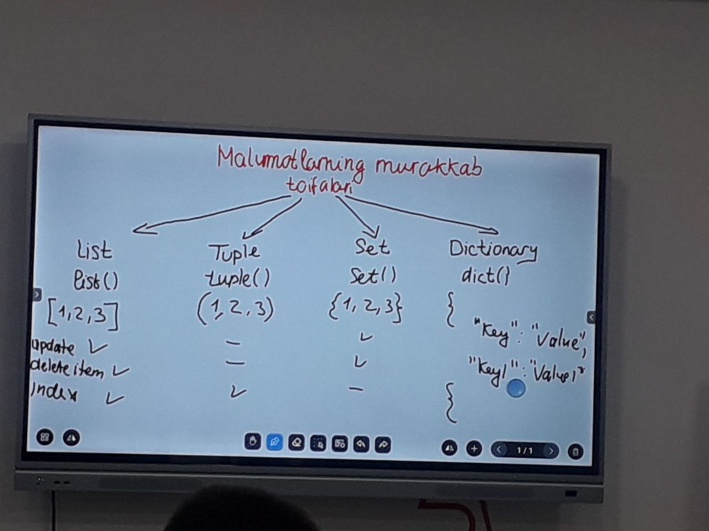

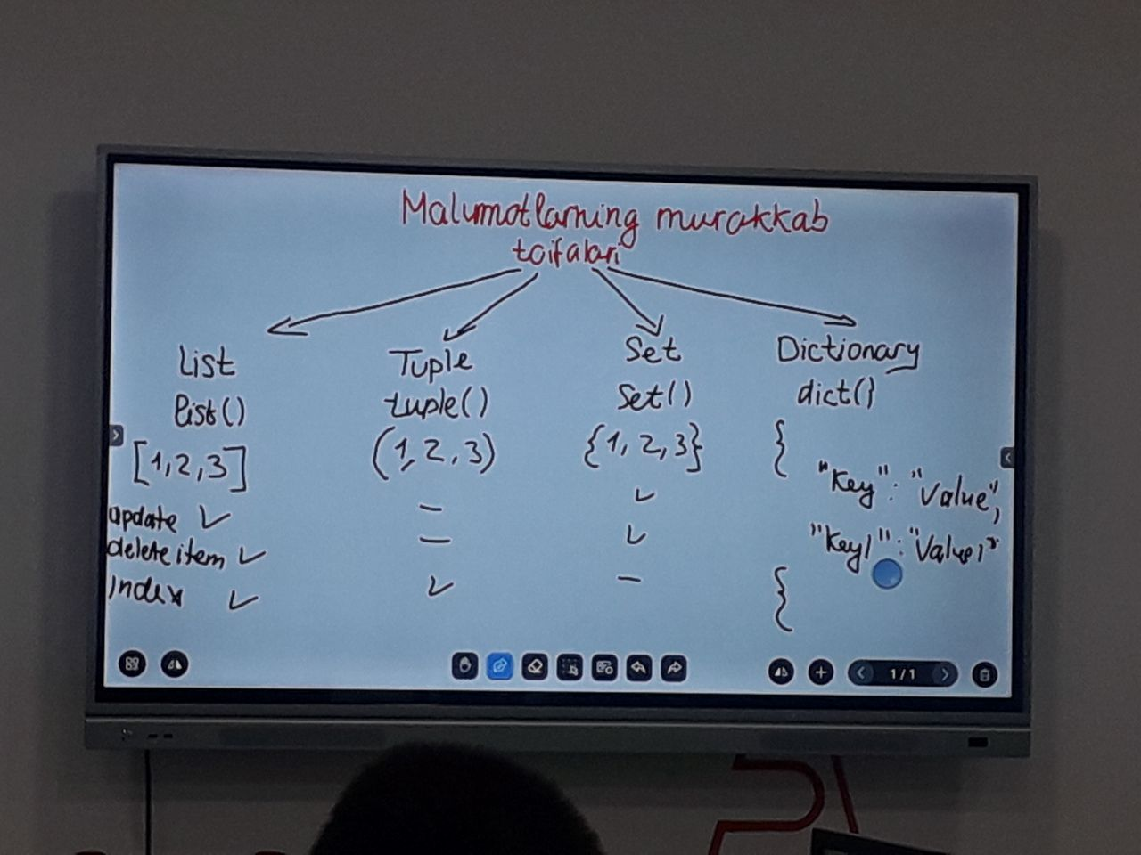

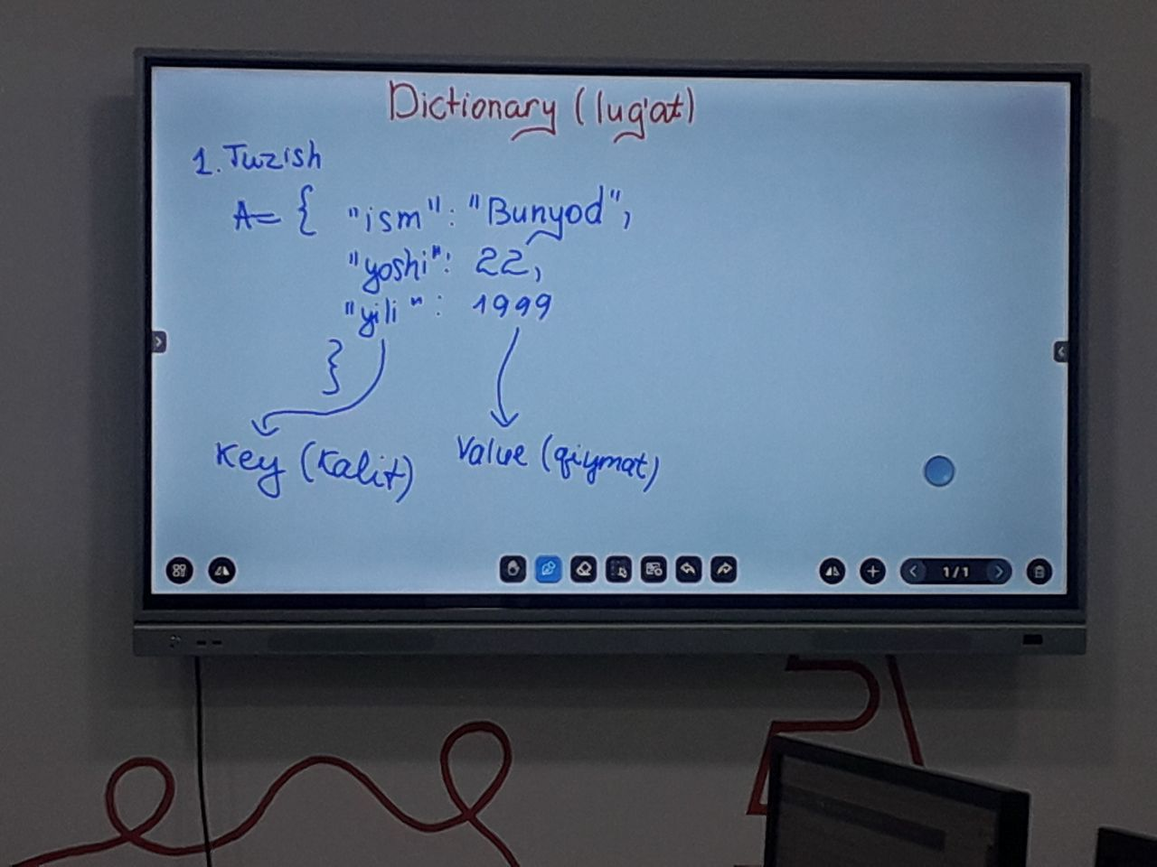



Oʏʙᴇᴋ Nᴀʀᴢᴜʟʟᴀʏᴇᴠ, [07.07.21 09:22]

""" set ni yaratish """

# 1. gulli qavslar bilan

numbers = {1, 2, 3, 4, 5, 6}

print(type(numbers))

# 2. set() kosntruktori bilan

numbers = set([1, 2, 3, 4, 5]) # listni setga aylantirish

print(numbers)

print(type(numbers))

numbers = set((1, 2, 3, 4))

print(numbers)

""" elementlariga murojaat """

# Diqqat: setda indeks yo'q!!!

# setni listga aylantirish:

numbers = {1, 2, 3, 4, 5, 6}

numbers = list(numbers) # endi numbers list ga aylandi

print(numbers)

print(numbers[0])

""" setni barcha elementlarini ko'rish """

numbers = {1, 2, 3, 4, 5, 6}

print(numbers) # shunchaki setni o'zini print qilish

for i in numbers:

print(i)

""" setda bir xil elementlar bo'lmadi """

fruits = {"apple", "orange", "banana", "apple"}

print(fruits)

# xulosa: set da bir xil element bo'lmaydi!

""" setda tarib muhimmas """

fruits = {"apple", "orange", "banana", "apple"}

fruits1 = {"orange", "apple", "banana"}

print(fruits1 == fruits)

""" element qo'shish """

mevalar = {"Olma", "Anor"}

# add funksiyasi bilan uning parametri mavjud bo'lishi shart! -> .metod(parametr)

mevalar.add("Shaftoli")

print(mevalar)

# set.method(parametr)

# update funksiyasi bilan set.update(*element)

mevalar.update(["Gilos", "Olxori"])

print(mevalar)

""" elementni o'chirish:"""

# remove

fruits = {"apple", "orange", "banana", "Cherry"}

fruits.remove("banana")

print(fruits)

# pop

fruits.pop()

print(fruits)

# clear -> tozalash

fruits = {"apple", "orange", "banana", "Cherry"}

fruits.clear() # bu bo'sh qiladi

print(fruits)

# del -> bu birato'la setni o'zini xotiradan o'chiradi

fruits = {"apple", "orange", "banana", "Cherry"}

del fruits

# print(fruits)

Oʏʙᴇᴋ Nᴀʀᴢᴜʟʟᴀʏᴇᴠ, [07.07.21 10:06]

# matematika, fizika, informatika fanlaridan olimpiada bo'ldi. Olimpiadalar ketma ket bo'ldi.\

# olimpiadaga kirgan o'quvchilar ro'yhatini chiqaring:

matematika = ["Ibrohim", "Muhammad", "Abbos", "Bunyod"]

fizika = ["Oybek", "Ibrohim", "Shoxzod", "Abbos"]

informatika = ["Oybek", "Ibrohim", "Abbos", "Shoxzod"]

a = matematika + fizika + informatika

a = set(a)

print(a)

Oʏʙᴇᴋ Nᴀʀᴢᴜʟʟᴀʏᴇᴠ, [07.07.21 11:01]

import random as rd

A = []

B = []

C = []

# A va b to'plamlarni birlashmasini olib C to'plam bilan kesishmasini olasiz

for i in range(10):

k = rd.randint(1, 10)

A.append(k)

for i in range(10):

k = rd.randint(1, 10)

B.append(k)

for i in range(10):

k = rd.randint(1, 10)

C.append(k)

print(A)

print(B)

AUB = set(A + B)

print(AUB)

AUB = list(AUB)

C = set(C)

print(C)

D = []

for i in C:

if i in AUB:

D.append(i)

D = set(D)

print(D)

Oʏʙᴇᴋ Nᴀʀᴢᴜʟʟᴀʏᴇᴠ, [07.07.21 11:02]

[In reply to Oʏʙᴇᴋ Nᴀʀᴢᴜʟʟᴀʏᴇᴠ]

maxsus masala

Oʏʙᴇᴋ Nᴀʀᴢᴜʟʟᴀʏᴇᴠ, [07.07.21 11:03]

import random as rd

A = []

B = []

C = []

# A va b to'plamlarni birlashmasini olib C to'plam bilan kesishmasini olasiz

for i in range(10):

A.append(rd.randint(1, 10))

B.append(rd.randint(1, 10))

C.append(rd.randint(1, 10))

print(A)

print(B)

AUB = set(A + B)

print(AUB)

AUB = list(AUB)

C = set(C)

print(C)

D = []

for i in C:

if i in AUB:

D.append(i)

D = set(D)

print(D)

Oʏʙᴇᴋ Nᴀʀᴢᴜʟʟᴀʏᴇᴠ, [07.07.21 11:44]

""" copy() parametri yo'q """

mevalar1 = {"Olma", "Anor"}

mevalar2 = mevalar1.copy()

print(f"{mevalar1} {mevalar2} ")

# nusxalashni o'zlashtirish amali bilan ham bajarsa bo'ladi

mevalar3 = mevalar1

mevalar1.clear()

print(mevalar3) # bu o'chib ketadi chunki bu o'zlashtirishdan hosil bo'lgan

print(mevalar2) # bu o'chmaydi chunki bu nusxalangan

""" difference() parametri bor u set qabul qiladi"""

mevalar1 = {"Olma", "Anor", "Olcha"}

mevalar2 = {"Apelsin", "Anor", "Ananas"}

print(mevalar1.difference(mevalar2)) # mevalar1 ni mevalar2 dan farqi

""" difference_update() parametr bor """

mevalar1 = {"Olma", "Anor", "Olcha"}

mevalar2 = {"Apelsin", "Anor", "Ananas"}

mevalar1.difference_update(mevalar2) # mevalar1 ni mevalar2 dan farqini o'ziga o'zlashtiradi

print(mevalar1)

""" intersection() kesishma ikkisida ham borlarini oladi """

mevalar1 = {"Olma", "Anor", "Olcha"}

mevalar2 = {"Apelsin", "Anor", "Ananas"}

print(mevalar1.intersection(mevalar2))

""" intersection_update ikkisida ham borlarini o'ziga o'zlashtiradi"""

mevalar1 = {"Olma", "Anor", "Olcha"}

mevalar2 = {"Apelsin", "Anor", "Ananas"}

mevalar1.intersection_update(mevalar2)

print(mevalar1)

""" isdisjoin() bu agar bitta setni ikkinchi setda bir xil elementi

bo'lmasa True bo'lsa False qaytaradi"""

mevalar1 = {"Olma", "Anor", "Olcha"}

mevalar2 = {"Apelsin", "Anor", "Ananas"}

print(mevalar1.isdisjoint(mevalar2)) # hozirgi holarda False chunki ikkisida ham anor bor

""" issubset() -> set1.issubset(set2) - agar set2 ichida set1 bo'lsa True aks holsa False """

mevalar1 = {"Olma", "Anor", "Olcha", "Ananas"}

mevalar2 = {"Anor", "Olma"}

print(mevalar2.issubset(mevalar1))

""" issuperset() -> set1.issuperset(set2) agar set1 ni ichida set2 bo'lsa True aks holda False """

mevalar1 = {"Olma", "Anor", "Olcha", "Ananas"}

mevalar2 = {"Anor", "Olma"}

print(mevalar2.issuperset(mevalar1)) # hozirgi holatda False

""" symmetric_difference() set3 = set1.symmetric_difference(set2) set1 va set2 dagi bir xil

elementlarini olib tashlab qolganlarini set3 ga o'zlashtiradi"""

mevalar1 = {"Olma", "Anor", "Olcha", "Ananas"}

mevalar2 = {"Anor", "Olma", "Apelsin", "Mandarin"}

mevalar3 = mevalar1.symmetric_difference(mevalar2)

print(mevalar3)

""" symmetric_difference_update() set1.symmetric_difference(set2) set1 va set2 dagi bir xil

elementlarini olib tashlab qolganlarini set1 o'ziga o'zlashtiradi"""

mevalar1 = {"Olma", "Anor", "Olcha", "Ananas"}

mevalar2 = {"Anor", "Olma", "Apelsin", "Mandarin"}

mevalar1.symmetric_difference_update(mevalar2)

print(mevalar1)

""" union -> set1.union(set2) -> set1 va set2 ni birlashmasi"""

mevalar1 = {"Olma", "Anor", "Olcha", "Ananas"}

mevalar2 = {"Anor", "Olma", "Apelsin", "Mandarin"}

mevalar3 = mevalar1.union(mevalar2)

print(mevalar3)

Oʏʙᴇᴋ Nᴀʀᴢᴜʟʟᴀʏᴇᴠ, [07.07.21 11:52]

# 1 - masala. ikkita set berilagan

# birinchisida 1 dan 10 gacha bo'lgan

# sonlar ikkinchisida

# 5 dan 15 gacha bo'lgan sonlar berilgan

# ikkita setni farqini alohida setga

# o'zlashtiring

Oʏʙᴇᴋ Nᴀʀᴢᴜʟʟᴀʏᴇᴠ, [08.07.21 09:20]

""" Dict (lug'at) """

# to'g'ridan to'g'ri e'lon qilish

shaxs = {

"ism": "Oybek",

"yoshi": 22,

"kasbi": "O'qituvchi"

}

# dict() konstruktori bilan

shaxs = dict({"ism": "Oybek", "yoshi": 22, "kasbi": "O'qituvchi"})

print(type(shaxs))

""" dict xossalari """

# dict bu tartiblangan

# elementlar takrorlanmaydi

# element -> {key : value}

shaxs = {

"ism": "Oybek",

"yoshi": 20,

"yoshi": 22,

"kasbi": "O'qituvchi"

}

print(shaxs)

""" elementlarga murojaat """

shaxs = {

"ism": "Oybek",

"yoshi": 20,

"kasbi": "O'qituvchi"

}

# 1 - usul

print(shaxs["ism"])

# 2 usul get() metodi bilan

print(shaxs.get("ism"))

""" keys() metodi faqatgina kalit so'zlarni

chiqarar ekan """

shaxs = {

"ism": "Oybek",

"yoshi": 20,

"kasbi": "O'qituvchi"

}

print(shaxs.keys())

""" values() nu metod faqatgina

qiymatlarni chiqarar ekan """

shaxs = {

"ism": "Oybek",

"yoshi": 20,

"kasbi": "O'qituvchi"

}

print(shaxs.values())

Oʏʙᴇᴋ Nᴀʀᴢᴜʟʟᴀʏᴇᴠ, [08.07.21 09:20]

# maxsus masala:

shaxslar = [

{

"ism": "Shoxzod",

"yoshi": 20

},

{

"ism": "Oybek",

"yoshi": 22

},

{

"ism": "Bunyod",

"yoshi": 22

},

{

"ism": "Madinabonu",

"yoshi": 13

}

]

for shaxs in shaxslar:

if shaxs["yoshi"] > 20:

print(shaxs["ism"])

Oʏʙᴇᴋ Nᴀʀᴢᴜʟʟᴀʏᴇᴠ, [08.07.21 09:32]

shaxslar = [

{

"ism": "Shoxzod",

"yoshi": 20,

"jinsi": "erkak"

},

{

"ism": "Oybek",

"yoshi": 22,

"jinsi": "erkak"

},

{

"ism": "Bunyod",

"yoshi": 22,

"jinsi": "erkak"

},

{

"ism": "Madinabonu",

"yoshi": 13,

"jinsi": "erkak"

}

]

Oʏʙᴇᴋ Nᴀʀᴢᴜʟʟᴀʏᴇᴠ, [08.07.21 09:51]

talaba = {

"ism": "Oybek",

"yoshi": 22,

}

yil = int(input("necha yil o'tdi -> "))

talaba["yoshi"] = talaba["yoshi"] + yil

print(talaba)

Oʏʙᴇᴋ Nᴀʀᴢᴜʟʟᴀʏᴇᴠ, [08.07.21 10:09]

""" Dict (lug'at) """

# to'g'ridan to'g'ri e'lon qilish

shaxs = {

"ism": "Oybek",

"yoshi": 22,

"kasbi": "O'qituvchi"

}

# dict() konstruktori bilan

shaxs = dict({"ism": "Oybek", "yoshi": 22, "kasbi": "O'qituvchi"})

print(type(shaxs))

""" dict xossalari """

# dict bu tartiblangan

# elementlar takrorlanmaydi

# element -> {key : value}

shaxs = {

"ism": "Oybek",

"yoshi": 20,

"yoshi": 22,

"kasbi": "O'qituvchi"

}

print(shaxs)

""" elementlarga murojaat """

shaxs = {

"ism": "Oybek",

"yoshi": 20,

"kasbi": "O'qituvchi"

}

# 1 - usul

print(shaxs["ism"])

# 2 usul get() metodi bilan

print(shaxs.get("ism"))

""" keys() metodi faqatgina kalit so'zlarni

chiqarar ekan """

shaxs = {

"ism": "Oybek",

"yoshi": 20,

"kasbi": "O'qituvchi"

}

print(shaxs.keys())

""" values() nu metod faqatgina

qiymatlarni chiqarar ekan """

shaxs = {

"ism": "Oybek",

"yoshi": 20,

"kasbi": "O'qituvchi"

}

print(shaxs.values())

""" element qo'shish """

shaxs = {

"ism": "Oybek",

"yoshi": 20,

"kasbi": "O'qituvchi"

}

# oddiy yangi elementni e'lon qilib:

shaxs["millati"] = "O'zbek"

print(shaxs)

# update() bir nechta elemnet qo'shishingiz mumkin

shaxs.update({"manzili": "Jizzax", "tel": "+99 894 646 24 99"})

print(shaxs)

""" element o'zgatirsh -> update"""

shaxs = {

"ism": "Oybek",

"yoshi": 20,

"kasbi": "O'qituvchi"

}

shaxs["ism"] = "Nodir"

print(shaxs) # endi ismi Nodir bo'ldi

""" element o'chirish """

shaxs = {

"ism": "Oybek",

"yoshi": 20,

"kasbi": "O'qituvchi",

"millati": "O'zbek"

}

# pop() -> dict.pop(any key) # dict - lug'at; any - har (lyuboy) key - kalit

shaxs.pop("millati")

print(shaxs)

# popitem() -> bu dict ni oxirgi elementini o'chiradi # dict.popitem() no parameter

shaxs = {

"ism": "Oybek",

"yoshi": 20,

"kasbi": "O'qituvchi",

"millati": "O'zbek"

}

shaxs.popitem()

print(shaxs)

# del -> del dict[key] - bunda o'sha key ga mos element o'chib ketadi

# del -> del dict - bu dict ni o'zini xotiradan o'chiradi

shaxs = {

"ism": "Oybek",

"yoshi": 20,

"kasbi": "O'qituvchi",

"millati": "O'zbek"

}

del shaxs["yoshi"]

print(shaxs)

del shaxs # o'chib ketdi...

# print(shaxs) agar buni kommentdan chiqarsan qib qizil xato bo'ladi

Oʏʙᴇᴋ Nᴀʀᴢᴜʟʟᴀʏᴇᴠ, [08.07.21 10:21]

person1 = {

"name": "John",

"father": "Bill",

"mother": "Anna",

"married": 0

}

person2 = {

"name": "Kate",

"father": "Pet",

"mother": "Maria",

"married": 0

}

Oʏʙᴇᴋ Nᴀʀᴢᴜʟʟᴀʏᴇᴠ, [07.07.21 09:22]

""" set ni yaratish """

# 1. gulli qavslar bilan

numbers = {1, 2, 3, 4, 5, 6}

print(type(numbers))

# 2. set() kosntruktori bilan

numbers = set([1, 2, 3, 4, 5]) # listni setga aylantirish

print(numbers)

print(type(numbers))

numbers = set((1, 2, 3, 4))

print(numbers)

""" elementlariga murojaat """

# Diqqat: setda indeks yo'q!!!

# setni listga aylantirish:

numbers = {1, 2, 3, 4, 5, 6}

numbers = list(numbers) # endi numbers list ga aylandi

print(numbers)

print(numbers[0])

""" setni barcha elementlarini ko'rish """

numbers = {1, 2, 3, 4, 5, 6}

print(numbers) # shunchaki setni o'zini print qilish

for i in numbers:

print(i)

""" setda bir xil elementlar bo'lmadi """

fruits = {"apple", "orange", "banana", "apple"}

print(fruits)

# xulosa: set da bir xil element bo'lmaydi!

""" setda tarib muhimmas """

fruits = {"apple", "orange", "banana", "apple"}

fruits1 = {"orange", "apple", "banana"}

print(fruits1 == fruits)

""" element qo'shish """

mevalar = {"Olma", "Anor"}

# add funksiyasi bilan uning parametri mavjud bo'lishi shart! -> .metod(parametr)

mevalar.add("Shaftoli")

print(mevalar)

# set.method(parametr)

# update funksiyasi bilan set.update(*element)

mevalar.update(["Gilos", "Olxori"])

print(mevalar)

""" elementni o'chirish:"""

# remove

fruits = {"apple", "orange", "banana", "Cherry"}

fruits.remove("banana")

print(fruits)

# pop

fruits.pop()

print(fruits)

# clear -> tozalash

fruits = {"apple", "orange", "banana", "Cherry"}

fruits.clear() # bu bo'sh qiladi

print(fruits)

# del -> bu birato'la setni o'zini xotiradan o'chiradi

fruits = {"apple", "orange", "banana", "Cherry"}

del fruits

# print(fruits)

Oʏʙᴇᴋ Nᴀʀᴢᴜʟʟᴀʏᴇᴠ, [07.07.21 10:06]

# matematika, fizika, informatika fanlaridan olimpiada bo'ldi. Olimpiadalar ketma ket bo'ldi.\

# olimpiadaga kirgan o'quvchilar ro'yhatini chiqaring:

matematika = ["Ibrohim", "Muhammad", "Abbos", "Bunyod"]

fizika = ["Oybek", "Ibrohim", "Shoxzod", "Abbos"]

informatika = ["Oybek", "Ibrohim", "Abbos", "Shoxzod"]

a = matematika + fizika + informatika

a = set(a)

print(a)

Oʏʙᴇᴋ Nᴀʀᴢᴜʟʟᴀʏᴇᴠ, [07.07.21 11:01]

import random as rd

A = []

B = []

C = []

# A va b to'plamlarni birlashmasini olib C to'plam bilan kesishmasini olasiz

for i in range(10):

k = rd.randint(1, 10)

A.append(k)

for i in range(10):

k = rd.randint(1, 10)

B.append(k)

for i in range(10):

k = rd.randint(1, 10)

C.append(k)

print(A)

print(B)

AUB = set(A + B)

print(AUB)

AUB = list(AUB)

C = set(C)

print(C)

D = []

for i in C:

if i in AUB:

D.append(i)

D = set(D)

print(D)

Oʏʙᴇᴋ Nᴀʀᴢᴜʟʟᴀʏᴇᴠ, [07.07.21 11:02]

[In reply to Oʏʙᴇᴋ Nᴀʀᴢᴜʟʟᴀʏᴇᴠ]

maxsus masala

Oʏʙᴇᴋ Nᴀʀᴢᴜʟʟᴀʏᴇᴠ, [07.07.21 11:03]

import random as rd

A = []

B = []

C = []

# A va b to'plamlarni birlashmasini olib C to'plam bilan kesishmasini olasiz

for i in range(10):

A.append(rd.randint(1, 10))

B.append(rd.randint(1, 10))

C.append(rd.randint(1, 10))

print(A)

print(B)

AUB = set(A + B)

print(AUB)

AUB = list(AUB)

C = set(C)

print(C)

D = []

for i in C:

if i in AUB:

D.append(i)

D = set(D)

print(D)

Oʏʙᴇᴋ Nᴀʀᴢᴜʟʟᴀʏᴇᴠ, [07.07.21 11:44]

""" copy() parametri yo'q """

mevalar1 = {"Olma", "Anor"}

mevalar2 = mevalar1.copy()

print(f"{mevalar1} {mevalar2} ")

# nusxalashni o'zlashtirish amali bilan ham bajarsa bo'ladi

mevalar3 = mevalar1

mevalar1.clear()

print(mevalar3) # bu o'chib ketadi chunki bu o'zlashtirishdan hosil bo'lgan

print(mevalar2) # bu o'chmaydi chunki bu nusxalangan

""" difference() parametri bor u set qabul qiladi"""

mevalar1 = {"Olma", "Anor", "Olcha"}

mevalar2 = {"Apelsin", "Anor", "Ananas"}

print(mevalar1.difference(mevalar2)) # mevalar1 ni mevalar2 dan farqi

""" difference_update() parametr bor """

mevalar1 = {"Olma", "Anor", "Olcha"}

mevalar2 = {"Apelsin", "Anor", "Ananas"}

mevalar1.difference_update(mevalar2) # mevalar1 ni mevalar2 dan farqini o'ziga o'zlashtiradi

print(mevalar1)

""" intersection() kesishma ikkisida ham borlarini oladi """

mevalar1 = {"Olma", "Anor", "Olcha"}

mevalar2 = {"Apelsin", "Anor", "Ananas"}

print(mevalar1.intersection(mevalar2))

""" intersection_update ikkisida ham borlarini o'ziga o'zlashtiradi"""

mevalar1 = {"Olma", "Anor", "Olcha"}

mevalar2 = {"Apelsin", "Anor", "Ananas"}

mevalar1.intersection_update(mevalar2)

print(mevalar1)

""" isdisjoin() bu agar bitta setni ikkinchi setda bir xil elementi

bo'lmasa True bo'lsa False qaytaradi"""

mevalar1 = {"Olma", "Anor", "Olcha"}

mevalar2 = {"Apelsin", "Anor", "Ananas"}

print(mevalar1.isdisjoint(mevalar2)) # hozirgi holarda False chunki ikkisida ham anor bor

""" issubset() -> set1.issubset(set2) - agar set2 ichida set1 bo'lsa True aks holsa False """

mevalar1 = {"Olma", "Anor", "Olcha", "Ananas"}

mevalar2 = {"Anor", "Olma"}

print(mevalar2.issubset(mevalar1))

""" issuperset() -> set1.issuperset(set2) agar set1 ni ichida set2 bo'lsa True aks holda False """

mevalar1 = {"Olma", "Anor", "Olcha", "Ananas"}

mevalar2 = {"Anor", "Olma"}

print(mevalar2.issuperset(mevalar1)) # hozirgi holatda False

""" symmetric_difference() set3 = set1.symmetric_difference(set2) set1 va set2 dagi bir xil

elementlarini olib tashlab qolganlarini set3 ga o'zlashtiradi"""

mevalar1 = {"Olma", "Anor", "Olcha", "Ananas"}

mevalar2 = {"Anor", "Olma", "Apelsin", "Mandarin"}

mevalar3 = mevalar1.symmetric_difference(mevalar2)

print(mevalar3)

""" symmetric_difference_update() set1.symmetric_difference(set2) set1 va set2 dagi bir xil

elementlarini olib tashlab qolganlarini set1 o'ziga o'zlashtiradi"""

mevalar1 = {"Olma", "Anor", "Olcha", "Ananas"}

mevalar2 = {"Anor", "Olma", "Apelsin", "Mandarin"}

mevalar1.symmetric_difference_update(mevalar2)

print(mevalar1)

""" union -> set1.union(set2) -> set1 va set2 ni birlashmasi"""

mevalar1 = {"Olma", "Anor", "Olcha", "Ananas"}

mevalar2 = {"Anor", "Olma", "Apelsin", "Mandarin"}

mevalar3 = mevalar1.union(mevalar2)

print(mevalar3)

Oʏʙᴇᴋ Nᴀʀᴢᴜʟʟᴀʏᴇᴠ, [07.07.21 11:52]

# 1 - masala. ikkita set berilagan

# birinchisida 1 dan 10 gacha bo'lgan

# sonlar ikkinchisida

# 5 dan 15 gacha bo'lgan sonlar berilgan

# ikkita setni farqini alohida setga

# o'zlashtiring

Oʏʙᴇᴋ Nᴀʀᴢᴜʟʟᴀʏᴇᴠ, [08.07.21 09:20]

""" Dict (lug'at) """

# to'g'ridan to'g'ri e'lon qilish

shaxs = {

"ism": "Oybek",

"yoshi": 22,

"kasbi": "O'qituvchi"

}

# dict() konstruktori bilan

shaxs = dict({"ism": "Oybek", "yoshi": 22, "kasbi": "O'qituvchi"})

print(type(shaxs))

""" dict xossalari """

# dict bu tartiblangan

# elementlar takrorlanmaydi

# element -> {key : value}

shaxs = {

"ism": "Oybek",

"yoshi": 20,

"yoshi": 22,

"kasbi": "O'qituvchi"

}

print(shaxs)

""" elementlarga murojaat """

shaxs = {

"ism": "Oybek",

"yoshi": 20,

"kasbi": "O'qituvchi"

}

# 1 - usul

print(shaxs["ism"])

# 2 usul get() metodi bilan

print(shaxs.get("ism"))

""" keys() metodi faqatgina kalit so'zlarni

chiqarar ekan """

shaxs = {

"ism": "Oybek",

"yoshi": 20,

"kasbi": "O'qituvchi"

}

print(shaxs.keys())

""" values() nu metod faqatgina

qiymatlarni chiqarar ekan """

shaxs = {

"ism": "Oybek",

"yoshi": 20,

"kasbi": "O'qituvchi"

}

print(shaxs.values())

Oʏʙᴇᴋ Nᴀʀᴢᴜʟʟᴀʏᴇᴠ, [08.07.21 09:20]

# maxsus masala:

shaxslar = [

{

"ism": "Shoxzod",

"yoshi": 20

},

{

"ism": "Oybek",

"yoshi": 22

},

{

"ism": "Bunyod",

"yoshi": 22

},

{

"ism": "Madinabonu",

"yoshi": 13

}

]

for shaxs in shaxslar:

if shaxs["yoshi"] > 20:

print(shaxs["ism"])

Oʏʙᴇᴋ Nᴀʀᴢᴜʟʟᴀʏᴇᴠ, [08.07.21 09:32]

shaxslar = [

{

"ism": "Shoxzod",

"yoshi": 20,

"jinsi": "erkak"

},

{

"ism": "Oybek",

"yoshi": 22,

"jinsi": "erkak"

},

{

"ism": "Bunyod",

"yoshi": 22,

"jinsi": "erkak"

},

{

"ism": "Madinabonu",

"yoshi": 13,

"jinsi": "erkak"

}

]

Oʏʙᴇᴋ Nᴀʀᴢᴜʟʟᴀʏᴇᴠ, [08.07.21 09:51]

talaba = {

"ism": "Oybek",

"yoshi": 22,

}

yil = int(input("necha yil o'tdi -> "))

talaba["yoshi"] = talaba["yoshi"] + yil

print(talaba)

Oʏʙᴇᴋ Nᴀʀᴢᴜʟʟᴀʏᴇᴠ, [08.07.21 10:09]

""" Dict (lug'at) """

# to'g'ridan to'g'ri e'lon qilish

shaxs = {

"ism": "Oybek",

"yoshi": 22,

"kasbi": "O'qituvchi"

}

# dict() konstruktori bilan

shaxs = dict({"ism": "Oybek", "yoshi": 22, "kasbi": "O'qituvchi"})

print(type(shaxs))

""" dict xossalari """

# dict bu tartiblangan

# elementlar takrorlanmaydi

# element -> {key : value}

shaxs = {

"ism": "Oybek",

"yoshi": 20,

"yoshi": 22,

"kasbi": "O'qituvchi"

}

print(shaxs)

""" elementlarga murojaat """

shaxs = {

"ism": "Oybek",

"yoshi": 20,

"kasbi": "O'qituvchi"

}

# 1 - usul

print(shaxs["ism"])

# 2 usul get() metodi bilan

print(shaxs.get("ism"))

""" keys() metodi faqatgina kalit so'zlarni

chiqarar ekan """

shaxs = {

"ism": "Oybek",

"yoshi": 20,

"kasbi": "O'qituvchi"

}

print(shaxs.keys())

""" values() nu metod faqatgina

qiymatlarni chiqarar ekan """

shaxs = {

"ism": "Oybek",

"yoshi": 20,

"kasbi": "O'qituvchi"

}

print(shaxs.values())

""" element qo'shish """

shaxs = {

"ism": "Oybek",

"yoshi": 20,

"kasbi": "O'qituvchi"

}

# oddiy yangi elementni e'lon qilib:

shaxs["millati"] = "O'zbek"

print(shaxs)

# update() bir nechta elemnet qo'shishingiz mumkin

shaxs.update({"manzili": "Jizzax", "tel": "+99 894 646 24 99"})

print(shaxs)

""" element o'zgatirsh -> update"""

shaxs = {

"ism": "Oybek",

"yoshi": 20,

"kasbi": "O'qituvchi"

}

shaxs["ism"] = "Nodir"

print(shaxs) # endi ismi Nodir bo'ldi

""" element o'chirish """

shaxs = {

"ism": "Oybek",

"yoshi": 20,

"kasbi": "O'qituvchi",

"millati": "O'zbek"

}

# pop() -> dict.pop(any key) # dict - lug'at; any - har (lyuboy) key - kalit

shaxs.pop("millati")

print(shaxs)

# popitem() -> bu dict ni oxirgi elementini o'chiradi # dict.popitem() no parameter

shaxs = {

"ism": "Oybek",

"yoshi": 20,

"kasbi": "O'qituvchi",

"millati": "O'zbek"

}

shaxs.popitem()

print(shaxs)

# del -> del dict[key] - bunda o'sha key ga mos element o'chib ketadi

# del -> del dict - bu dict ni o'zini xotiradan o'chiradi

shaxs = {

"ism": "Oybek",

"yoshi": 20,

"kasbi": "O'qituvchi",

"millati": "O'zbek"

}

del shaxs["yoshi"]

print(shaxs)

del shaxs # o'chib ketdi...

# print(shaxs) agar buni kommentdan chiqarsan qib qizil xato bo'ladi

Oʏʙᴇᴋ Nᴀʀᴢᴜʟʟᴀʏᴇᴠ, [08.07.21 10:21]

person1 = {

"name": "John",

"father": "Bill",

"mother": "Anna",

"married": 0

}

person2 = {

"name": "Kate",

"father": "Pet",

"mother": "Maria",

"married": 0

}

Oʏʙᴇᴋ Nᴀʀᴢᴜʟʟᴀʏᴇᴠ, [08.07.21 11:18]

# 1 - masala yoshi degan key bormi yo'qmi

for i in talaba:

if i == "yosh":

print("bor")

break

else:

print("yo'q")

Oʏʙᴇᴋ Nᴀʀᴢᴜʟʟᴀʏᴇᴠ, [08.07.21 11:19]

EnUz = {

"i": "men",

"you": ["sen", "siz"],

"he": "u",

"she": "u",

"it": "u",

"we": "biz",

"they": "ular",

"teacher": "o'qituvchi",

"pupil": "o'quvchi",

"hello": "salom",

"bye": "xayir",

"world": "dunyo",

"uzbekistan": "O'zbekiston"

}

Oʏʙᴇᴋ Nᴀʀᴢᴜʟʟᴀʏᴇᴠ, [08.07.21 11:59]

uquvchilar = [

{

"ismi": "Oybek",

"sinfi": "9-V",

"baholari": {

"matematika": 4,

"fizika": 3,

"infortika": 5

},

"sinfSardori": True

},

{

"ismi": "Shoxzod",

"sinfi": "9-B",

"baholari": {

"matematika": 5,

"fizika": 5,

"infortika": 5

},

"sinfSardori": False

},

{

"ismi": "Ibrohim",

"sinfi": "9-V",

"baholari": {

"matematika": 3,

"fizika": 2,

"infortika": 5

},

"sinfSardori": False

},

{

"ismi": "Muhammad",

"sinfi": "9-B",

"baholari": {

"matematika": 2,

"fizika": 5,

"infortika": 4

},

"sinfSardori": True

},

{

"ismi": "Abbos",

"sinfi": "9-B",

"baholari": {

"matematika": 4,

"fizika": 5,

"infortika": 5

},

"sinfSardori": False

},

{

"ismi": "Islombek",

"sinfi": "9-V",

"baholari": {

"matematika": 4,

"fizika": 5,

"infortika": 2

},

"sinfSardori": False

}

]

Oʏʙᴇᴋ Nᴀʀᴢᴜʟʟᴀʏᴇᴠ, [08.07.21 11:59]

[In reply to Oʏʙᴇᴋ Nᴀʀᴢᴜʟʟᴀʏᴇᴠ]

Hisobot tayorlaysiz:

Oʏʙᴇᴋ Nᴀʀᴢᴜʟʟᴀʏᴇᴠ, [08.07.21 12:00]

""" Dict (lug'at) """

# to'g'ridan to'g'ri e'lon qilish

shaxs = {

"ism": "Oybek",

"yoshi": 22,

"kasbi": "O'qituvchi"

}

# dict() konstruktori bilan

shaxs = dict({"ism": "Oybek", "yoshi": 22, "kasbi": "O'qituvchi"})

print(type(shaxs))

""" dict xossalari """

# dict bu tartiblangan

# elementlar takrorlanmaydi

# element -> {key : value}

shaxs = {

"ism": "Oybek",

"yoshi": 20,

"yoshi": 22,

"kasbi": "O'qituvchi"

}

print(shaxs)

""" elementlarga murojaat """

shaxs = {

"ism": "Oybek",

"yoshi": 20,

"kasbi": "O'qituvchi"

}

# 1 - usul

print(shaxs["ism"])

# 2 usul get() metodi bilan

print(shaxs.get("ism"))

""" keys() metodi faqatgina kalit so'zlarni

chiqarar ekan """

shaxs = {

"ism": "Oybek",

"yoshi": 20,

"kasbi": "O'qituvchi"

}

print(shaxs.keys())

""" values() nu metod faqatgina

qiymatlarni chiqarar ekan """

shaxs = {

"ism": "Oybek",

"yoshi": 20,

"kasbi": "O'qituvchi"

}

print(shaxs.values())

""" element qo'shish """

shaxs = {

"ism": "Oybek",

"yoshi": 20,

"kasbi": "O'qituvchi"

}

# oddiy yangi elementni e'lon qilib:

shaxs["millati"] = "O'zbek"

print(shaxs)

# update() bir nechta elemnet qo'shishingiz mumkin

shaxs.update({"manzili": "Jizzax", "tel": "+99 894 646 24 99"})

print(shaxs)

""" element o'zgatirsh -> update"""

shaxs = {

"ism": "Oybek",

"yoshi": 20,

"kasbi": "O'qituvchi"

}

shaxs["ism"] = "Nodir"

print(shaxs) # endi ismi Nodir bo'ldi

""" element o'chirish """

shaxs = {

"ism": "Oybek",

"yoshi": 20,

"kasbi": "O'qituvchi",

"millati": "O'zbek"

}

# pop() -> dict.pop(any key) # dict - lug'at; any - har (lyuboy) key - kalit

shaxs.pop("millati")

print(shaxs)

# popitem() -> bu dict ni oxirgi elementini o'chiradi # dict.popitem() no parameter

shaxs = {

"ism": "Oybek",

"yoshi": 20,

"kasbi": "O'qituvchi",

"millati": "O'zbek"

}

shaxs.popitem()

print(shaxs)

# clear() bu tozalash

shaxs = {

"ism": "Oybek",

"yoshi": 20,

"kasbi": "O'qituvchi",

"millati": "O'zbek"

}

shaxs.clear()

print(shaxs)

# del -> del dict[key] - bunda o'sha key ga mos element o'chib ketadi

# del -> del dict - bu dict ni o'zini xotiradan o'chiradi

shaxs = {

"ism": "Oybek",

"yoshi": 20,

"kasbi": "O'qituvchi",

"millati": "O'zbek"

}

del shaxs["yoshi"]

print(shaxs)

del shaxs # o'chib ketdi...

# print(shaxs) agar buni kommentdan chiqarsan qib qizil xato bo'ladi

""" loop lar (takrorlash) """

shaxs = {

"ism": "Oybek",

"yoshi": 20,

"kasbi": "O'qituvchi",

"millati": "O'zbek"

}

for i in shaxs: # bu yerda i -> keylar

print(i) # bunda keylar chiqadi

for i in shaxs:

print(shaxs[i]) # bunda value lar chiqadi

for i in shaxs:

print(shaxs.get(i)) # bunda ham value lar chiqadi

for i in shaxs.keys():

print(i) # bunda keylar chiqadi

for i in shaxs.values():

print(i) # bunda ham value lar chiqadi

for x, y in shaxs.items():

print(x, y)

""" copy() dict.copy() no parameter"""

shaxs = {

"ism": "Oybek",

"yoshi": 20,

"kasbi": "O'qituvchi",

"millati": "O'zbek"

}

shaxs1 = shaxs.copy()

shaxs2 = shaxs

shaxs.clear()

print("sh1", shaxs1)

print("sh2", shaxs2)

""" Joylashtirilgan lug'at """

oila = {

"ota": {

"ism": "John",

"yoshi": 24

},

"ona": {

"ism": "Anna",

"yoshi": 20

},

"bola": {

"ismi": "Jack",

"yoshi": 2

}

}

# bolani ismini chiqarish

print(oila.get("bola").get("ismi"))

print(oila["bola"]["ismi"])

for azo in oila:

if azo == "bola":

for i in oila[azo]:

if i == "ismi":

print(oila[azo][i])

Oʏʙᴇᴋ Nᴀʀᴢᴜʟʟᴀʏᴇᴠ, [08.07.21 12:12]

import pygame

import sys

import random

class Snake():

def init(self):

self.length = 1

self.positions = [((screen_width/2), (screen_height/2))]

self.direction = random.choice([up, down, left, right])

self.color = (17, 24, 47)

# Special thanks to YouTubers Mini - Cafetos and Knivens Beast for raising this issue!

# Code adjustment courtesy of YouTuber Elija de Hoog

self.score = 0

def get_head_position(self):

return self.positions[0]

def turn(self, point):

if self.length > 1 and (point[0]*-1, point[1]*-1) == self.direction:

return

else:

self.direction = point

def move(self):

cur = self.get_head_position()

x,y = self.direction

new = (((cur[0]+(x*gridsize))%screen_width), (cur[1]+(y*gridsize))%screen_height)

if len(self.positions) > 2 and new in self.positions[2:]:

self.reset()

else:

self.positions.insert(0,new)

if len(self.positions) > self.length:

self.positions.pop()

def reset(self):

self.length = 1

self.positions = [((screen_width/2), (screen_height/2))]

self.direction = random.choice([up, down, left, right])

self.score = 0

def draw(self,surface):

for p in self.positions:

r = pygame.Rect((p[0], p[1]), (gridsize,gridsize))

pygame.draw.rect(surface, self.color, r)

pygame.draw.rect(surface, (93,216, 228), r, 1)

def handle_keys(self):

for event in pygame.event.get():

if event.type == pygame.QUIT:

pygame.quit()

sys.exit()

elif event.type == pygame.KEYDOWN:

if event.key == pygame.K_UP:

self.turn(up)

elif event.key == pygame.K_DOWN:

self.turn(down)

elif event.key == pygame.K_LEFT:

self.turn(left)

elif event.key == pygame.K_RIGHT:

self.turn(right)

class Food():

def init(self):

self.position = (0,0)

self.color = (223, 163, 49)

self.randomize_position()

def randomize_position(self):

self.position = (random.randint(0, grid_width-1)*gridsize, random.randint(0, grid_height-1)*gridsize)

def draw(self, surface):

r = pygame.Rect((self.position[0], self.position[1]), (gridsize, gridsize))

pygame.draw.rect(surface, self.color, r)

pygame.draw.rect(surface, (93, 216, 228), r, 1)

def drawGrid(surface):

for y in range(0, int(grid_height)):

for x in range(0, int(grid_width)):

if (x+y)%2 == 0:

r = pygame.Rect((x*gridsize, y*gridsize), (gridsize,gridsize))

pygame.draw.rect(surface,(93,216,228), r)

else:

rr = pygame.Rect((x*gridsize, y*gridsize), (gridsize,gridsize))

pygame.draw.rect(surface, (84,194,205), rr)

screen_width = 480

screen_height = 480

gridsize = 20

grid_width = screen_width/gridsize

grid_height = screen_height/gridsize

up = (0,-1)

down = (0,1)

left = (-1,0)

right = (1,0)

Oʏʙᴇᴋ Nᴀʀᴢᴜʟʟᴀʏᴇᴠ, [08.07.21 12:12]

def main():

pygame.init()

clock = pygame.time.Clock()

screen = pygame.display.set_mode((screen_width, screen_height), 0, 32)

surface = pygame.Surface(screen.get_size())

surface = surface.convert()

drawGrid(surface)

snake = Snake()

food = Food()

myfont = pygame.font.SysFont("monospace",16)

while (True):

clock.tick(10)

snake.handle_keys()

drawGrid(surface)

snake.move()

if snake.get_head_position() == food.position:

snake.length += 1

snake.score += 1

food.randomize_position()

snake.draw(surface)

food.draw(surface)

screen.blit(surface, (0,0))

text = myfont.render("Score {0}".format(snake.score), 1, (0,0,0))

screen.blit(text, (5,10))

pygame.display.update()

main()

Oʏʙᴇᴋ Nᴀʀᴢᴜʟʟᴀʏᴇᴠ, [07.07.21 09:22]

""" set ni yaratish """

# 1. gulli qavslar bilan

numbers = {1, 2, 3, 4, 5, 6}

print(type(numbers))

# 2. set() kosntruktori bilan

numbers = set([1, 2, 3, 4, 5]) # listni setga aylantirish

print(numbers)

print(type(numbers))

numbers = set((1, 2, 3, 4))

print(numbers)

""" elementlariga murojaat """

# Diqqat: setda indeks yo'q!!!

# setni listga aylantirish:

numbers = {1, 2, 3, 4, 5, 6}

numbers = list(numbers) # endi numbers list ga aylandi

print(numbers)

print(numbers[0])

""" setni barcha elementlarini ko'rish """

numbers = {1, 2, 3, 4, 5, 6}

print(numbers) # shunchaki setni o'zini print qilish

for i in numbers:

print(i)

""" setda bir xil elementlar bo'lmadi """

fruits = {"apple", "orange", "banana", "apple"}

print(fruits)

# xulosa: set da bir xil element bo'lmaydi!

""" setda tarib muhimmas """

fruits = {"apple", "orange", "banana", "apple"}

fruits1 = {"orange", "apple", "banana"}

print(fruits1 == fruits)

""" element qo'shish """

mevalar = {"Olma", "Anor"}

# add funksiyasi bilan uning parametri mavjud bo'lishi shart! -> .metod(parametr)

mevalar.add("Shaftoli")

print(mevalar)

# set.method(parametr)

# update funksiyasi bilan set.update(*element)

mevalar.update(["Gilos", "Olxori"])

print(mevalar)

""" elementni o'chirish:"""

# remove

fruits = {"apple", "orange", "banana", "Cherry"}

fruits.remove("banana")

print(fruits)

# pop

fruits.pop()

print(fruits)

# clear -> tozalash

fruits = {"apple", "orange", "banana", "Cherry"}

fruits.clear() # bu bo'sh qiladi

print(fruits)

# del -> bu birato'la setni o'zini xotiradan o'chiradi

fruits = {"apple", "orange", "banana", "Cherry"}

del fruits

# print(fruits)

Oʏʙᴇᴋ Nᴀʀᴢᴜʟʟᴀʏᴇᴠ, [07.07.21 10:06]

# matematika, fizika, informatika fanlaridan olimpiada bo'ldi. Olimpiadalar ketma ket bo'ldi.\

# olimpiadaga kirgan o'quvchilar ro'yhatini chiqaring:

matematika = ["Ibrohim", "Muhammad", "Abbos", "Bunyod"]

fizika = ["Oybek", "Ibrohim", "Shoxzod", "Abbos"]

informatika = ["Oybek", "Ibrohim", "Abbos", "Shoxzod"]

a = matematika + fizika + informatika

a = set(a)

print(a)

Oʏʙᴇᴋ Nᴀʀᴢᴜʟʟᴀʏᴇᴠ, [07.07.21 11:01]

import random as rd

A = []

B = []

C = []

# A va b to'plamlarni birlashmasini olib C to'plam bilan kesishmasini olasiz

for i in range(10):

k = rd.randint(1, 10)

A.append(k)

for i in range(10):

k = rd.randint(1, 10)

B.append(k)

for i in range(10):

k = rd.randint(1, 10)

C.append(k)

print(A)

print(B)

AUB = set(A + B)

print(AUB)

AUB = list(AUB)

C = set(C)

print(C)

D = []

for i in C:

if i in AUB:

D.append(i)

D = set(D)

print(D)

Oʏʙᴇᴋ Nᴀʀᴢᴜʟʟᴀʏᴇᴠ, [07.07.21 11:02]

[In reply to Oʏʙᴇᴋ Nᴀʀᴢᴜʟʟᴀʏᴇᴠ]

maxsus masala

Oʏʙᴇᴋ Nᴀʀᴢᴜʟʟᴀʏᴇᴠ, [07.07.21 11:03]

import random as rd

A = []

B = []

C = []

# A va b to'plamlarni birlashmasini olib C to'plam bilan kesishmasini olasiz

for i in range(10):

A.append(rd.randint(1, 10))

B.append(rd.randint(1, 10))

C.append(rd.randint(1, 10))

print(A)

print(B)

AUB = set(A + B)

print(AUB)

AUB = list(AUB)

C = set(C)

print(C)

D = []

for i in C:

if i in AUB:

D.append(i)

D = set(D)

print(D)

Oʏʙᴇᴋ Nᴀʀᴢᴜʟʟᴀʏᴇᴠ, [07.07.21 11:44]

""" copy() parametri yo'q """

mevalar1 = {"Olma", "Anor"}

mevalar2 = mevalar1.copy()

print(f"{mevalar1} {mevalar2} ")

# nusxalashni o'zlashtirish amali bilan ham bajarsa bo'ladi

mevalar3 = mevalar1

mevalar1.clear()

print(mevalar3) # bu o'chib ketadi chunki bu o'zlashtirishdan hosil bo'lgan

print(mevalar2) # bu o'chmaydi chunki bu nusxalangan

""" difference() parametri bor u set qabul qiladi"""

mevalar1 = {"Olma", "Anor", "Olcha"}

mevalar2 = {"Apelsin", "Anor", "Ananas"}

print(mevalar1.difference(mevalar2)) # mevalar1 ni mevalar2 dan farqi

""" difference_update() parametr bor """

mevalar1 = {"Olma", "Anor", "Olcha"}

mevalar2 = {"Apelsin", "Anor", "Ananas"}

mevalar1.difference_update(mevalar2) # mevalar1 ni mevalar2 dan farqini o'ziga o'zlashtiradi

print(mevalar1)

""" intersection() kesishma ikkisida ham borlarini oladi """

mevalar1 = {"Olma", "Anor", "Olcha"}

mevalar2 = {"Apelsin", "Anor", "Ananas"}

print(mevalar1.intersection(mevalar2))

""" intersection_update ikkisida ham borlarini o'ziga o'zlashtiradi"""

mevalar1 = {"Olma", "Anor", "Olcha"}

mevalar2 = {"Apelsin", "Anor", "Ananas"}

mevalar1.intersection_update(mevalar2)

print(mevalar1)

""" isdisjoin() bu agar bitta setni ikkinchi setda bir xil elementi

bo'lmasa True bo'lsa False qaytaradi"""

mevalar1 = {"Olma", "Anor", "Olcha"}

mevalar2 = {"Apelsin", "Anor", "Ananas"}

print(mevalar1.isdisjoint(mevalar2)) # hozirgi holarda False chunki ikkisida ham anor bor

""" issubset() -> set1.issubset(set2) - agar set2 ichida set1 bo'lsa True aks holsa False """

mevalar1 = {"Olma", "Anor", "Olcha", "Ananas"}

mevalar2 = {"Anor", "Olma"}

print(mevalar2.issubset(mevalar1))

""" issuperset() -> set1.issuperset(set2) agar set1 ni ichida set2 bo'lsa True aks holda False """

mevalar1 = {"Olma", "Anor", "Olcha", "Ananas"}

mevalar2 = {"Anor", "Olma"}

print(mevalar2.issuperset(mevalar1)) # hozirgi holatda False

""" symmetric_difference() set3 = set1.symmetric_difference(set2) set1 va set2 dagi bir xil

elementlarini olib tashlab qolganlarini set3 ga o'zlashtiradi"""

mevalar1 = {"Olma", "Anor", "Olcha", "Ananas"}

mevalar2 = {"Anor", "Olma", "Apelsin", "Mandarin"}

mevalar3 = mevalar1.symmetric_difference(mevalar2)

print(mevalar3)

""" symmetric_difference_update() set1.symmetric_difference(set2) set1 va set2 dagi bir xil

elementlarini olib tashlab qolganlarini set1 o'ziga o'zlashtiradi"""

mevalar1 = {"Olma", "Anor", "Olcha", "Ananas"}

mevalar2 = {"Anor", "Olma", "Apelsin", "Mandarin"}

mevalar1.symmetric_difference_update(mevalar2)

print(mevalar1)

""" union -> set1.union(set2) -> set1 va set2 ni birlashmasi"""

mevalar1 = {"Olma", "Anor", "Olcha", "Ananas"}

mevalar2 = {"Anor", "Olma", "Apelsin", "Mandarin"}

mevalar3 = mevalar1.union(mevalar2)

print(mevalar3)

Oʏʙᴇᴋ Nᴀʀᴢᴜʟʟᴀʏᴇᴠ, [07.07.21 11:52]

# 1 - masala. ikkita set berilagan

# birinchisida 1 dan 10 gacha bo'lgan

# sonlar ikkinchisida

# 5 dan 15 gacha bo'lgan sonlar berilgan

# ikkita setni farqini alohida setga

# o'zlashtiring

Oʏʙᴇᴋ Nᴀʀᴢᴜʟʟᴀʏᴇᴠ, [08.07.21 09:20]

""" Dict (lug'at) """

# to'g'ridan to'g'ri e'lon qilish

shaxs = {

"ism": "Oybek",

"yoshi": 22,

"kasbi": "O'qituvchi"

}

# dict() konstruktori bilan

shaxs = dict({"ism": "Oybek", "yoshi": 22, "kasbi": "O'qituvchi"})

print(type(shaxs))

""" dict xossalari """

# dict bu tartiblangan

# elementlar takrorlanmaydi

# element -> {key : value}

shaxs = {

"ism": "Oybek",

"yoshi": 20,

"yoshi": 22,

"kasbi": "O'qituvchi"

}

print(shaxs)

""" elementlarga murojaat """

shaxs = {

"ism": "Oybek",

"yoshi": 20,

"kasbi": "O'qituvchi"

}

# 1 - usul

print(shaxs["ism"])

# 2 usul get() metodi bilan

print(shaxs.get("ism"))

""" keys() metodi faqatgina kalit so'zlarni

chiqarar ekan """

shaxs = {

"ism": "Oybek",

"yoshi": 20,

"kasbi": "O'qituvchi"

}

print(shaxs.keys())

""" values() nu metod faqatgina

qiymatlarni chiqarar ekan """

shaxs = {

"ism": "Oybek",

"yoshi": 20,

"kasbi": "O'qituvchi"

}

print(shaxs.values())

Oʏʙᴇᴋ Nᴀʀᴢᴜʟʟᴀʏᴇᴠ, [08.07.21 09:20]

# maxsus masala:

shaxslar = [

{

"ism": "Shoxzod",

"yoshi": 20

},

{

"ism": "Oybek",

"yoshi": 22

},

{

"ism": "Bunyod",

"yoshi": 22

},

{

"ism": "Madinabonu",

"yoshi": 13

}

]

for shaxs in shaxslar:

if shaxs["yoshi"] > 20:

print(shaxs["ism"])

Oʏʙᴇᴋ Nᴀʀᴢᴜʟʟᴀʏᴇᴠ, [08.07.21 09:32]

shaxslar = [

{

"ism": "Shoxzod",

"yoshi": 20,

"jinsi": "erkak"

},

{

"ism": "Oybek",

"yoshi": 22,

"jinsi": "erkak"

},

{

"ism": "Bunyod",

"yoshi": 22,

"jinsi": "erkak"

},

{

"ism": "Madinabonu",

"yoshi": 13,

"jinsi": "erkak"

}

]

Oʏʙᴇᴋ Nᴀʀᴢᴜʟʟᴀʏᴇᴠ, [08.07.21 09:51]

talaba = {

"ism": "Oybek",

"yoshi": 22,

}

yil = int(input("necha yil o'tdi -> "))

talaba["yoshi"] = talaba["yoshi"] + yil

print(talaba)

Oʏʙᴇᴋ Nᴀʀᴢᴜʟʟᴀʏᴇᴠ, [08.07.21 10:09]

""" Dict (lug'at) """

# to'g'ridan to'g'ri e'lon qilish

shaxs = {

"ism": "Oybek",

"yoshi": 22,

"kasbi": "O'qituvchi"

}

# dict() konstruktori bilan

shaxs = dict({"ism": "Oybek", "yoshi": 22, "kasbi": "O'qituvchi"})

print(type(shaxs))

""" dict xossalari """

# dict bu tartiblangan

# elementlar takrorlanmaydi

# element -> {key : value}

shaxs = {

"ism": "Oybek",

"yoshi": 20,

"yoshi": 22,

"kasbi": "O'qituvchi"

}

print(shaxs)

""" elementlarga murojaat """

shaxs = {

"ism": "Oybek",

"yoshi": 20,

"kasbi": "O'qituvchi"

}

# 1 - usul

print(shaxs["ism"])

# 2 usul get() metodi bilan

print(shaxs.get("ism"))

""" keys() metodi faqatgina kalit so'zlarni

chiqarar ekan """

shaxs = {

"ism": "Oybek",

"yoshi": 20,

"kasbi": "O'qituvchi"

}

print(shaxs.keys())

""" values() nu metod faqatgina

qiymatlarni chiqarar ekan """

shaxs = {

"ism": "Oybek",

"yoshi": 20,

"kasbi": "O'qituvchi"

}

print(shaxs.values())

""" element qo'shish """

shaxs = {

"ism": "Oybek",

"yoshi": 20,

"kasbi": "O'qituvchi"

}

# oddiy yangi elementni e'lon qilib:

shaxs["millati"] = "O'zbek"

print(shaxs)

# update() bir nechta elemnet qo'shishingiz mumkin

shaxs.update({"manzili": "Jizzax", "tel": "+99 894 646 24 99"})

print(shaxs)

""" element o'zgatirsh -> update"""

shaxs = {

"ism": "Oybek",

"yoshi": 20,

"kasbi": "O'qituvchi"

}

shaxs["ism"] = "Nodir"

print(shaxs) # endi ismi Nodir bo'ldi

""" element o'chirish """

shaxs = {

"ism": "Oybek",

"yoshi": 20,

"kasbi": "O'qituvchi",

"millati": "O'zbek"

}

# pop() -> dict.pop(any key) # dict - lug'at; any - har (lyuboy) key - kalit

shaxs.pop("millati")

print(shaxs)

# popitem() -> bu dict ni oxirgi elementini o'chiradi # dict.popitem() no parameter

shaxs = {

"ism": "Oybek",

"yoshi": 20,

"kasbi": "O'qituvchi",

"millati": "O'zbek"

}

shaxs.popitem()

print(shaxs)

# del -> del dict[key] - bunda o'sha key ga mos element o'chib ketadi

# del -> del dict - bu dict ni o'zini xotiradan o'chiradi

shaxs = {

"ism": "Oybek",

"yoshi": 20,

"kasbi": "O'qituvchi",

"millati": "O'zbek"

}

del shaxs["yoshi"]

print(shaxs)

del shaxs # o'chib ketdi...

# print(shaxs) agar buni kommentdan chiqarsan qib qizil xato bo'ladi

Oʏʙᴇᴋ Nᴀʀᴢᴜʟʟᴀʏᴇᴠ, [08.07.21 10:21]

person1 = {

"name": "John",

"father": "Bill",

"mother": "Anna",

"married": 0

}

person2 = {

"name": "Kate",

"father": "Pet",

"mother": "Maria",

"married": 0

}

Oʏʙᴇᴋ Nᴀʀᴢᴜʟʟᴀʏᴇᴠ, [08.07.21 11:18]

# 1 - masala yoshi degan key bormi yo'qmi

for i in talaba:

if i == "yosh":

print("bor")

break

else:

print("yo'q")

Oʏʙᴇᴋ Nᴀʀᴢᴜʟʟᴀʏᴇᴠ, [08.07.21 11:19]

EnUz = {

"i": "men",

"you": ["sen", "siz"],

"he": "u",

"she": "u",

"it": "u",

"we": "biz",

"they": "ular",

"teacher": "o'qituvchi",

"pupil": "o'quvchi",

"hello": "salom",

"bye": "xayir",

"world": "dunyo",

"uzbekistan": "O'zbekiston"

}

Oʏʙᴇᴋ Nᴀʀᴢᴜʟʟᴀʏᴇᴠ, [08.07.21 11:59]

uquvchilar = [

{

"ismi": "Oybek",

"sinfi": "9-V",

"baholari": {

"matematika": 4,

"fizika": 3,

"infortika": 5

},

"sinfSardori": True

},

{

"ismi": "Shoxzod",

"sinfi": "9-B",

"baholari": {

"matematika": 5,

"fizika": 5,

"infortika": 5

},

"sinfSardori": False

},

{

"ismi": "Ibrohim",

"sinfi": "9-V",

"baholari": {

"matematika": 3,

"fizika": 2,

"infortika": 5

},

"sinfSardori": False

},

{

"ismi": "Muhammad",

"sinfi": "9-B",

"baholari": {

"matematika": 2,

"fizika": 5,

"infortika": 4

},

"sinfSardori": True

},

{

"ismi": "Abbos",

"sinfi": "9-B",

"baholari": {

"matematika": 4,

"fizika": 5,

"infortika": 5

},

"sinfSardori": False

},

{

"ismi": "Islombek",

"sinfi": "9-V",

"baholari": {

"matematika": 4,

"fizika": 5,

"infortika": 2

},

"sinfSardori": False

}

]

Oʏʙᴇᴋ Nᴀʀᴢᴜʟʟᴀʏᴇᴠ, [08.07.21 11:59]

[In reply to Oʏʙᴇᴋ Nᴀʀᴢᴜʟʟᴀʏᴇᴠ]

Hisobot tayorlaysiz:

Shukurullo Isroilov, [09.07.21 09:04]

def salom(name):

print(f"Salom {name}")

#funksiyni chaqirish

ism=(input("ismingizni kiriting: "))

yosh=int(input("tug`ilgan yilingizni kiriting: "))

salom(ism)

print("siz ",2021-yosh," yoshdasiz")

Shukurullo Isroilov, [09.07.21 09:25]

def ism_yosh(ism,yosh):

print(f"Salom {ism} siz {2021-yosh} -yilda tug`ilgansiz")

x=input("ism kiriting ")

y=int(input("yoshingizni kiriting"))

ism_yosh(x,y)

Shukurullo Isroilov, [09.07.21 09:41]

#Agar funksiyaga bir nechta parametr kiritish kerak bo`lsa...

def ismlar(*ism):

print(f"Salom {ism} sizlar ruyxatdan utdingiz")

x=input("ism kiriting")

y=input("ism kiriting")

z=input("ism kiriting")

k=input("ism kiriting")

ismlar(x,k)

Oʏʙᴇᴋ Nᴀʀᴢᴜʟʟᴀʏᴇᴠ, [09.07.21 10:29]

import matplotlib.pyplot as plt

import numpy as np

# if using a jupyter notebook

# %matplotlib inline

x = np.arange(0, 4 * np.pi, 0.1) # start,stop,step

y = np.sin(x)

plt.plot(x, y)

plt.show()

Oʏʙᴇᴋ Nᴀʀᴢᴜʟʟᴀʏᴇᴠ, [09.07.21 10:34]

""" ro'yhat argument sifatida """

def uquvchilar(x):

for i in x:

print(i)

uquvchi = []

k = int(input("o'quvchilar sonini kiriting: "))

for i in range(k):

ism = input(f"{i + 1} - o'quvchi ismi: ")

uquvchi.append(ism)

uquvchilar(uquvchi)

Oʏʙᴇᴋ Nᴀʀᴢᴜʟʟᴀʏᴇᴠ, [09.07.21 10:46]

# # namunaviy masala

# a = [1, 2, 3, 4]

# b = [1, 2, 3, 4]

# c = [1, 2, 3, 4]

#

#

# # ro'yhatlarni 2 dan katta elementlarini ekranga chiqaring

# def myFunction(x):

# for i in x:

# if i > 2:

# print(i)

#

#

# myFunction(a)

# myFunction(b)

# myFunction(c)

""" funcksiyalar va protseduralar """

# funksiyani yaratish

# def <funksiya_nomi> (<parametrlari>):

# <amallar>

# return <o'zgaruvchi>

#

# def salom():

# print("salom")

#

# # funskiyani chaqirish

# salom()

#

#

# # argument va parametr

# # 1) funksiyani e'lon qilish

# def salom(name): # bu yerda name parameter

# print(f"Salom {name}")

#

# # 2) funksiyani chaqirish

# ism = input("ismingizni kiritng: ")

# salom(ism)

# """ ko'p parameterli funksiya"""

#

#

# def tuliq_ism(ism, familiyani):

# tuliq = ism + ' ' + familiyani

# print(tuliq)

#

#

# tuliq_ism("Oybek", "Narzullayev")

# tuliq_ism("John", "Doe")

#

# """ *args -> bu parametrlar to'plami """

#

#

# def ismlar_ruyhati(*ism):

# print(ism)

#

#

# ismlar_ruyhati("Oybek", "Shoxzod", "Muhammad", "Ibrohim")

#

#

# def fanlar_ruyhati(*fan):

# print(fan)

#

#

# fanlar_ruyhati("Matematika", "Fizika", "Informatika")

#

# """ keyword -> kalit so'z """

#

#

# def tuliq_ism(ism, famliya):

# print(f"{ism} {famliya}")

#

#

# firstname = input("ism : ")

# lastname = input("familiya : ")

# tuliq_ism(famliya=lastname, ism=firstname)

# """ many keyword **args-> kalit so'zlar to'plami """

#

#

# def uquvchi(**x):

# print(x)

#

#

# malumot = dict({})

# uquvchi(ismi="Ibrohim", yoshi=18, millati="O'zbek")

#

#

# def myfunction(tulov=0):

# print(f"sizdan {tulov} so'm")

#

#

# myfunction(20000)

# myfunction(10000)

# myfunction()

#

#

# def rang(r="qora"):

# print(f"men yoqtirgan rang: {r}")

#

#

# rang("oq")

# rang()

# """ ro'yhat argument sifatida """

#

#

# def uquvchilar(x):

# for i in x:

# print(i)

#

#

# uquvchi = ["Oybek", "Shoxzod", "Madinabonu"]

#

# uquvchilar(uquvchi)

# """ pass """

#

#

# def main1():

# pass

#

#

# main1()

# print("salom")

Shukurullo Isroilov, [09.07.21 11:18]

def katta(a,b):

if a>b:

return a

elif a==b:

return b+a

else:

return b

a=int(input('a ni: '))

b=int(input('a ni: '))

print(katta(a,b))

Oʏʙᴇᴋ Nᴀʀᴢᴜʟʟᴀʏᴇᴠ, [09.07.21 11:39]

""" return """

a = 2

b = 1

# shularni yig'indisni hisoblasin

def yigindi(a, b):

return a + b

print(yigindi(a, b))

""" o'rta arifmetik """

def urta(a, b, c):

return (a + b + c)/3

a = 2

b = 1

c = 3

urt = urta(a, b, c)

print(urt)

# 2 - masala

def f(x):

if x == 0:

return 0

elif x % 2 == 0:

return 1

elif x % 2 == 1:

return -1

x = int(input("x = "))

y = f(x)

print(y)

# 3 - masala. ikki sonning kattasini qaytarib beradigan funksiya tuzing

def katta(a, b):

if a > b:

return a

else:

return b

print(katta(3, 2))

sum = 0

for i in range(3):

sum += i

print(i)

print(i, sum)

# 4 - masala. berilgan sonni avval modulini topib so'ng ikkiga orttiriladigan qiymatini qaytaring

def modul(n):

if n >= 0:

return n

else:

return -n

def ikkilash(n):

return 2 * n

def masala(n):

m = modul(n)

return ikkilash(m)

print(masala(-5))

# 5 - masala. 1) biringi juft toqligini topasiz. 2) ikkinchi toq bo'lsa 4 ga ko'pyatirb qaytarasiz

# juft bo'lsa ikkiga ko'paytirb qaytarasiz.

# 3) umumiy masala degan f-ya bu qolgan ikkisini chaqiradi

def jufttoq(n):

if n % 2 == 0:

return 0

else:

return 1

def amal(n, key):

if key == 0:

return n * 2

else:

return n * 4

def masala(n):

k = jufttoq(n)

return amal(n, k)

print(masala(2))

Oʏʙᴇᴋ Nᴀʀᴢᴜʟʟᴀʏᴇᴠ, [09.07.21 11:47]

def PowerA3(n):

return n ** 3

A = 1.1

B = 2.2

C = 3.3

D = 1

E = 2

print(PowerA3(A))

print(PowerA3(B))

print(PowerA3(C))

print(PowerA3(D))

print(PowerA3(E))

Oʏʙᴇᴋ Nᴀʀᴢᴜʟʟᴀʏᴇᴠ, [09.07.21 11:51]

def PowerA3(*n):

k = []

for i in range(len(n)):

k.append(n[i] ** 3)

return k

A = 1.1

B = 2.2

C = 3.3

D = 1

E = 2

a = PowerA3(A, B, C, D, E)

for i in a:

print(i)

# namunaviy masala

# FunSimple5

def RectPS(x1, y1 ,x2, y2):

# tomonlarini quramiz:

a = abs(x2 - x1)

b = abs(y2 - y1)

# perimetrini topamiz

P = 2 * (a + b)

# yuzasini topamiz

S = a * b

print(f"perimetri: {P}; yuzasi {S}")

RectPS(1, 5, 2, 7)

Oʏʙᴇᴋ Nᴀʀᴢᴜʟʟᴀʏᴇᴠ, [12.07.21 10:12]

a = 1

b = 2

def qushish(a, b):

return a + b

def ayirish(a, b):

return a - b

def ikkilash(a):

return 2 * a

def perimetr(a, b):

n = qushish(a, b)

return ikkilash(n)

def urt(a, b):

return qushish(a, b) / 2

# P = 2 * (a + b)

print(qushish(a, b))

print(ayirish(a, b))

print(perimetr(a, b))

print(urt(a, b))

# 1 - masala

from math import factorial as f

def myFunction(n, k):

return f(n) / (f(k) * f(n - k))

print(myFunction(6, 4))

# 2 - masala

n = int(input("n = "))

def myFunction2(n):

qiymat = []

for i in range(1, n):

if i ** 2 < n:

qiymat.append(i)

return qiymat

print(myFunction2(n))

3 - masala

n = int(input("n = "))

def n_chiziq(paramatr): # e'lon qilish

txt = '' # bo'sh satr e'lon qilish

for i in range(paramatr): # qadamlarni tuzish

txt += '-' # nechta qadan bo'lsa o'shancha qadamni txt ga qo'shish

print(txt) # natini print qilish

# 2 - usul oson va tez

# def n_chiziq(paramatr):

# print('-' * paramatr)

n_chiziq(n) # funksiyani chaqirish

# 3 - masala

n = int(input("n = "))

def nYulduz(n):

for i in range(n):

print(n * "*")

"""

2 - usul:

def nYulduz(n):

print((n * "*" + '\n') * n)

"""

nYulduz(n)

# 2 - masala

n = int(input("n = "))

def buluvchilar(a):

for i in range(1, a + 1):

if a % i == 0:

print(i, end=" ") # print(i, end="\n") == print(i)

buluvchilar(n)

Oʏʙᴇᴋ Nᴀʀᴢᴜʟʟᴀʏᴇᴠ, [12.07.21 11:18]

# 3 - masala. 200 ga teng va undan kichik sonlar uchun

n = int(input("n = "))

def rim(a):

txt = ''

if a // 100 > 0:

k = a // 100

txt += k * 'C'

if a // 10 % 10 >= 0:

k = a // 10 % 10

if k <= 3:

txt += k * 'X'

elif k == 4:

txt += 'XL'

elif k >= 5 and k < 9:

txt += 'L' + (k - 5) * 'X'

elif k == 9:

txt += 'XC'

if a % 10 > 0:

v = a % 10

if v < 4:

txt += 'I' * v

elif v == 4:

txt += 'IV'

elif v < 9 and v > 4:

txt += "V" + (v - 5) * "I"

elif v == 9:

txt += "IX"

print(txt)

rim(n)

Shukurullo Isroilov, [12.07.21 11:42]

def fun(num):

yig = 0

for i in str(num):

yig+=int(i)

print(yig)

fun(n)

Oʏʙᴇᴋ Nᴀʀᴢᴜʟʟᴀʏᴇᴠ, [12.07.21 11:47]

[Forwarded from Oʏʙᴇᴋ Nᴀʀᴢᴜʟʟᴀʏᴇᴠ]

# 4 - masala.

n = int(input("n = "))

# def xona_yigindi(a):

# yigindi = 0

# for i in range(len(str(a))):

# yigindi += a // (10 ** i) % 10

#

# print(yigindi)

def xona_yigindi(a):

summa = 0

a = str(a)

for i in a:

summa += int(i)

print(summa)

xona_yigindi(n)

Oʏʙᴇᴋ Nᴀʀᴢᴜʟʟᴀʏᴇᴠ, [12.07.21 12:01]

# 5 - masala.

ballar = []

for i in range(5):

k = int(input(f"{i + 1} - hakam -> "))

ballar.append(k)

eng_katta = max(ballar)

eng_kichik = min(ballar)

def urt(a):

summa = 0

for i in a:

if i == eng_katta or i == eng_kichik:

continue

else:

summa += i

return summa / (len(a) - 2)

print(f"{eng_kichik} {eng_katta}")

print(f"{urt(ballar)}")

Abduqayumov Shohruh Jamolxonovich, [12.07.21 12:03]

n = int(input("n = "))

def xona_soni(a):

s = 0

a = str(a)

for i in a:

s += 1

print(s)

xona_soni(n)

Oʏʙᴇᴋ Nᴀʀᴢᴜʟʟᴀʏᴇᴠ, [12.07.21 12:19]

# 6 - masala.

n = int(input("n = "))

def xona_soni(a):

return len(str(a))

def xona_soni1(a):

xonalar = 0

d = 0

while 10 ** d <= a: # 1 <= 125; 10 <= 125;

xonalar += 1

d += 1

return xonalar

print(xona_soni1(n))

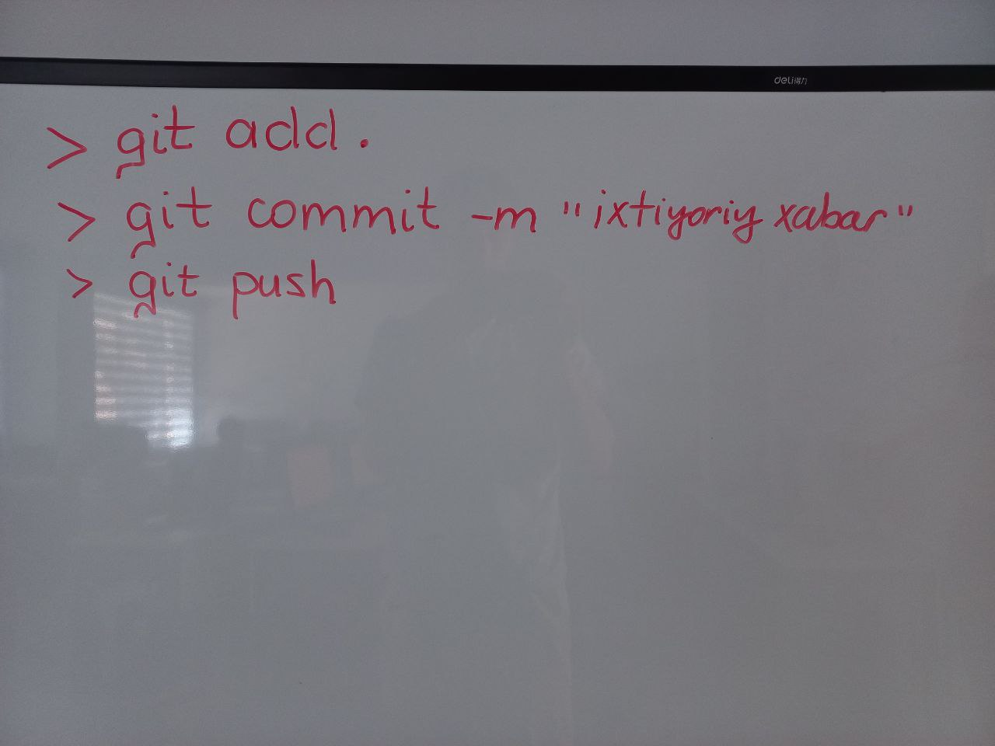

Oʏʙᴇᴋ Nᴀʀᴢᴜʟʟᴀʏᴇᴠ, [13.07.21 10:01]

# # rekursiya - o'ziga murojaat qiladigan funksiya ekan.

#

# # 1 - masala. k dan n gacha bo'lgan natural sonlarni ekranga chiqarish:

#

# def birDanNgacha(k, n): # parameter kiradi

# if n == k:

# print(f"{k}, {n}")

# else:

# print(f"{k}, {n}")

# birDanNgacha(k + 1, n) # rekursiya

#

#

# birDanNgacha(1, 10)

#

# # 2 - masala. n dan 1 gacha teskari tartibda:

#

#

# def n_dan_1_gacha(n):

# print(n)

# n_dan_1_gacha(n - 1)

#

#

# n_dan_1_gacha(10)

#

# # 3 - masala. faktorial

# def fakt(n):

# if n == 1 or n == 0:

# return 1

# else:

# return n * fakt(n - 1) # 5 * 4 * 3 * 2 * 1

#

#

# print(fakt(0))

#

# # 4 - masala.

# def yigindi(n):

# if n == 1:

# return 1

# else:

# return n + yigindi(n - 1) # 5 + 4 + 3 + 2 + 1

#

#

# print(yigindi(5))

#

# # 5 - masala. 1 dan gacha bo'lgan sonlarni teskari tartibda chiqarish

# def yigindi_toq(n):

# if n == 1:

# print(n)

# else:

# if n % 2 == 0:

# n = n - 1

# print(n)

# yigindi_toq(n - 2)

#

#

# print(yigindi_toq(7))

# 6 - masala. fibonachi sonlarini n - chi xadini topshish:

# 1, 1, 2, 3, 5, 8 ...

a = []

def fib(n):

if n == 1 or n == 2:

return 1

else:

return fib(n - 1) + fib(n - 2)

def fib_hadlari(n):

for i in range(1, n + 1):

print(fib(i), end=" ")

fib_hadlari(9)

Oʏʙᴇᴋ Nᴀʀᴢᴜʟʟᴀʏᴇᴠ, [13.07.21 11:14]

# """ xatolar bilan ishlash yoki istisnolar """

#

# # SyntaxError

# print("hello",,

#

# # IdentationError:

# for i in range(5):

# print(i)

# # NameError

# try:

# ism = "Oybek"

# print(ims)

# except:

# print("xato -> NameError")

# # valueError

# try:

# x = "1.2"

# int(x)

# except:

# print("ValueError")

# try -> urunib ko'rmoq

# except -> istisno qilish

# """ bir necha istisnolar """

# try:

# # nameError

# ism = "Oybek"

# print(ism)

# # valueError

# i = '1.02'

# int(i)

# except NameError:

# print("ism o'zgaruvsini nomida xato")

# except ValueError:

# print("qiymatda xatolik")

# """ else -> kodingiz to'g'ri ishlaganda chiqadigan natija"""

#

# try:

# print("inson holati: ", end=" ")

# print(x)

# except:

# print("inson kasal")

# else:

# print("soppa - sog'")

""" finally -> try except jarayoni tagagundan so'ng ishlatiladi"""

y = 0

try:

y = 0

print("salom")

except:

y += 1

print("try dagi nimadur xato")

finally:

if y == 0:

print("dasturda xato yo'q")

else:

print("dasturda xato bor")

Oʏʙᴇᴋ Nᴀʀᴢᴜʟʟᴀʏᴇᴠ, [13.07.21 12:03]

# """ xatolar bilan ishlash yoki istisnolar """

#

# # SyntaxError

# print("hello",,

#

# # IdentationError:

# for i in range(5):

# print(i)

# # NameError

# try:

# ism = "Oybek"

# print(ims)

# except:

# print("xato -> NameError")

# # valueError

# try:

# x = "1.2"

# int(x)

# except:

# print("ValueError")

# try -> urunib ko'rmoq

# except -> istisno qilish

# """ bir necha istisnolar """

# try:

# # nameError

# ism = "Oybek"

# print(ism)

# # valueError

# i = '1.02'

# int(i)

# except NameError:

# print("ism o'zgaruvsini nomida xato")

# except ValueError:

# print("qiymatda xatolik")

# """ else -> kodingiz to'g'ri ishlaganda chiqadigan natija"""

#

# try:

# print("inson holati: ", end=" ")

# print(x)

# except:

# print("inson kasal")

# else:

# print("soppa - sog'")

# """ finally -> try except jarayoni tagagundan so'ng ishlatiladi"""

# y = 0

# try:

# y = 0

#

# print("salom")

# except:

# y += 1

# print("try dagi nimadur xato")

# finally:

# if y == 0:

# print("dasturda xato yo'q")

# else:

# print("dasturda xato bor")

# """ raise -> xatolarni keltirib chiqarish"""

# try:

# n = int(input("n = "))

#

# if n < 0:

# raise Exception()

# except:

# print("xato")

# else:

# print("xato yoq ")

# """ xato xabarini ko'rish """

# import sys

#

# try:

# x = 21 / 0

# except:

# print(sys.exc_info()[0])

#

# 3 - masala. x sonini kiriting agar son juft bo'lsa xato keltirib chiqaring

# va istisno qiling hamda juft son kiritlmasa to'gri ishlagani haqida xabar bering

# va finallyni ham ishlating.

import sys

try:

n = int(input("n = "))

if n % 2 == 0:

raise Exception("Siz juft son kiritdingiz")

except:

print(sys.exc_info()[1])

else:

print("xato yo'q")

finally:

print("dastur tugadi")

Oʏʙᴇᴋ Nᴀʀᴢᴜʟʟᴀʏᴇᴠ, [14.07.21 09:53]

[Forwarded from Oʏʙᴇᴋ Nᴀʀᴢᴜʟʟᴀʏᴇᴠ]

# """ lambda funkdiya """

#

#

# def ikkilash(a):

# return a * 2

#

#

# print(ikkilash(5))

#

#

# ikkilash1 = lambda a: a * 2 # return a * 2; a: nuqta esa ()

# print(ikkilash1(10))

#

# """

# lambda -> def

# ikkilash1 -> ikkilash

# """

# ikki va undan ortiq parameter

# def yigindi(a, b):

# return a + b

#

#

# yigindi1 = lambda a, b: a + b

#

# print(yigindi(2, 3))

# print(yigindi1(1, 2))

#

# urt = lambda a, b, c, d: yigindi(yigindi1(a, b), yigindi1(c, d)) / 4

#

# urt1 = lambda a, b, c, d: (a + b + c + d) / 4

#

# print(urt1(1, 2, 3, 4))

# funksiyani ichida lambda

# masala. sonlar darajasini chiqarish:

def kvadrat(n):

return lambda a: n ** 2

son = kvadrat(5) # son = lambda a: a ** n

print(son(2))

print(kvadrat(5)(2))

# masala doirani uzunligini kiritish orqali funksiyani ichida lambdani qo'llab

# yuzsini chiqaring

# L = 2 * pi * R

# S = pi * (R ** 2)

def aynala(L):

return lambda pi: pi * (L/(2 * pi))**2

x = aynala(10)

print(x(3.14))

# 2 - masala.

def paralelopiped(a, b):

return lambda c: a * b * c

x = paralelopiped(2, 3)

print(x(5))

# ikki sonning ko'paytmasi

def kub(a):

return lambda b: a * b

y = kub(5)

print(y(2))

def kub(a):

return a

y = lambda b: kub(5) * b

# ikki sonni yig'indisini n - darajasini chiqaring

def yigindi(a, b):

d = a + b

return lambda n: d ** n

x = int(input("x = "))

y = int(input("y = "))

z = int(input("z = "))

k = yigindi(x, y) # d = 5

print(k(z))

# ismingizni input qilasiz uni n marta chiqarasiz:

def ism(i):

return lambda n: (i + ' ') * n

k = input("ismingizni kiriting: ")

n_ta_ism = ism(k)

print(n_ta_ism(5))

Oʏʙᴇᴋ Nᴀʀᴢᴜʟʟᴀʏᴇᴠ, [14.07.21 11:21]

import pygame

pygame.init()

dis=pygame.display.set_mode((400,300))

pygame.display.set_caption('Snake game by Edureka')

blue=(0,0,255)

red=(255,0,0)

game_over=False

while not game_over:

for event in pygame.event.get():

if event.type==pygame.QUIT:

game_over=True

pygame.draw.rect(dis,blue,[200,150,10,10])

pygame.display.update()

pygame.quit()

quit()

Oʏʙᴇᴋ Nᴀʀᴢᴜʟʟᴀʏᴇᴠ, [14.07.21 11:37]

import pygame

pygame.init()

white = (255, 255, 255)

black = (0, 0, 0)

red = (255, 0, 0)

dis = pygame.display.set_mode((800, 600))

pygame.display.set_caption('Snake Game by Edureka')

game_over = False

x1 = 300

y1 = 300

x1_change = 0

y1_change = 0

clock = pygame.time.Clock()

while not game_over:

for event in pygame.event.get():

if event.type == pygame.QUIT:

game_over = True

if event.type == pygame.KEYDOWN:

if event.key == pygame.K_LEFT:

x1_change = -10

y1_change = 0

elif event.key == pygame.K_RIGHT:

x1_change = 10

y1_change = 0

elif event.key == pygame.K_UP:

y1_change = -10

x1_change = 0

elif event.key == pygame.K_DOWN:

y1_change = 10

x1_change = 0

x1 += x1_change

y1 += y1_change

dis.fill(white)

pygame.draw.rect(dis, black, [x1, y1, 10, 10])

pygame.display.update()

clock.tick(10)

pygame.quit()

quit()

Oʏʙᴇᴋ Nᴀʀᴢᴜʟʟᴀʏᴇᴠ, [14.07.21 11:42]

import pygame

import time

pygame.init()

white = (255, 255, 255)

black = (0, 0, 0)

red = (255, 0, 0)

dis_width = 800

dis_height = 600

dis = pygame.display.set_mode((dis_width, dis_width))

pygame.display.set_caption('Snake Game by Edureka')

game_over = False

x1 = dis_width/2

y1 = dis_height/2

snake_block=10

x1_change = 0

y1_change = 0

clock = pygame.time.Clock()

snake_speed=30

font_style = pygame.font.SysFont(None, 50)

def message(msg,color):

mesg = font_style.render(msg, True, color)

dis.blit(mesg, [dis_width/2, dis_height/2])

while not game_over:

for event in pygame.event.get():

if event.type == pygame.QUIT:

game_over = True

if event.type == pygame.KEYDOWN:

if event.key == pygame.K_LEFT:

x1_change = -snake_block

y1_change = 0

elif event.key == pygame.K_RIGHT:

x1_change = snake_block

y1_change = 0

elif event.key == pygame.K_UP:

y1_change = -snake_block

x1_change = 0

elif event.key == pygame.K_DOWN:

y1_change = snake_block

x1_change = 0

if x1 >= dis_width or x1 < 0 or y1 >= dis_height or y1 < 0:

game_over = True

x1 += x1_change

y1 += y1_change

dis.fill(white)

pygame.draw.rect(dis, black, [x1, y1, snake_block, snake_block])

pygame.display.update()

clock.tick(snake_speed)

message("You lost",red)

pygame.display.update()

time.sleep(2)

pygame.quit()

quit()

Oʏʙᴇᴋ Nᴀʀᴢᴜʟʟᴀʏᴇᴠ, [14.07.21 11:47]

import pygame

import time

import random

pygame.init()

white = (255, 255, 255)

black = (0, 0, 0)

red = (255, 0, 0)

blue = (0, 0, 255)

dis_width = 800

dis_height = 600

dis = pygame.display.set_mode((dis_width, dis_height))

pygame.display.set_caption('Snake Game by Edureka')

clock = pygame.time.Clock()

snake_block = 10

snake_speed = 30

font_style = pygame.font.SysFont(None, 30)

def message(msg, color):

mesg = font_style.render(msg, True, color)

dis.blit(mesg, [dis_width/3, dis_height/3])

def gameLoop(): # creating a function

game_over = False

game_close = False

x1 = dis_width / 2

y1 = dis_height / 2

x1_change = 0

y1_change = 0

foodx = round(random.randrange(0, dis_width - snake_block) / 10.0) * 10.0

foody = round(random.randrange(0, dis_width - snake_block) / 10.0) * 10.0

while not game_over:

while game_close == True:

dis.fill(white)

message("You Lost! Press Q-Quit or C-Play Again", red)

pygame.display.update()

for event in pygame.event.get():

if event.type == pygame.KEYDOWN:

if event.key == pygame.K_q:

game_over = True

game_close = False

if event.key == pygame.K_c:

gameLoop()

for event in pygame.event.get():

if event.type == pygame.QUIT:

game_over = True

if event.type == pygame.KEYDOWN:

if event.key == pygame.K_LEFT:

x1_change = -snake_block

y1_change = 0

elif event.key == pygame.K_RIGHT:

x1_change = snake_block

y1_change = 0

elif event.key == pygame.K_UP:

y1_change = -snake_block

x1_change = 0

elif event.key == pygame.K_DOWN:

y1_change = snake_block

x1_change = 0

if x1 >= dis_width or x1 < 0 or y1 >= dis_height or y1 < 0:

game_close = True

x1 += x1_change

y1 += y1_change

dis.fill(white)

pygame.draw.rect(dis, blue, [foodx, foody, snake_block, snake_block])

pygame.draw.rect(dis, black, [x1, y1, snake_block, snake_block])

pygame.display.update()

if x1 == foodx and y1 == foody:

print("Yummy!!")

clock.tick(snake_speed)

pygame.quit()

quit()

gameLoop()

Oʏʙᴇᴋ Nᴀʀᴢᴜʟʟᴀʏᴇᴠ, [14.07.21 11:54]

import pygame

import time

import random

pygame.init()

white = (255, 255, 255)

yellow = (255, 255, 102)

black = (0, 0, 0)

red = (213, 50, 80)

green = (0, 255, 0)

blue = (50, 153, 213)

dis_width = 600

dis_height = 400

dis = pygame.display.set_mode((dis_width, dis_height))

pygame.display.set_caption('Snake Game by Edureka')

clock = pygame.time.Clock()

snake_block = 10

snake_speed = 15

font_style = pygame.font.SysFont("bahnschrift", 25)

score_font = pygame.font.SysFont("comicsansms", 35)

def our_snake(snake_block, snake_list):

for x in snake_list:

pygame.draw.rect(dis, black, [x[0], x[1], snake_block, snake_block])

def message(msg, color):

mesg = font_style.render(msg, True, color)

dis.blit(mesg, [dis_width / 6, dis_height / 3])

def gameLoop():

game_over = False

game_close = False

x1 = dis_width / 2

y1 = dis_height / 2

x1_change = 0

y1_change = 0

snake_List = []

Length_of_snake = 1

foodx = round(random.randrange(0, dis_width - snake_block) / 10.0) * 10.0

foody = round(random.randrange(0, dis_height - snake_block) / 10.0) * 10.0

while not game_over:

while game_close == True:

dis.fill(blue)

message("You Lost! Press C-Play Again or Q-Quit", red)

pygame.display.update()

for event in pygame.event.get():

if event.type == pygame.KEYDOWN:

if event.key == pygame.K_q:

game_over = True

game_close = False

if event.key == pygame.K_c:

gameLoop()

for event in pygame.event.get():

if event.type == pygame.QUIT:

game_over = True

if event.type == pygame.KEYDOWN:

if event.key == pygame.K_LEFT:

x1_change = -snake_block

y1_change = 0

elif event.key == pygame.K_RIGHT:

x1_change = snake_block

y1_change = 0

elif event.key == pygame.K_UP:

y1_change = -snake_block

x1_change = 0

elif event.key == pygame.K_DOWN:

y1_change = snake_block

x1_change = 0

if x1 >= dis_width or x1 < 0 or y1 >= dis_height or y1 < 0:

game_close = True

x1 += x1_change

y1 += y1_change

dis.fill(blue)

pygame.draw.rect(dis, green, [foodx, foody, snake_block, snake_block])

snake_Head = []

snake_Head.append(x1)

snake_Head.append(y1)

snake_List.append(snake_Head)

if len(snake_List) > Length_of_snake:

del snake_List[0]

for x in snake_List[:-1]:

if x == snake_Head:

game_close = True

our_snake(snake_block, snake_List)

pygame.display.update()

if x1 == foodx and y1 == foody:

foodx = round(random.randrange(0, dis_width - snake_block) / 10.0) * 10.0

foody = round(random.randrange(0, dis_height - snake_block) / 10.0) * 10.0

Length_of_snake += 1

clock.tick(snake_speed)

pygame.quit()

quit()

gameLoop()

Oʏʙᴇᴋ Nᴀʀᴢᴜʟʟᴀʏᴇᴠ, [15.07.21 09:27]

""" 1. modullar bilan ishlash """

# import qilish

'1. modulni import qilish'

import pygame

'2. moduldagi funksiyani import qilish'

from time import daylight

'3. moduldan bir necha obyektni import qilish'

from os import chdir, remove

'4. moduldagi barcha obyektlarni import qilish'

from math import *

import math

print(sin(0))

""" o'zimiz yaratgan modulni import qilish """

# from meningModulim import *

# print(y, x)

""" boshqa papkalardagi modullarni import qilish """

from examp2 import sonlar

print(sonlar)

**model1 dan model2 ikkiga otkazish uchun**

def name():  
 print('Bekzod')  
#  
# def fulname():  
# print('Nasimov')  
# def yigindi(a,b,c):  
# print(a+b+c)  
# from myFolder import name  
# name.fio()

**model2 ikkiga otkazish uchun fayl orqali otkizish**

import modul1  
modul1.name()

**papka orqali otkazish papka Directory orqali papka ochish**

def fulname():  
 print('Nasimov')  
 def yigindi(a,b,c):

print(a+b+c)

**pakani chaqirish:**

from myFolder import name  
 name.fio()

**TEST TUZISH DASTURI**

Oʏʙᴇᴋ Nᴀʀᴢᴜʟʟᴀʏᴇᴠ, [15.07.21 11:29]

import datetime as dt

x = dt.datetime.now().second

while True:

print(dt.datetime.now().second - x)

if x + 5 == dt.datetime.now().second:

print("salom")

x = dt.datetime.now().second

break

Oʏʙᴇᴋ Nᴀʀᴢᴜʟʟᴀʏᴇᴠ, [15.07.21 12:13]

import datetime as dt

n = int(input("Savollar sonini kiriting: "))

testVaqti = 0

testlar = []

testSavoli = {

"savol": "",

"javoblar": [

'',

'',

''

],

"kalit": "A"

}

for i in range(n):

print(i + 1, " - savolni tuzamiz:")

print("Savolni kiriting: ", end=" ")

testSavoli["savol"] = input()

for j in range(3):

print(f"Javob {j + 1} ni kiriting: ", end=' ')

testSavoli["javoblar"][j] = input()

print("to'g'ri javob indeksini kiriting yani A, B, C")

testSavoli["kalit"] = input()

testSavoli["kalit"] = testSavoli["kalit"].upper()

testShablon = testSavoli.copy()

testlar.append(testShablon)

testVaqti = int(input("Test vaqtini kiriting (sekund): "))

print("Tayyor!!!")

print("Boshlash uchun ixtiyoriy klavishni bosing")

vaqt = dt.datetime.now().second

z = input()

tugri_javoblar = 0

print("boshlandi omad!!!")

while True:

if int(vaqt + testVaqti) == int(dt.datetime.now().second):

print("vaqt tugadi")

break

for i in range(n):

print(i + 1, " - savol. ", testlar[i]['savol'])

for j in range(3):

print(f"{j + 1} {testlar[i]['javoblar'][j]}")

k = input("tog'ri javobni kiriting(A,B,C): ")

if k == testlar[i]["kalit"]:

tugri_javoblar += 1

**print(f"siz {tugri_javoblar} ta to'g'ri ishlagansiz!")**

Oʏʙᴇᴋ Nᴀʀᴢᴜʟʟᴀʏᴇᴠ, [16.07.21 09:10]

# faylni yaratish

# f = open("mening_faylim.txt", 'x')

# faylni o'qish uchun ochish

# f = open("mening_faylim.txt") # 'r' -> read

# print(f.read())

# yozish uchun ochish

# f = open("mening_faylim.txt", 'w') # white - yozish

# f.write("Salom")

# faylni ochish stillari:

# f = open("nomi.kengaytmasi", "stili")

# stillari:

# "r" -> read -> o'qish uchun

# "a" -> append -> bu oxiridan yozish uchun

# "w" -> write -> ustidan yozish uchun (overwrite)

# "x" -> Create -> yaratish uchun

# "t" -> text -> matn stili birlamchi holatda

# "b" -> binar still

# faylni yana o'qish uchun ochib ko'ramiz:

# f = open("mening_faylim.txt", 'r')

# print(f.read())

# "a" -> append

f = open("mening_faylim.txt", "r")

print(f.read())

f.close()

f = open("mening_faylim.txt", "a")

f.write(" !!!")

f.close()

f = open("mening_faylim.txt", "r")

print(f.read())

# close() -> bu muhim

**Oʏʙᴇᴋ Nᴀʀᴢᴜʟʟᴀʏᴇᴠ, [16.07.21 09:35]**

# yaratish

# f = open("men_haqimda.txt", "x")

# isminni yozaman

f = open("men_haqimda.txt", 'w')

f.write("Oybek")

# konsolga chiqarish

f = open("men_haqimda.txt", 'r')

print(f.read())

# familiyamni yozaman

f = open("men_haqimda.txt", "a")

f.write("Narzullayev")

# konsolga chiqarish

f = open("men_haqimda.txt", 'r')

print(f.read())

Oʏʙᴇᴋ Nᴀʀᴢᴜʟʟᴀʏᴇᴠ, [16.07.21 09:48]

# faylni yaratish

# f = open("mening_faylim.txt", 'x')

# faylni o'qish uchun ochish

# f = open("mening_faylim.txt") # 'r' -> read

# print(f.read())

# yozish uchun ochish

# f = open("mening_faylim.txt", 'w') # white - yozish

# f.write("Salom")

# faylni ochish stillari:

# f = open("nomi.kengaytmasi", "stili")

# stillari:

# "r" -> read -> o'qish uchun

# "a" -> append -> bu oxiridan yozish uchun

# "w" -> write -> ustidan yozish uchun (overwrite)

# "x" -> Create -> yaratish uchun

# "t" -> text -> matn stili birlamchi holatda

# "b" -> binar still

# faylni yana o'qish uchun ochib ko'ramiz:

# f = open("mening_faylim.txt", 'r')

# print(f.read())

# "a" -> append

# f = open("mening_faylim.txt", "r")

# print(f.read())

# f.close()

# f = open("mening_faylim.txt", "a")

# f.write(" !!!")

# f.close()

# f = open("mening_faylim.txt", "r")

# print(f.read())

# close() -> bu muhim

# men_haqimda.txt degan txt yaratsiz, unga

# ismingizni yozasiz

# keyin o'qib konsolga chiqarasiz

# keyin familiyangizni qo'shib qo'yasiz

# va yana konsolga chiqarasiz

# "x" -> create

# "w"

# "r"

# "a"

# "r"

# yaratish

# f = open("men_haqimda.txt", "x")

# # isminni yozaman

# f = open("men_haqimda.txt", 'w')

# f.write("Oybek")

# konsolga chiqarish

# f = open("men_haqimda.txt", 'r')

# print(f.read())

# familiyamni yozaman

# f = open("men_haqimda.txt", "a")

# f.write("Narzullayev")

# konsolga chiqarish

# f = open("men_haqimda.txt", 'r')

# print(f.read())

# """ faylni o'qish turlari """

# f = open("men_haqimda.txt", 'r')

# print(f.read(3))

# print(f.readline(1))

# # print(f.readline())

# # print(f.readline())

# for i in f:

# print(i)

# read() -> hammasini o'qish

# read(3) -> boshidagi 3 ta element o'qiladi

# readline() -> boshidan boshlab qatorlar o'qiladi

f = open('men_haqimda.txt', 'w')

f.write("Oybek\nNarzullayev")

f.close()

f = open('men_haqimda.txt', 'a')

f.write('\nJizzax')

f = open('men_haqimda.txt', 'r')

print(f.read())

**Oʏʙᴇᴋ Nᴀʀᴢᴜʟʟᴀʏᴇᴠ, [16.07.21 09:58]**

import os

if os.path.exists("mening_faylim.txt"):

os.remove("mening_faylim.txt")

print("fayl o'chdi")

else:

print("Bunday fayl mavjud emas")

**Oʏʙᴇᴋ Nᴀʀᴢᴜʟʟᴀʏᴇᴠ, [16.07.21 09:59]**

https://python-docx.readthedocs.io/en/latest/user/documents.html

**Oʏʙᴇᴋ Nᴀʀᴢᴜʟʟᴀʏᴇᴠ, [16.07.21 11:09]**

[Forwarded from Oʏʙᴇᴋ Nᴀʀᴢᴜʟʟᴀʏᴇᴠ]

# import os

#

# # 1. baza.txt faylini bor yo'qligini tekshirish

# if not os.path.exists("baza.txt"):

# f = open("baza.txt", "x")

#

# n = int(input("Xodimlar sonini kiriting: "))

#

# f = open('baza.txt', 'a')

#

xodimlar = []

xodim = {

"id": 0,

"ism": '',

"fam": '',

"maosh": '',

"manzil": ''

}

#

# for i in range(n):

# print("Xodim ma'lumotlarini kiriting: ")

# print(f"{i + 1} - xodim")

# xodim['id'] = i + 1

# xodim["ism"] = input("ismi: ")

# xodim["fam"] = input("familiyasi: ")

# xodim["maosh"] = input("maoshi: ")

# xodim["manzil"] = input("manzili: ")

# temp = xodim.copy()

# xodimlar.append(temp)

#

# f.write(str(xodimlar))

# f.close()

# # yangilash

# print("Yangilamoqchi bo'lgan xodim ismini kiriting: ")

# key = int(input("ismi: "))

# f = open("baza.txt", 'r')

# data = f.read().split('}, {')

#

# for i in range(len(data)):

# ekranga chiqarish:

f = open("baza.txt", 'r')

data = f.read()

data = data.split(', ')

for i in data:

print(i)

Nodir Atayev, [16.07.21 11:09]

[Forwarded from Oʏʙᴇᴋ Nᴀʀᴢᴜʟʟᴀʏᴇᴠ]

# import os

#

# # 1. baza.txt faylini bor yo'qligini tekshirish

# if not os.path.exists("baza.txt"):

# f = open("baza.txt", "x")

#

# n = int(input("Xodimlar sonini kiriting: "))

#

# f = open('baza.txt', 'a')

#

xodimlar = []

xodim = {

"id": 0,

"ism": '',

"fam": '',

"maosh": '',

"manzil": ''

}

#

# for i in range(n):

# print("Xodim ma'lumotlarini kiriting: ")

# print(f"{i + 1} - xodim")

# xodim['id'] = i + 1

# xodim["ism"] = input("ismi: ")

# xodim["fam"] = input("familiyasi: ")

# xodim["maosh"] = input("maoshi: ")

# xodim["manzil"] = input("manzili: ")

# temp = xodim.copy()

# xodimlar.append(temp)

#

# f.write(str(xodimlar))

# f.close()

# # yangilash

# print("Yangilamoqchi bo'lgan xodim ismini kiriting: ")

# key = int(input("ismi: "))

# f = open("baza.txt", 'r')

# data = f.read().split('}, {')

#

# for i in range(len(data)):

# ekranga chiqarish:

f = open("baza.txt", 'r')

data = f.read()

data = data.split(', ')

for i in data:

print(i)

Oʏʙᴇᴋ Nᴀʀᴢᴜʟʟᴀʏᴇᴠ, [16.07.21 11:33]

f = open("baza.txt", 'w')

username = "Narzullaev"

password = "1234"

f.write(username + '\n' + str(hash(password)))

f.close()

print("Tizimga kirish: ")

username = input("Login: ")

password = input("password: ")

f = open("baza.txt", 'r')

login = username in f.readline()

passw = str(hash(password)) in f.readline()

if login and passw:

print("tizimdan o'tdingiz!")

else:

print("login yoki parol xato!")

Oʏʙᴇᴋ Nᴀʀᴢᴜʟʟᴀʏᴇᴠ, [16.07.21 11:50]

from random import randint as ri

salt = ri(1, 1000)

f = open("baza.txt", 'w')

username = "Narzullaev"

password = "1234"

f.write(username + '\n' + str(hash(password) + salt))

f.close()

print("Tizimga kirish: ")

username = input("Login: ")

password = input("password: ")

f = open("baza.txt", 'r')

login = username in f.readline()

passw = str(hash(password) + salt) in f.readline()

if login and passw:

print("tizimdan o'tdingiz!")

else:

print("login yoki parol xato!")

Oʏʙᴇᴋ Nᴀʀᴢᴜʟʟᴀʏᴇᴠ, [17.07.21 09:29]

class Son:

x = 1

y = 2

son1 = Son() # son1 -> bu obyekt, Son() -> klass

print(son1.y, son1.x)

son2 = Son()

print(son2.x, son2.y)

# xulosa. Bitta klassdan hohlagancha obyekt olish mumkin

""" def __init__() funksiyasi: """

class Son:

def __init__(self, x, y):

self.x = x

self.y = y

son3 = Son(4, 5)

print(son3.x, son3.y)

son4 = Son(6, 7)

print(son4.x, son4.y)

**Oʏʙᴇᴋ Nᴀʀᴢᴜʟʟᴀʏᴇᴠ, [17.07.21 09:34]**

class Avtomobil:

def __init__(self, rusumi, yili, rangi, firmasi):

self.rusumi = rusumi,

self.yili = yili,

self.rangi = rangi,

self.firmasi = firmasi

malibu = Avtomobil("Malibu", 2022, "qora", "Chevrolet")

lacetti = Avtomobil("lacetti", 2020, "oq", "Chevrolet")

print(malibu.rusumi, malibu.rangi)

Oʏʙᴇᴋ Nᴀʀᴢᴜʟʟᴀʏᴇᴠ, [17.07.21 10:01]

""" classda metodlar """

class Avtomobil:

def __init__(self, rusumi):

self.rusumi = rusumi

def signal(self):

print("Biiib!!!!")

malibu = Avtomobil("Malibu")

malibu.signal()

class Shaxs:

def __init__(self, ism, fam):

self.ism = ism

self.fam = fam

def tuliq_ism(self):

return self.ism + ' ' + self.fam

sh1 = Shaxs("Oybek", "Narzullaev")

print(sh1.tuliq_ism())

class shaxs:

def init(self,ismi,familyasi,viloyat,tuman):

self.ismi = ismi

self.familyasi =familyasi

self.viloyat = viloyat

self.tuman = tuman

def salom(self):

return self.ismi + ' ' + self.familyasi

def adress(self): # self bu def init,ni ,ichidan xar bir elementni chaqiradi

return self.viloyat + ' '+ self.tuman

sh1 = shaxs('Jurabek','Davletov','Jizzax','Zafarobod')

print(sh1.salom(),sh1.adress())

class Shaxs:

def __init__(self, ism, fam, shahri, mahallasi):

self.ism = ism

self.fam = fam

self.shahri = shahri

self.mahallasi = mahallasi

def tuliq_ism(self):

return self.ism + ' ' + self.fam

def tuliq_manzil(self):

return f"{self.shahri} shahri; {self.mahallasi} mahalasi"

sh1 = Shaxs("Oybek", "Narzullaev", "Jizzax", "Uchariq")

print(sh1.tuliq_ism())

print(sh1.tuliq_manzil())

**Oʏʙᴇᴋ Nᴀʀᴢᴜʟʟᴀʏᴇᴠ, [17.07.21 10:50]**

# 1 - masala. Xodim class yaratasiz undan 5 ta obyekt olasiz

# Xodim klasida -> ismi, manzili, maoshi

# maoshi 2 mln dan kamlarini ismini chiqarasiz

**Oʏʙᴇᴋ Nᴀʀᴢᴜʟʟᴀʏᴇᴠ, [17.07.21 10:54]**

class Xodim:

def __init__(self, ismi, manzili, maoshi):

self.ismi = ismi

self.manzili = manzili

self.maoshi = maoshi

xodimlar = []

x1 = Xodim("Bunyod", "Lalmikor", 4000000)

xodimlar.append(x1)

# 1 - masala. Xodim class yaratasiz undan 5 ta obyekt olasiz

# Xodim klasida -> ismi, manzili, maoshi

# maoshi 2 mln dan kamlarini ismini chiqarasiz

class Xodim:

def __init__(self, ismi, manzili, maoshi):

self.ismi = ismi

self.manzili = manzili

self.maoshi = maoshi

xodimlar = []

x1 = Xodim("Bunyod", "Lalmikor", 4000000)

xodimlar.append(x1)

x2 = Xodim("Sunnat", "Lalmikor", 400000)

xodimlar.append(x2)

x3 = Xodim("Doston", "Lalmikor", 3000000)

xodimlar.append(x3)

x4 = Xodim("Ilyos", "Lalmikor", 1500000)

xodimlar.append(x4)

x5 = Xodim("Shoxzod", "Lalmikor", 9000000)

xodimlar.append(x5)

for xodim in xodimlar:

if xodim.maoshi < 2000000:

print(xodim.ismi)

class Xodim:

def __init__(self, ismi, manzili, maoshi):

self.ismi = ismi

self.manzili = manzili

self.maoshi = maoshi

def gap(self):

print(f"Mening ismi {self.ismi}; maoshim {self.maoshi}")

xodimlar = []

x1 = Xodim("Bunyod", "Lalmikor", 4000000)

xodimlar.append(x1)

x2 = Xodim("Sunnat", "Lalmikor", 400000)

xodimlar.append(x2)

x3 = Xodim("Doston", "Lalmikor", 3000000)

xodimlar.append(x3)

x4 = Xodim("Ilyos", "Lalmikor", 1500000)

xodimlar.append(x4)

x5 = Xodim("Shoxzod", "Lalmikor", 9000000)

xodimlar.append(x5)

for xodim in xodimlar:

xodim.gap()

# 1. dastlab xodimlar sonini kiriting.

# 2. har bir xodim ma'lumotlarini input qilib obyekt yarating

# 3. gap() metodida agar oyligini 1mln dan past bo'lsa

# "mening oyligim kam degan yozuv ham chiqsin"

# 4. barcha xodim ma'lumotlarini gap metodi orqali konsolga chiqaring

# 1. dastlab xodimlar sonini kiriting.

# 2. har bir xodim ma'lumotlarini input qilib obyekt yarating

# 3. gap() metodida agar oyligini 1mln dan past bo'lsa

# "mening oyligim kam degan yozuv ham chiqsin"

# 4. barcha xodim ma'lumotlarini gap metodi orqali konsolga chiqaring

class Xodim:

def init(self, ism, manzili, maoshi):

self.ism = ism

self.manzili = manzili

self.maoshi = maoshi

def gap(self):

print(f"Mening ismim {xodim.ism} maoshim {xodim.maoshi}")

if self.maoshi < 1000000:

print("Mening oyligim kam!!!")

xodimlar = []

n = int(input("Xodimlar soni: "))

for i in range(n):

print(f"{i + 1} - xodim")

ism = input("Ism kiriting: ")

manzili = input("Manzil kiriting")

maoshi = int(input("Maoshini kiriting"))

xodimlar.append(Xodim(ism=ism, manzili=manzili, maoshi=maoshi))

for xodim in xodimlar:

xodim.gap()